****Tarlac State University

**COLLEGE OF COMPUTER STUDIES**

Case Study

in

Integrative Programming Technology 2

Submitted By:

**FERNANDEZ, Cyrus Ortega**

**LAXAMANA, RYAN**

**LEONES, John Alvin Ferrer**

**QUIAMBAO, Elson Jr. Simbillo**

Submitted To:

**Millet, Axel D.**

Date: []

**Table of Contents**

**A.** **Definition** 3

**B.** **Case Analysis (Git and GitHub Workflow)** 4

**B.1** **Fernandez Documentation** 4

**A.** **Remote Repository (GitHub) Creating a Milestone** 4

**B.** **Local Repository (Git)** 6

**C.** **Case Analysis (Git and GitHub Workflow)** 16

**C.1** **Laxamana Documentation** 16

**A.** **Remote Repository (GitHub) Creating a Milestone** 16

**B.** **Local Repository (Git)** 17

**D.** **Case Analysis (Git and GitHub Workflow)** 46

**D.1** **Leones Documentation** 46

**A.** **Remote Repository (GitHub) Milestone** 46

**B.** **Local Repository (Git)** 48

**E.** **Case Analysis (Git and GitHub Workflow)** 56

**E.1** **Quiambao Documentation** 56

**A.** **Remote Repository (GitHub) Creating a Milestone** 56

**B.** **Local Repository (Git)** 58

**F.** **Individual HTML** 68

**G.** **References** 70

# **Definition**

The Lab Quiz#2 you did (Static Website) upload the documentation and files in your GitHub repository and add a minimum of 3 more webpages to add in your repository during the development use Git and GitHub and create a documentation of all.

**For the development of the Portfolio Webpages using (Git and GitHub) Issues, Pull Request, Milestone, Branching**

**Quiz # 1 LAB: Portfolio**

**Portfolio Web Pages Upload to GitHub Using Git**

**Requirements:**

* Each member in your group will need to upload **a webpage**
* Create a **Pull Request** for each member in Github with comments.
* Create an **Issue** for each member in Github and comment.
* Create a **Milestone** for the group in Github.
* Create a branch for each member and merge it with your master in Github.

**Define and describe how you use of each command with screenshot in your case study.**

* ~~Git clone~~
* ~~Git Pull~~
* ~~Git Push~~
* ~~Git Fetch~~
* ~~Git Merge~~
* ~~Issue~~
* Pull Request
* ~~Milestone~~
* ~~Branch~~

**Note: List the contributions of your group members**

# **Case Analysis (Git and GitHub Workflow)**

## **Fernandez Documentation**

Since I’m the leader of this project, I’ve created our GitHub repository named IPT2_Group 5 then later the name changed to BSIT-TSM-3A-IPT2CS-G5. A repository is the most basic element of GitHub. It's a place where you can store your code, your files, and each file's revision history. Repositories can have multiple collaborators and can be either public or private [1].

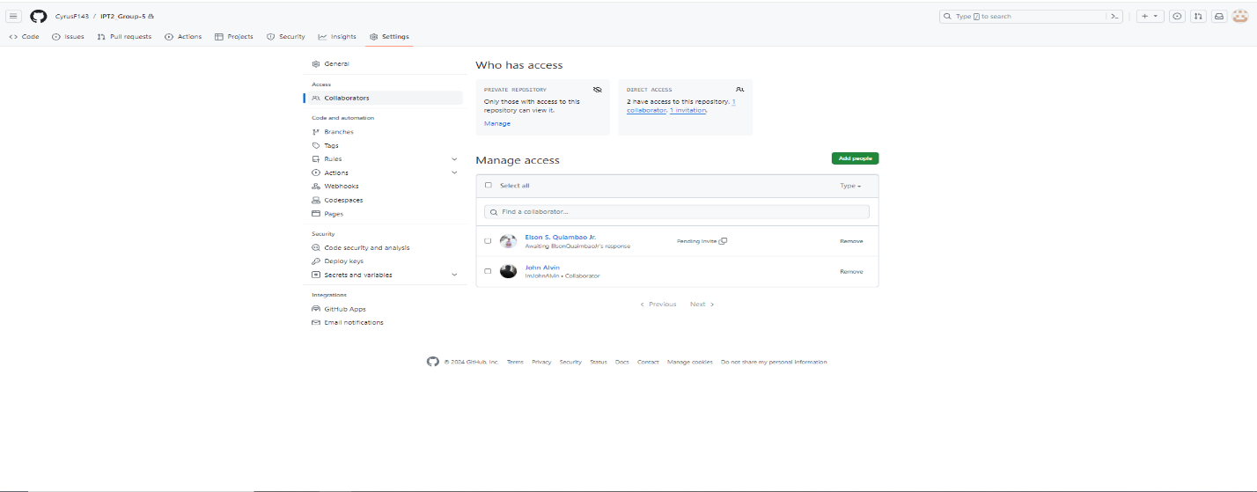

After creating the repository, it is also my responsibility to add all my members to the GitHub repository also my professor since it is indicated in the instructions for monitoring purposes.

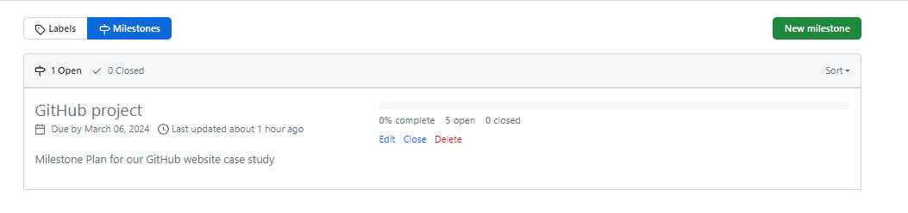

I’ve also created one milestone for our project since it is not to complex, I just created one milestone with 5 issues within it every time the issues close the percentage of the Milestone increase indicating that were making a progress**.** You can use milestones to track progress on groups of issues or pull requests in a repository. When you create a milestone, you can associate it with issues and pull requests. To better manage your project, you can view details about your milestone. [2]

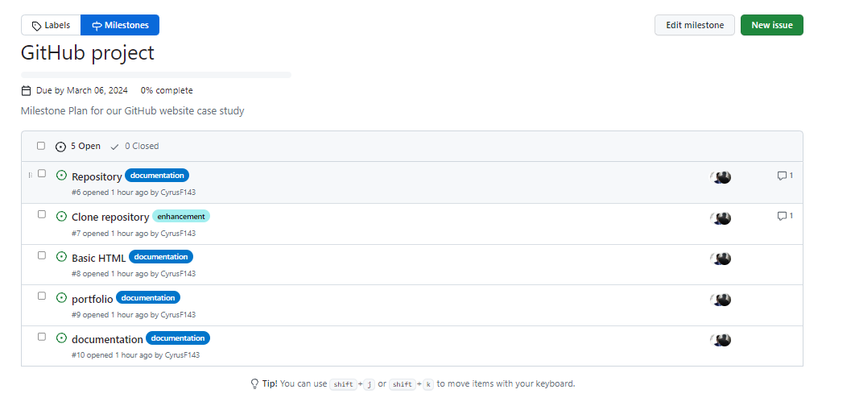

On this par I’ve created some issues and incorporate it to our milestone this issues is just a simple part by part plan/steps of our projects. Issues are simple to create and flexible to suit a variety of scenarios. You can use issues to track work, give or receive feedback, collaborate on ideas or tasks, and efficiently communicate with others. [3]

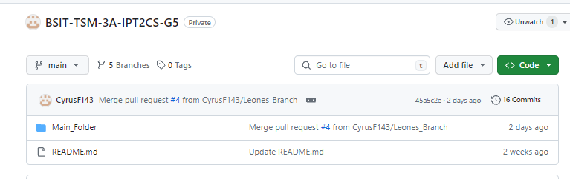

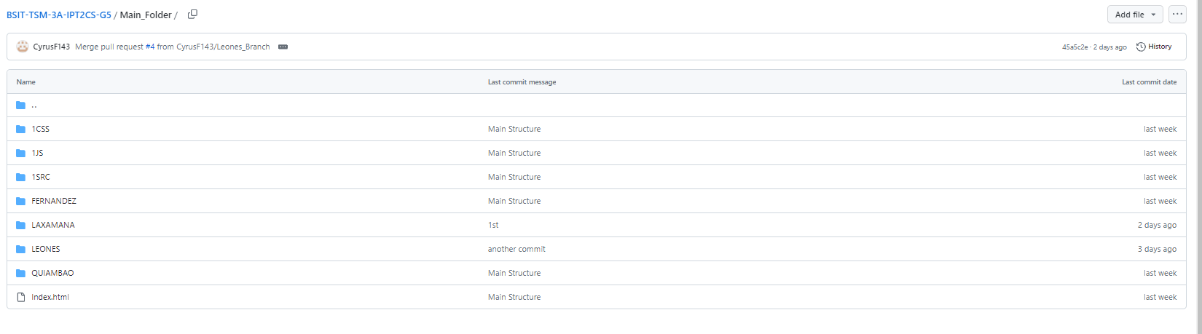

In this par I just simply uploaded a Main_Folder for our project’s this folder contains the main html that would be the landing page of our project then a designated folder for our individual Portfolio I made it this way to be more organized and incorporating some Modularity principles.

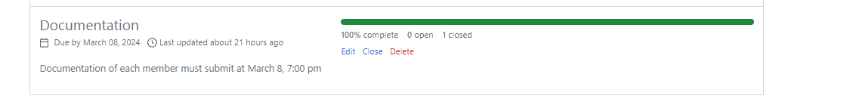

I’ve created another milestone this milestone is just for the uploading of their final document just to create a guide for them when to upload.[2]

### **Local Repository (Git)**

**Cloning the repository from GitHub to local repository using bash terminal**

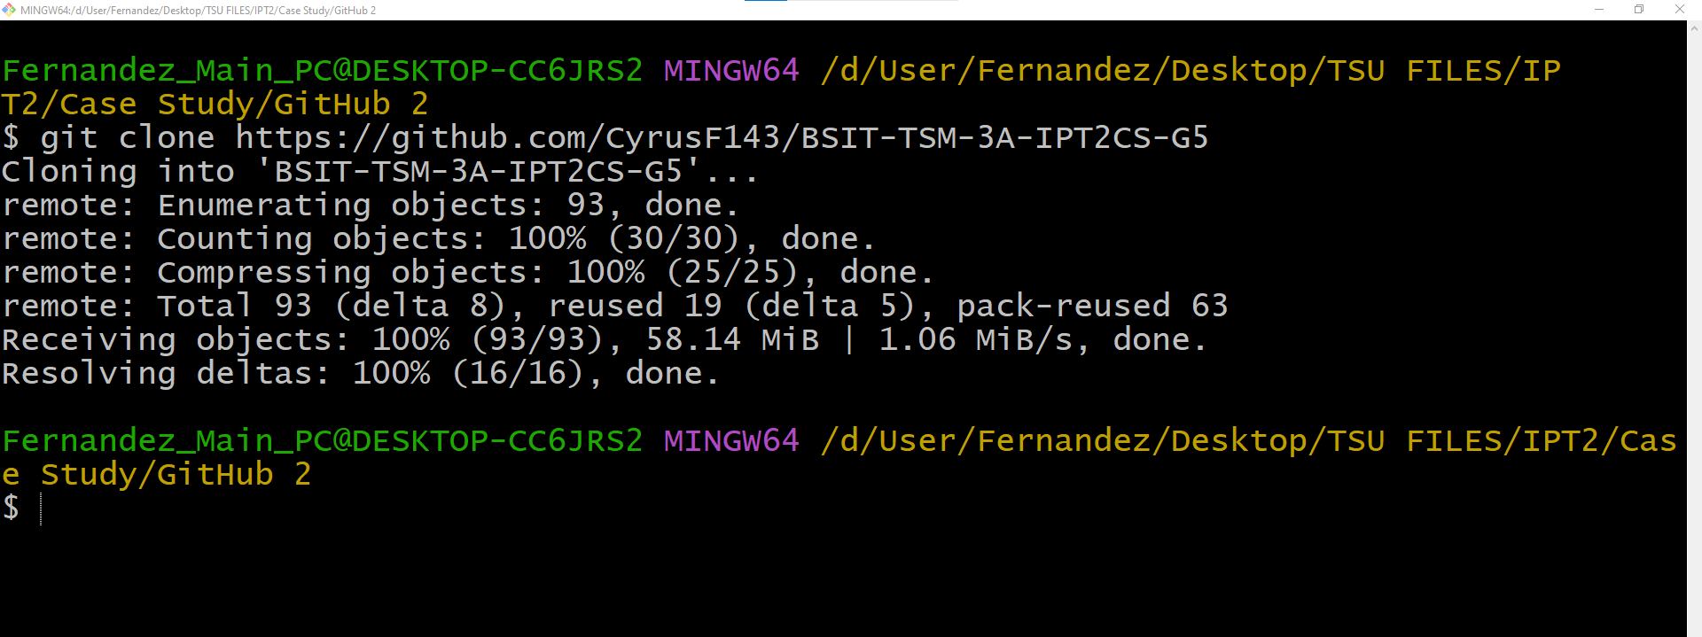

The first thing that I do is clone our GitHub repository I didn’t initialize my local repository since previously already uploaded a starting point for everyone that’s why I just copy the repository straight, on git bash type “git clone ***URL OF YOUR GITHUB.”***  To copy the files from your GitHub Repository. Clones a repository into a newly created directory, creates remote-tracking branches for each branch in the cloned repository. [4]

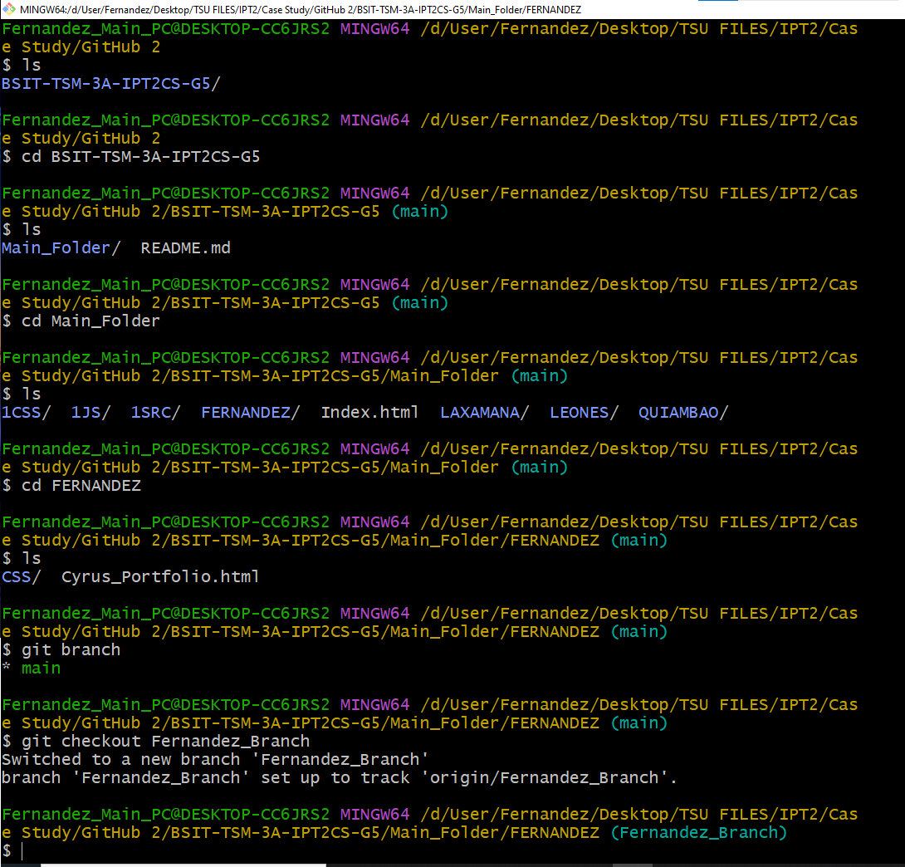**Working on local-repo and creating a local-branch**

On this part after cloning the GitHub repository I’ve navigate my self to my respective folder and typed “git checkout -b ***Fernandez_Branch***” to create my own branch. Git branches are effectively a pointer to a snapshot of your changes. When you want to add a new feature or fix a bug—no matter how big or how small—you spawn a new branch to encapsulate your changes. [5]

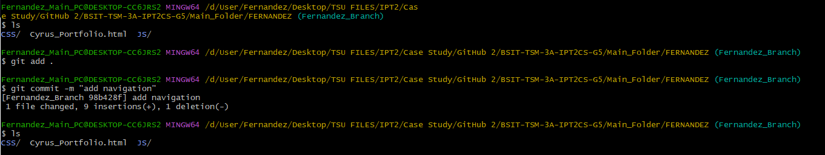

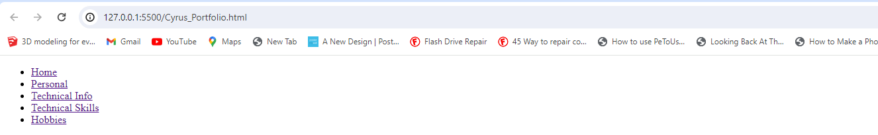

I’ve added a navigation bar to my html file cloned form the GitHub, sine I’ve edited the file it is now modified by using ***“git add .”***  the file would be switched to tracked and after that we can use “git commit -m ***MESSAGE***” to fully commit the file and get a snapshot.

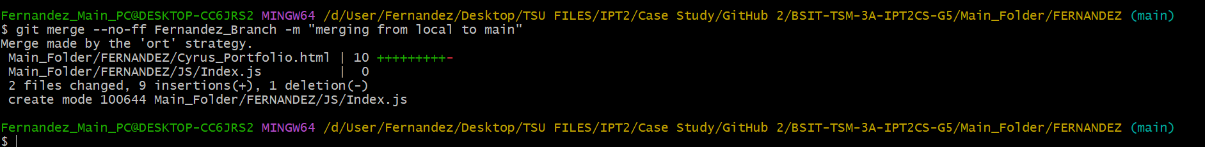

I use “git merge –no-f ***BRANCH*** -m” to merge my local branch to the main branch. Incorporates changes from the named commits (since the time their histories diverged from the current branch) into the current branch. [6]

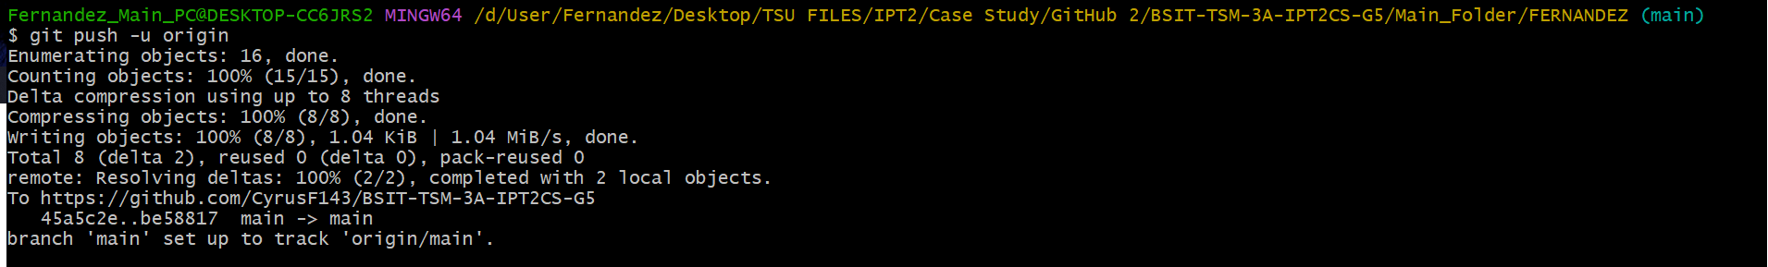

I’ve pushed my local main to the git hub branch with the command “git push -u origin”. git push origin will push the current branch to the branch of the matching name in the remote repository. [7]



The git fetch command downloads commits, files, and refs from a remote repository into your local repo. Fetching is what you do when you want to see what everybody else has been working on. [8]

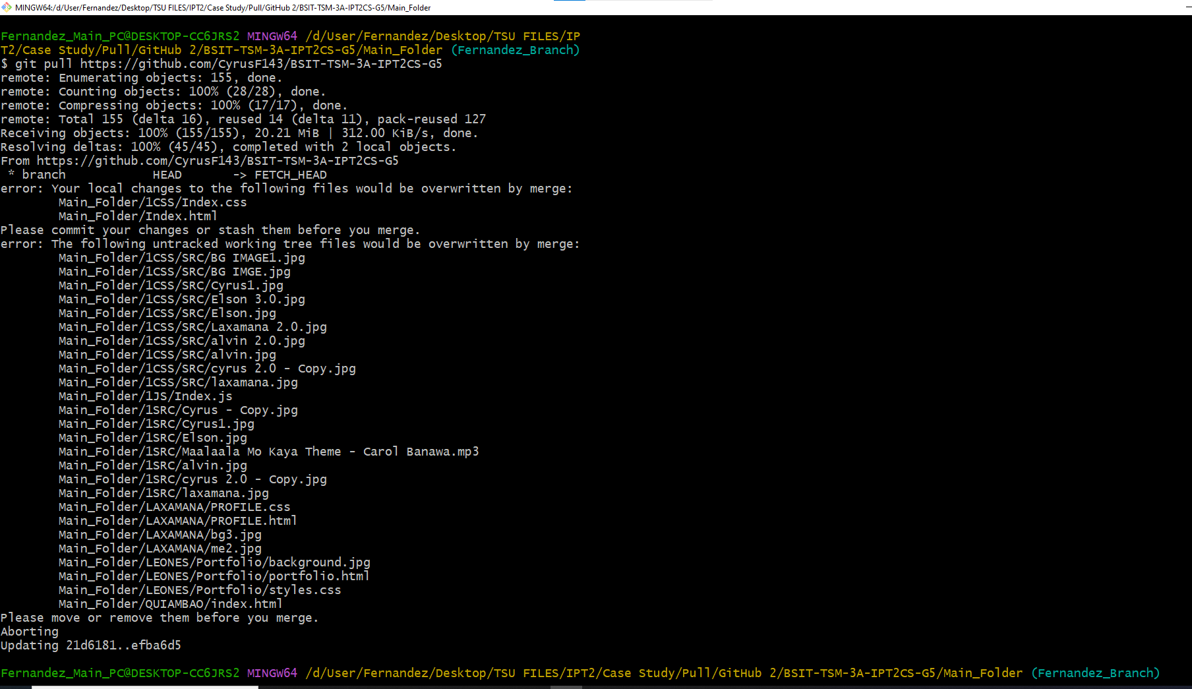

Since my team is done with their respective html it’s time for me to pull all the updates within our remote repository to my local repository to have the latest updates and to finish our lading page. Incorporates changes from a remote repository into the current branch. If the current branch is behind the remote, then by default it will fast-forward the current branch to match the remote. [9]

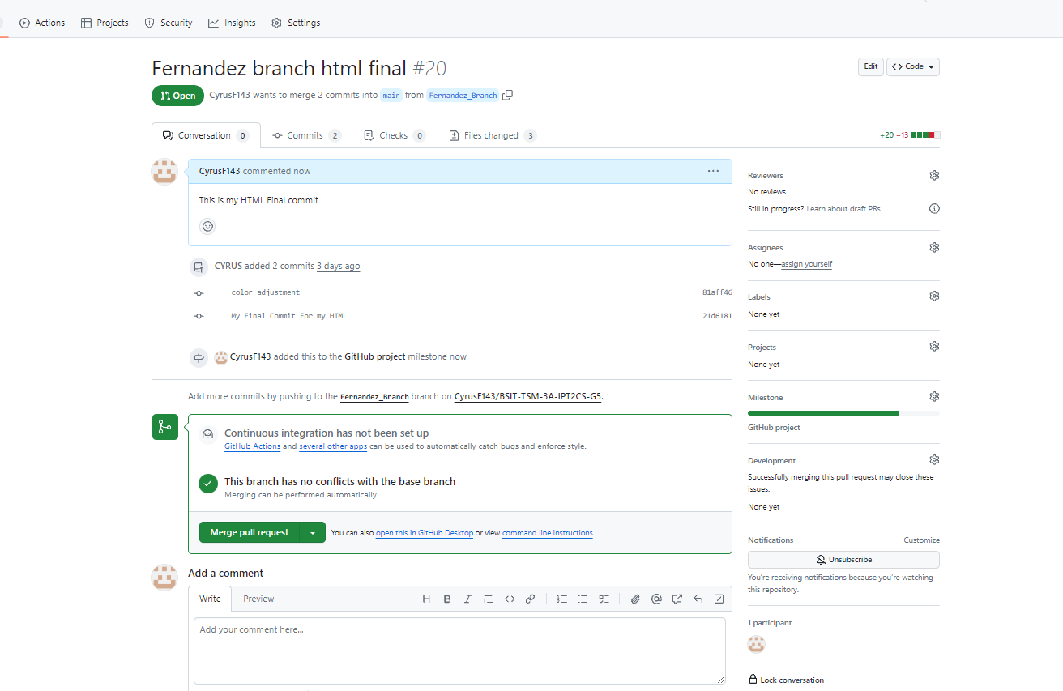

This is the merge pull request this is the part that finish my html and need to merge and pull request to our main default branch. Pull requests let you tell others about changes you've pushed to a branch in a repository on GitHub. Once a pull request is opened, you can discuss and review the potential changes with collaborators and add follow-up commits before your changes are merged into the base branch. [10]

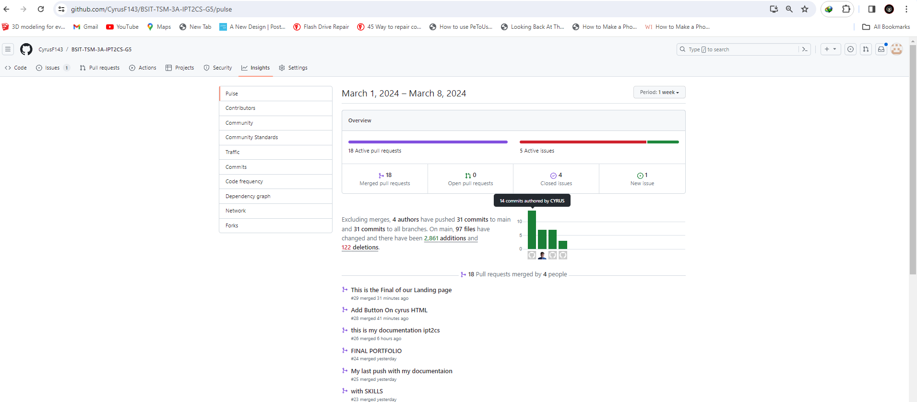

**Creating the first version of my HTML Portfolio**

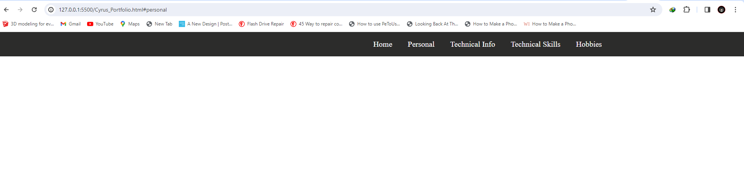

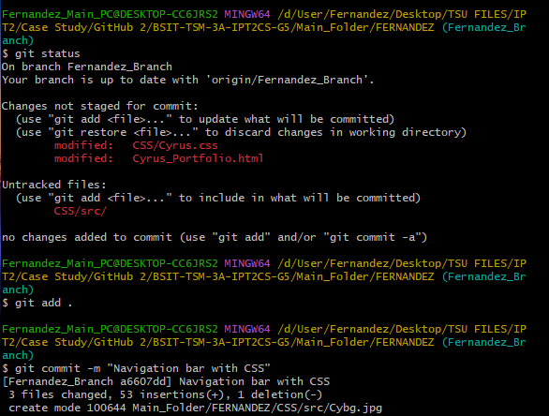

This is one of the commits in mu local repository as you can see, I’ve added some navigation and design it this is the very first part of my HTML.

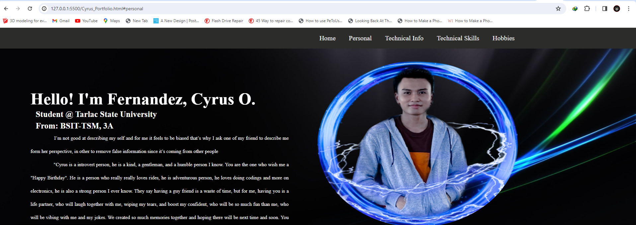

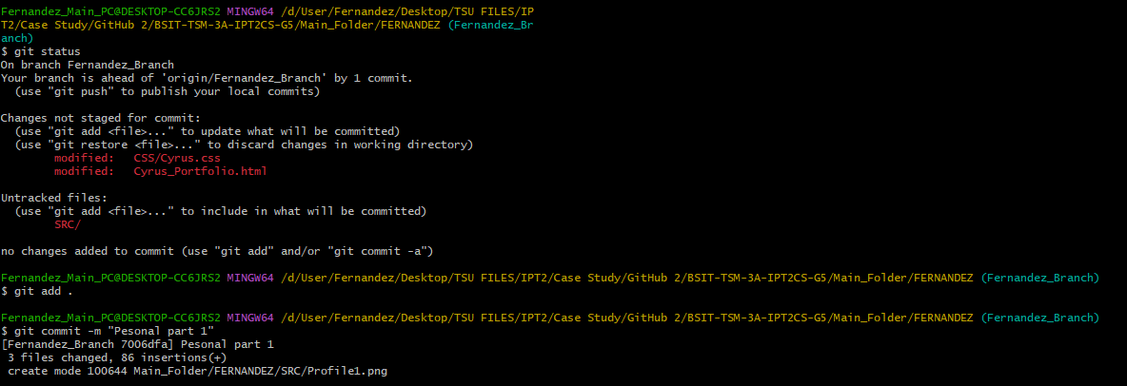

In this part I’ve created the first section of my html this contains my name, university, and section, also some description about my self this description didn’t come from me since I wanted to avoid bias and I wanted to provide the information that other people think about me. That’s why this description comes form one of my friends. Lastly there’s an image that you can hover and when you hover it will just glow a little bit.

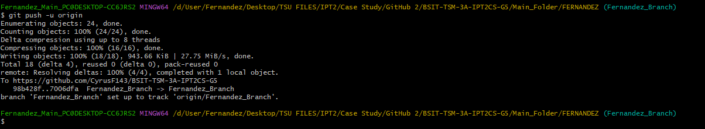

I used git push -u origin to push my progress from local repository to our remote repository.

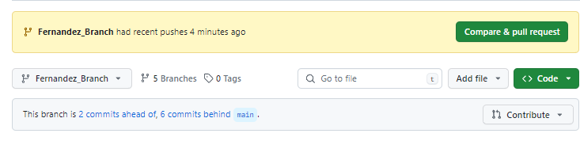

Since I’ve pushed my local repository, I can now compare & pull request.

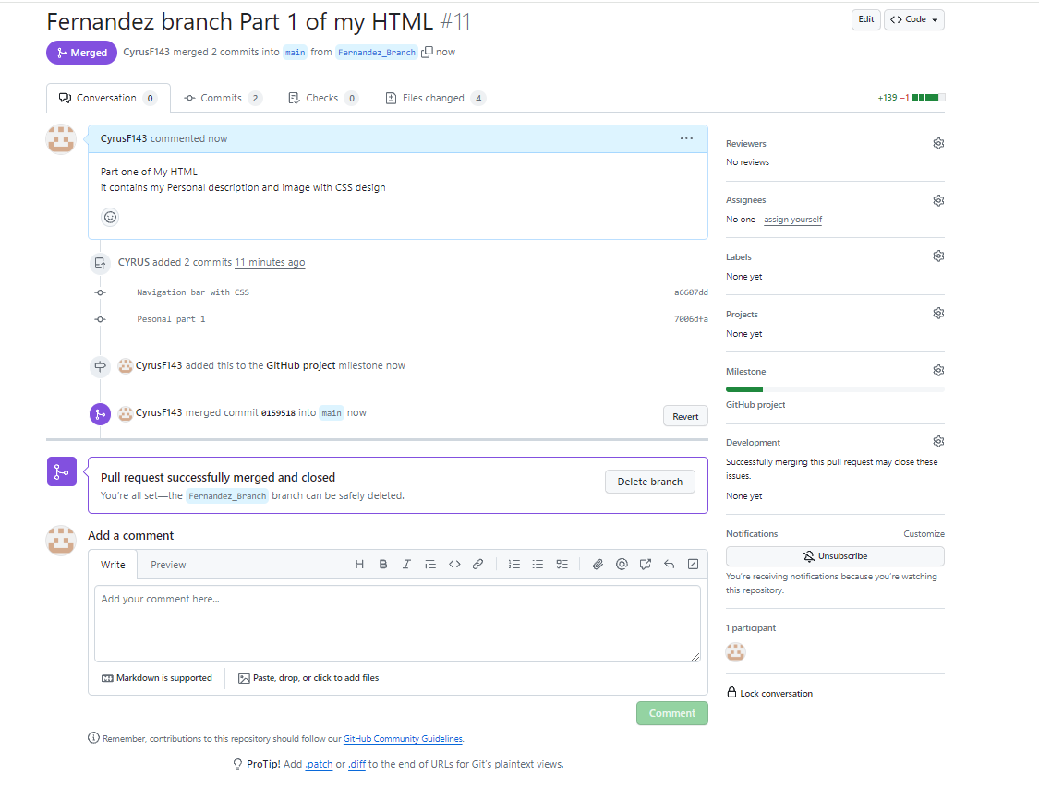

I now merge my branch to our main branch since this is the instructions that I give to my members that every time they finish something, and it has no issues they can ask to compare & merge it to our main branch. I didn’t delete the branch this time since we still have many things to do.

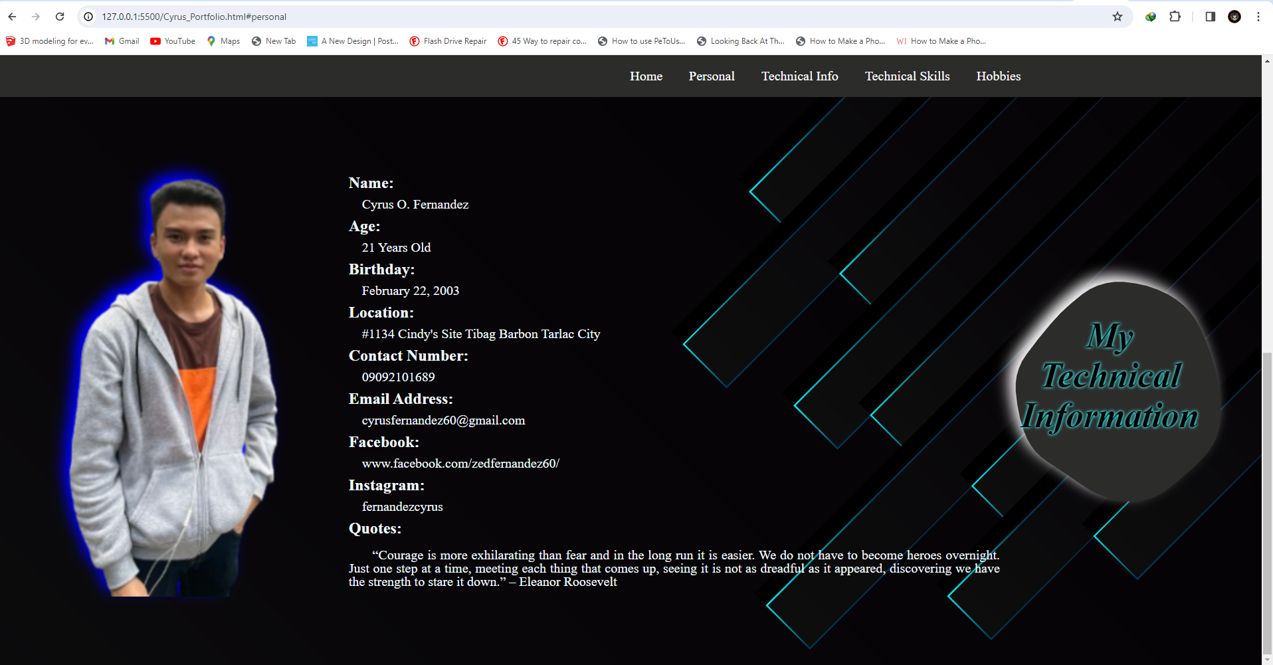

This is the Second section of my html this is my technical info it consists of my name, age, birthday, location, and contact information. Also, I’ve added one quote since I always like reading quotes and image of myself.

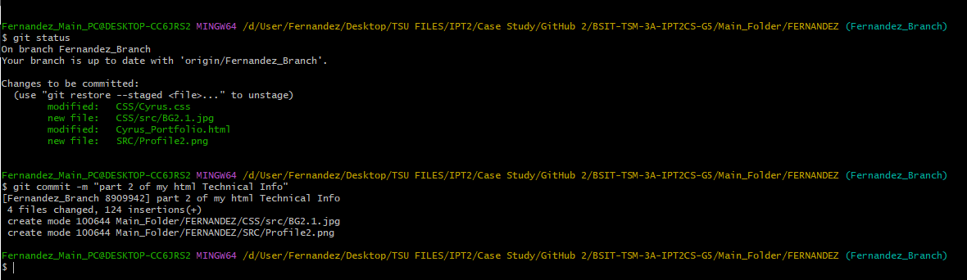

In this part I’ve just committed the second part of my html but didn’t push it to the remote repository since I’ll push it along with the third part of my html.

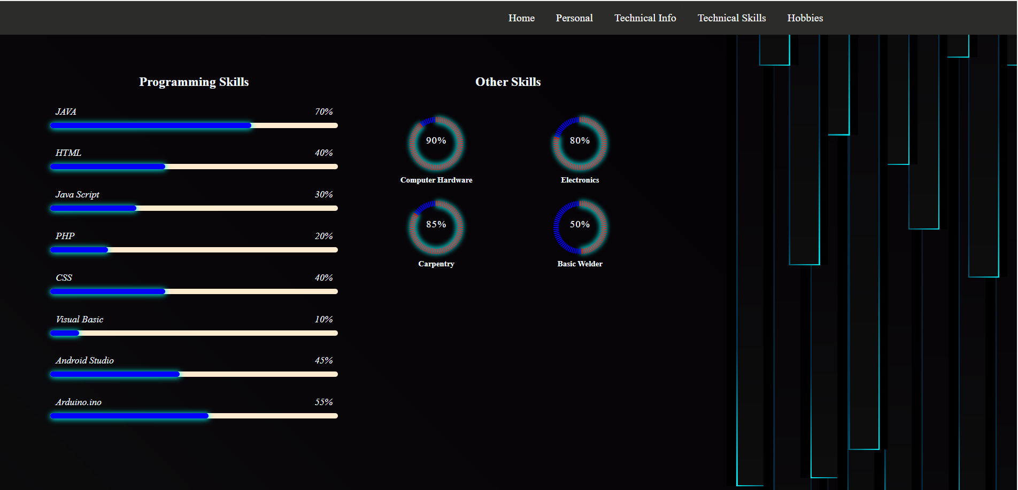

This is the third part of my html the technical skills basically it contains the skills that I have and presented it using graph, in this part I’ve used the CSS and Java Script to animate the graph to make it more presentable.

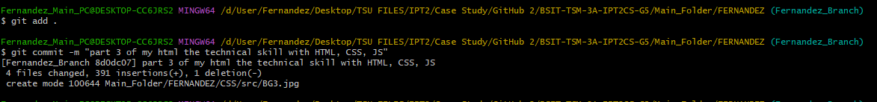

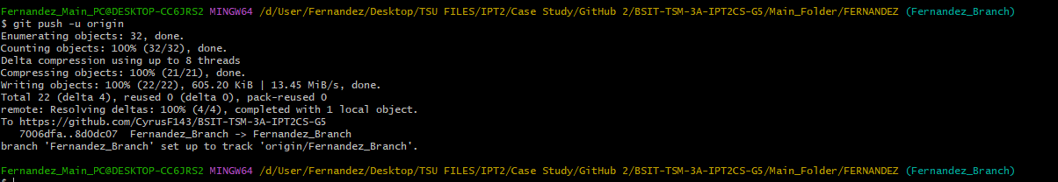

This part I’ve committed my technical skills and push it to the remote repository since I don’t see any issues and to record my progress.

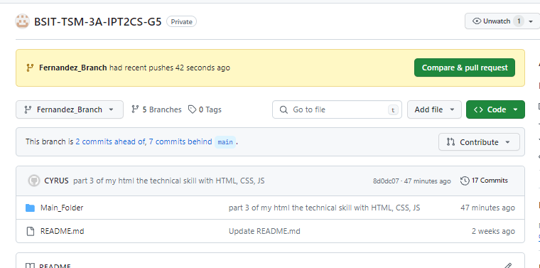

Since I’ve recently pushed my local repository, I can now compare & pull request, and this contains the Second part and Third part of my html.

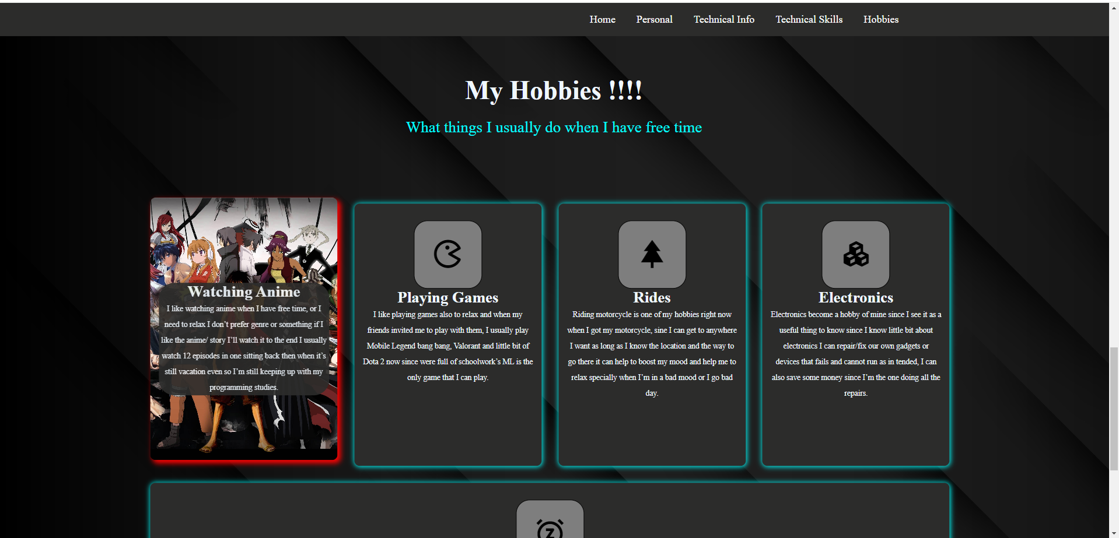

This is the last part of html My Hobbies, this is just simple list of my hobbies and when you hover to it, it shows image and some explanation regarding that.

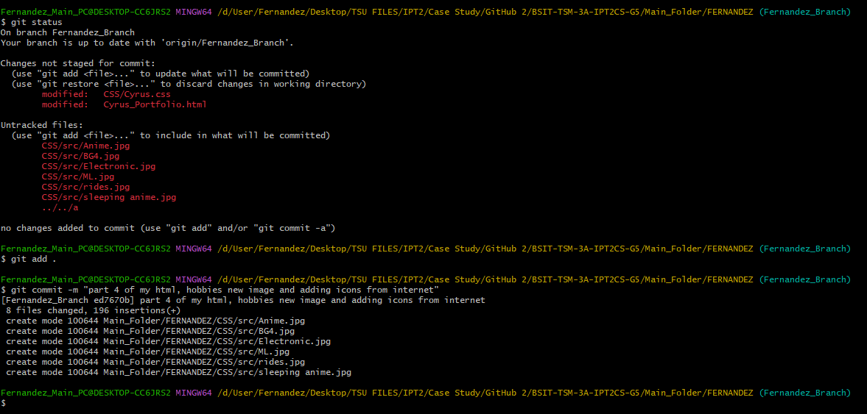

After finishing the last part of my html, I commit it for it to be push on our remote repository.

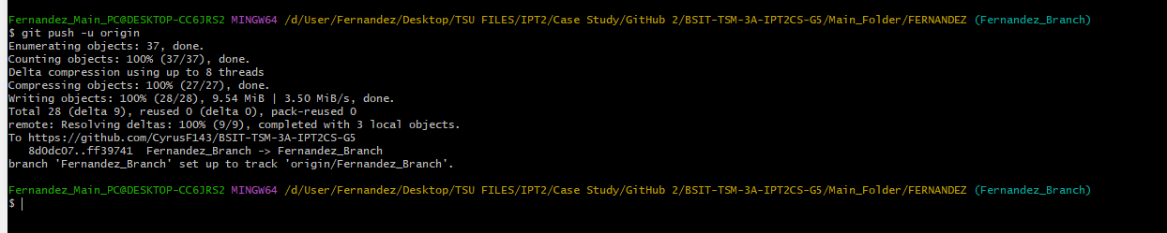

In this part I just simply push the very last part of my html

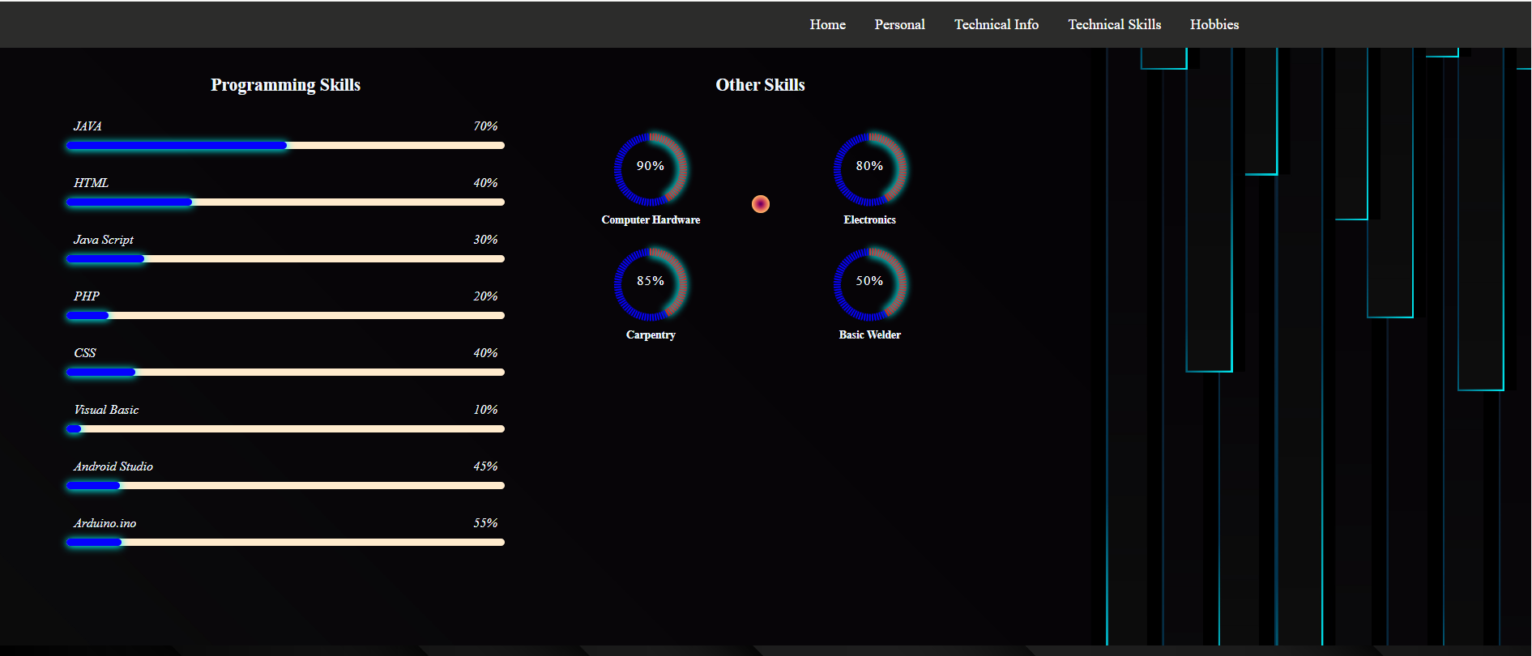

In this I just edited the cursor of my html to make it more appealing

# **Case Analysis (Git and GitHub Workflow)**

## **Laxamana Documentation**

### **Remote Repository (GitHub) Creating a Milestone**

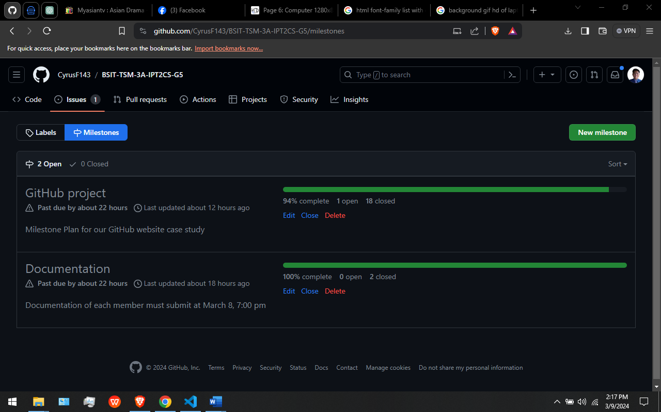

In this Figure. This are the milestone that our leader have created.

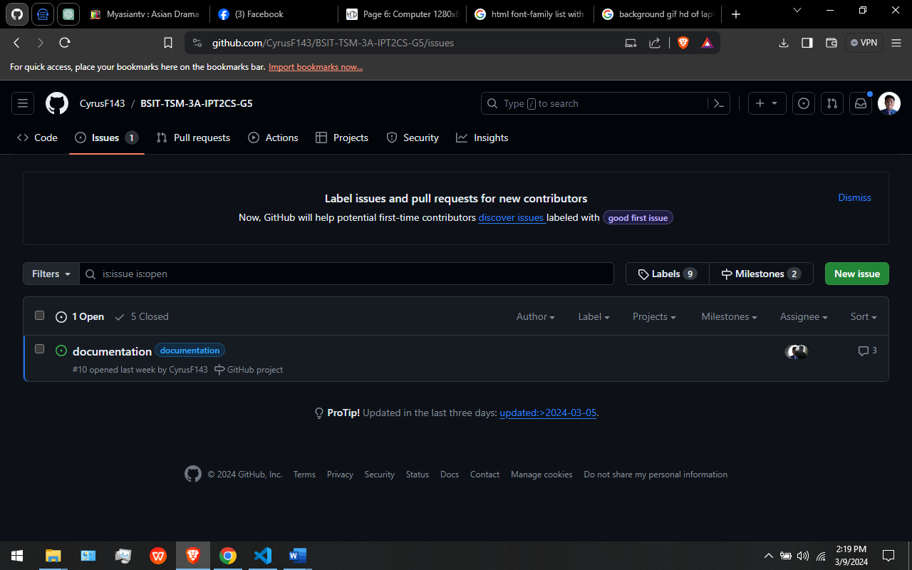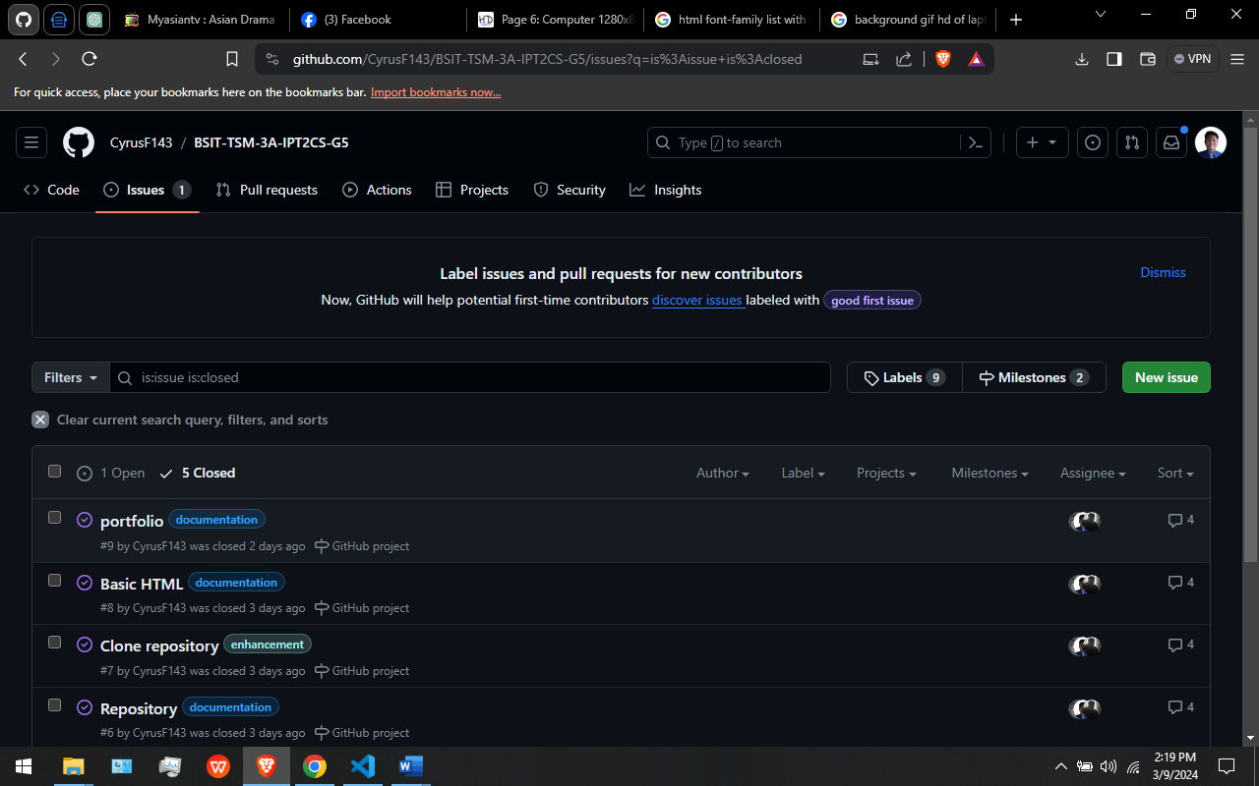

In this Figure. This are the Issues that are currently open and closed.

### **Local Repository (Git)**

**CLONING THE REMOTE REPOSITORY IN MY LOCAL REPOSITORY USING GITBASH**

**GIT CLONE:** Git Clone Command, “git clone” is a Git command line utility which is used to target an existing repository and create a clone, or copy of the target repository [10].

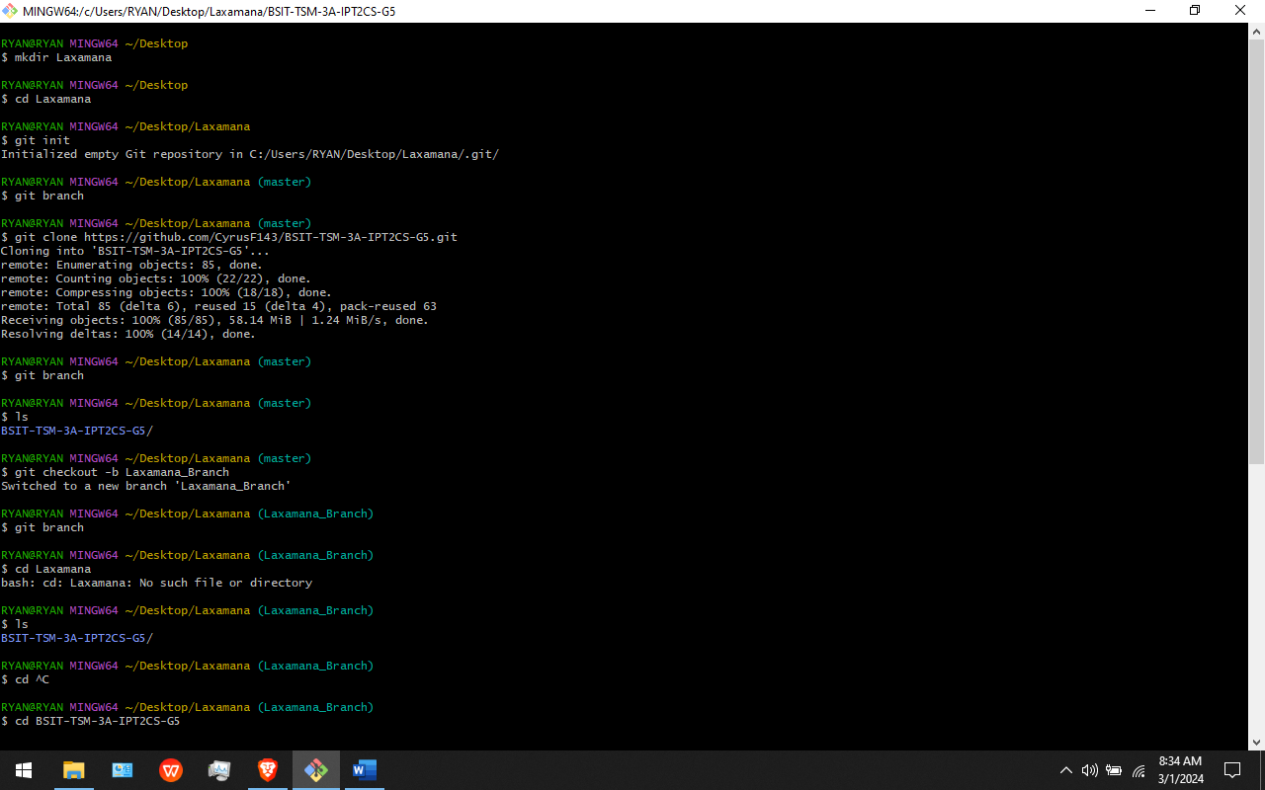

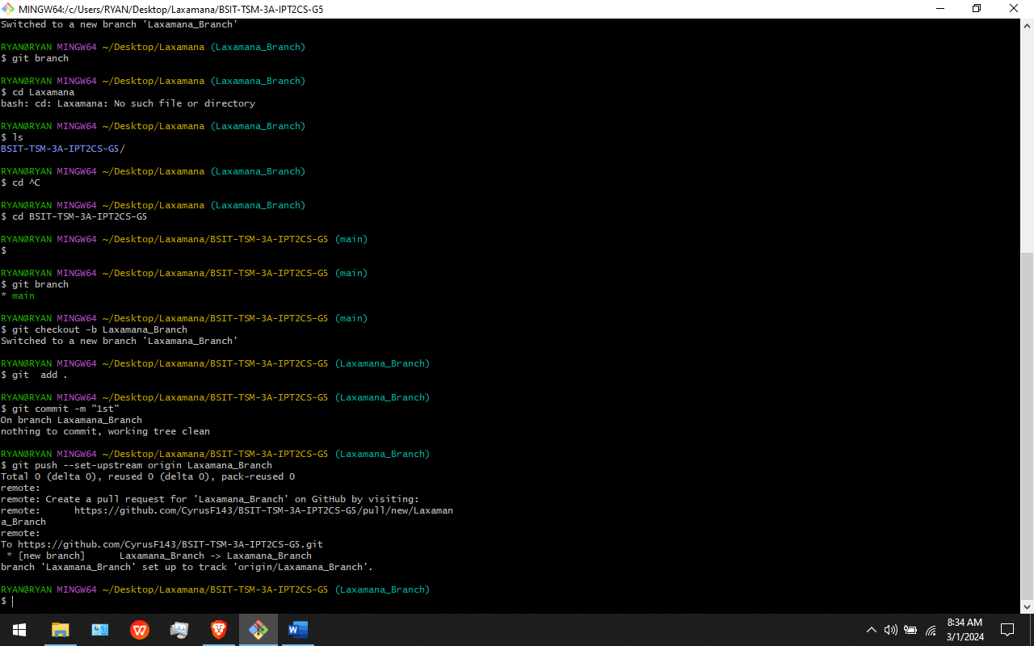

In this Figure: I Successfully Create a Folder, Cloning the Remote repository, Creating my Own Branch and Pushing my Branch to the github. I use git clone command to clone/copy the remote repository.

**GIT PULL:** The git pull command is used to fetch and download content from a remote repository and immediately update the local repository to match that content [14].

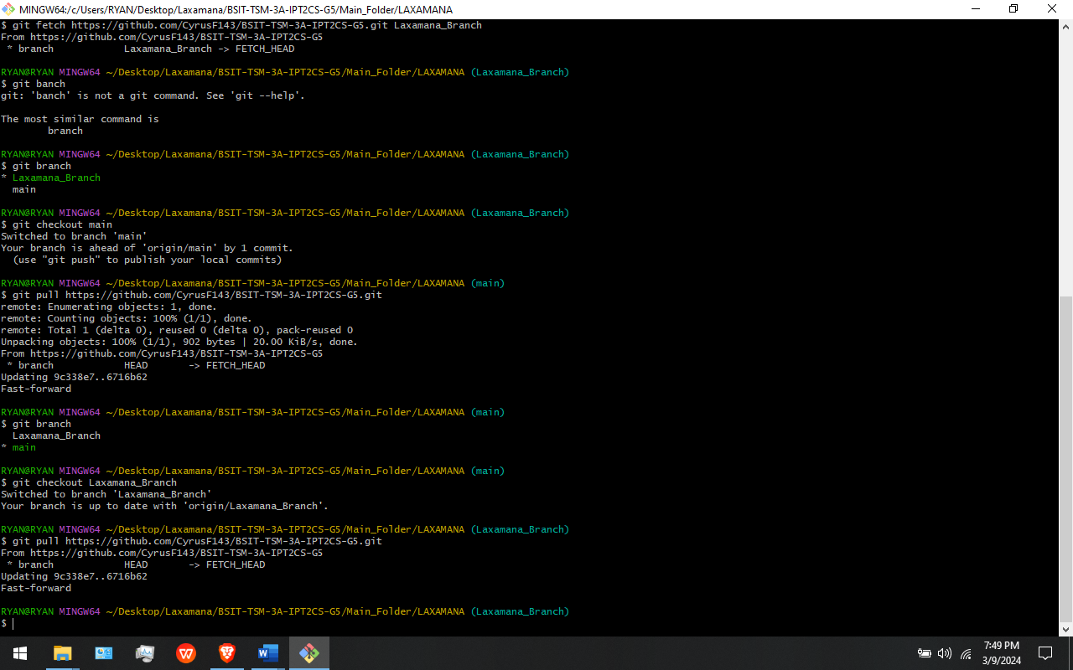

In This Figure: I use the command “git pull” to download all the files in the remote repository into the local repository.

**GIT PUSH:** Git push origin will push the current branch to the branch of the matching name in the remote repository. [7]



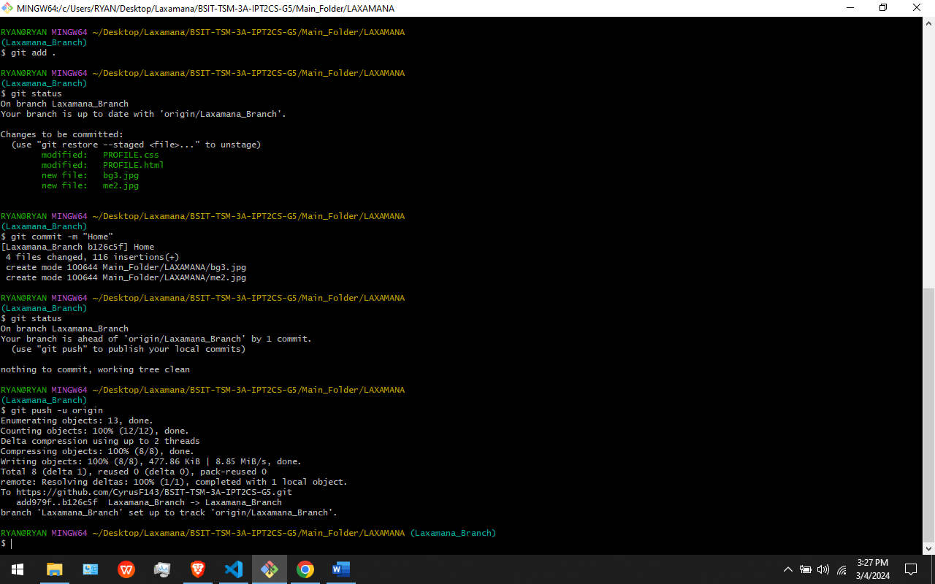

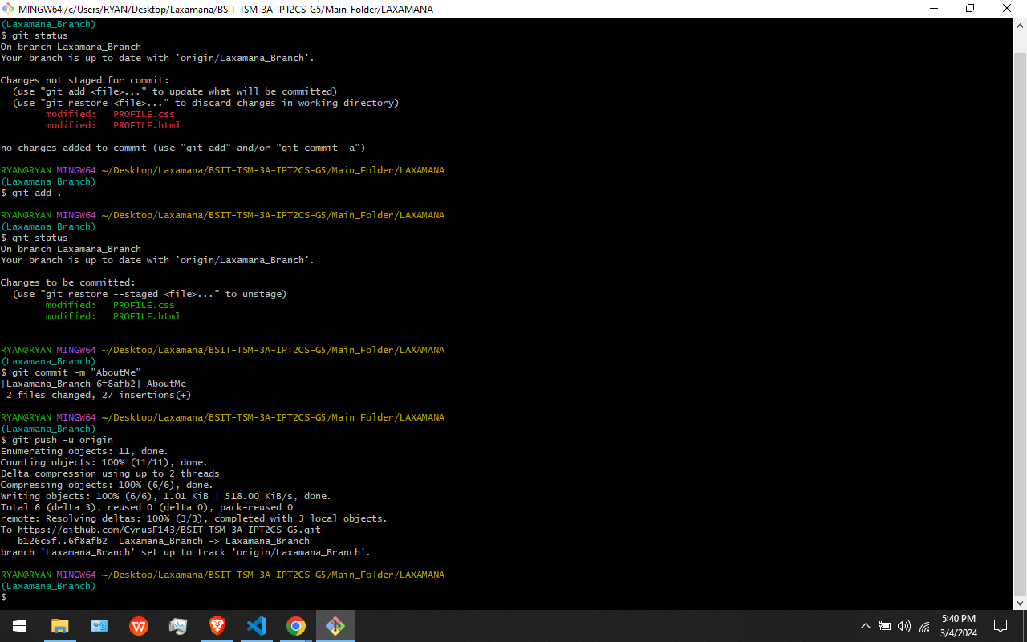

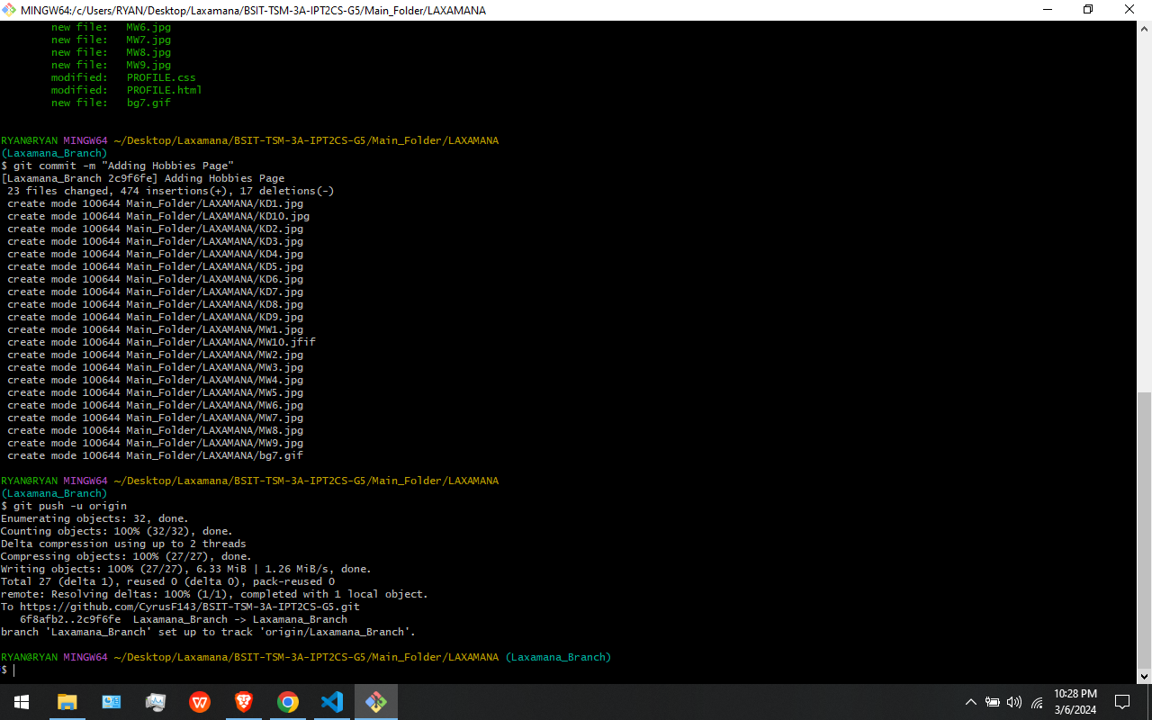

In This Figure: These are my Git Push. I use “git push -u origin” command to push my updated html, css, and javascript to the github repository.

**GIT FETCH:** The git fetch command downloads commits, files, and refs from a remote repository into your local repo. Fetching is what you do when you want to see what everybody else has been working on [15].

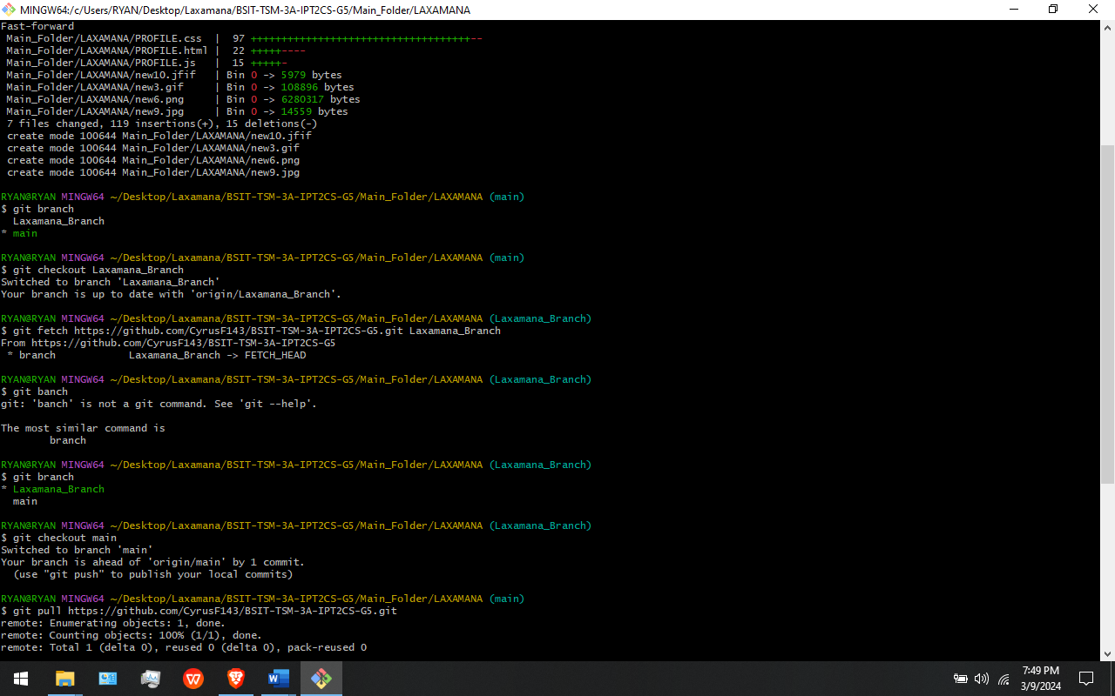

In This Figure: I use the command “git fetch” to downloads all my commits, files from the remote repository into my local repository.

**GIT MERGE:** Merging is Git's way of putting a forked history back together again. The git merge command lets you take the independent lines of development created by git branch and integrate them into a single branch [16].

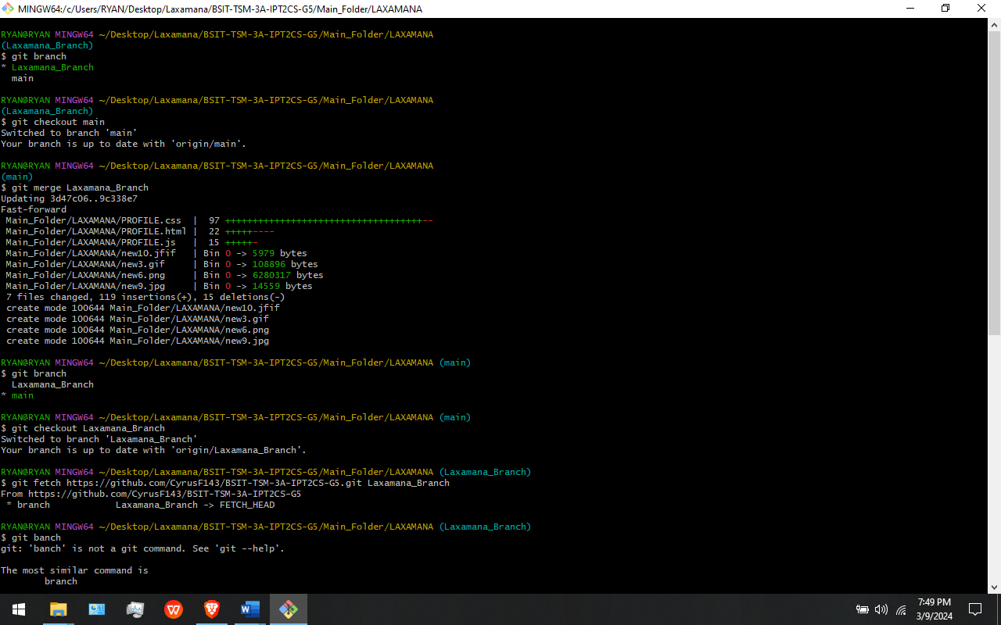

In This Figure: I use the command “git merge” to merge my branch into the main branch in the git bash.

**ISSUE:** GitHub Issues are items you can create in a repository to plan, discuss and track work [13].

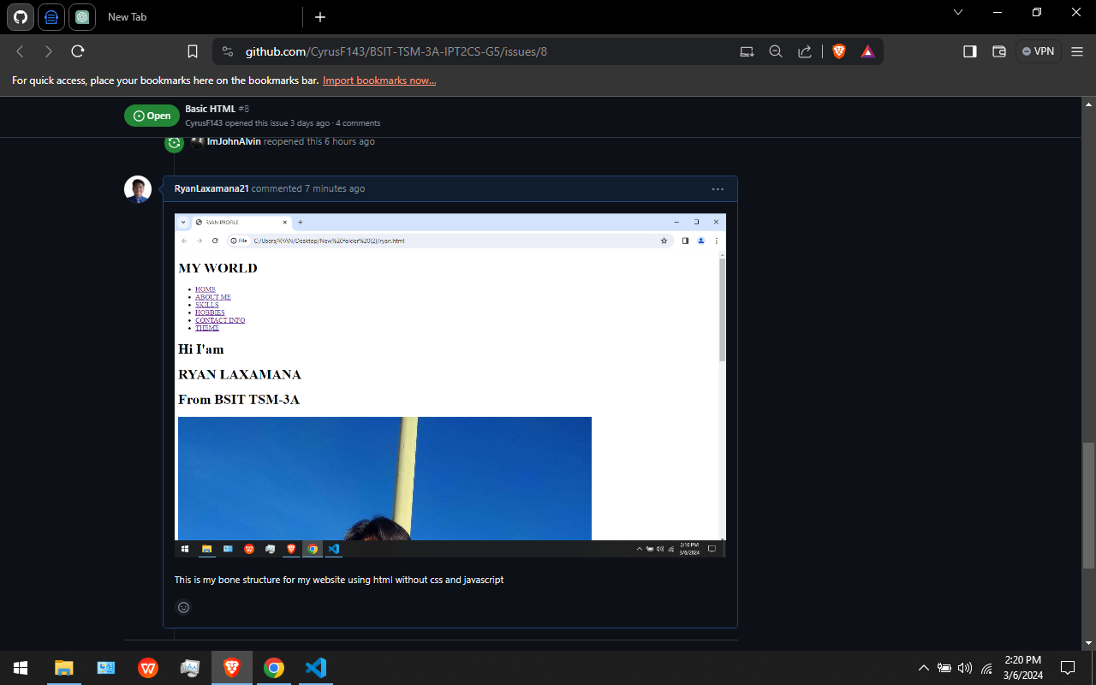

In This Figure: One of our issues is our HTML file without CSS for design and JAVASCIPT.

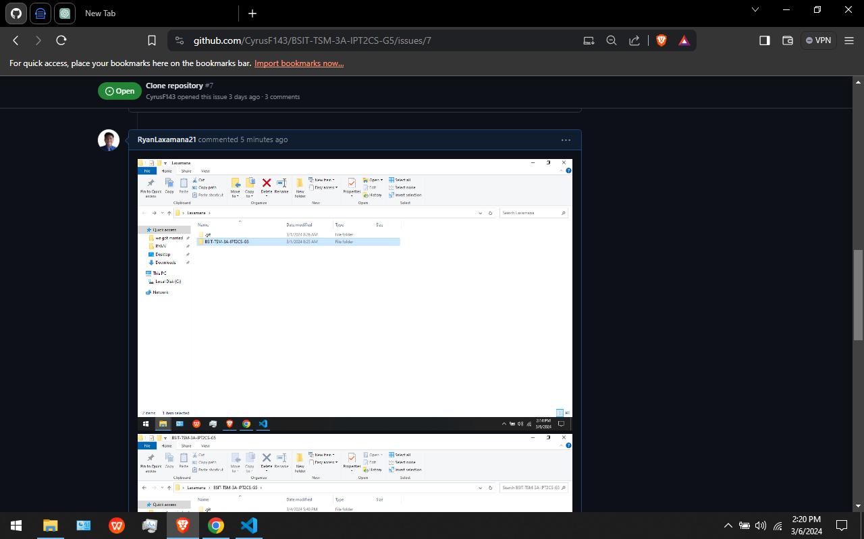

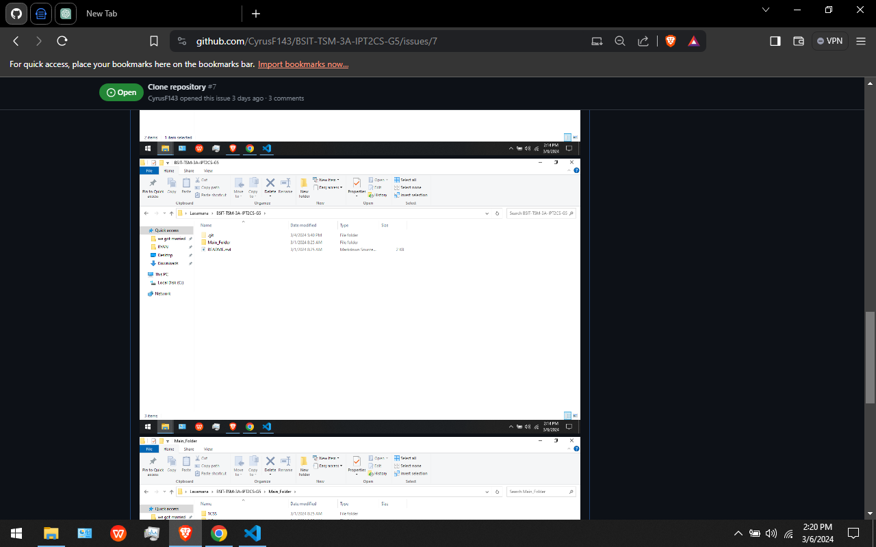

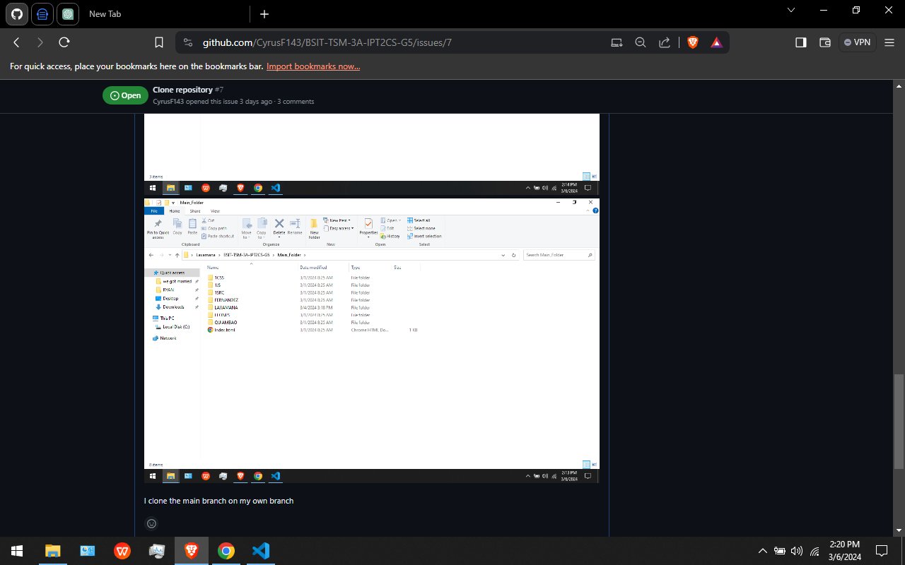

In This Figure: Another one of our issues that is already closed is the cloning of the repository on git bash.

**PULL REQUEST:** A pull request is a proposal to merge a set of changes from one branch into another. In a pull request, collaborators can review and discuss the proposed set of changes before they integrate the changes into the main codebase.

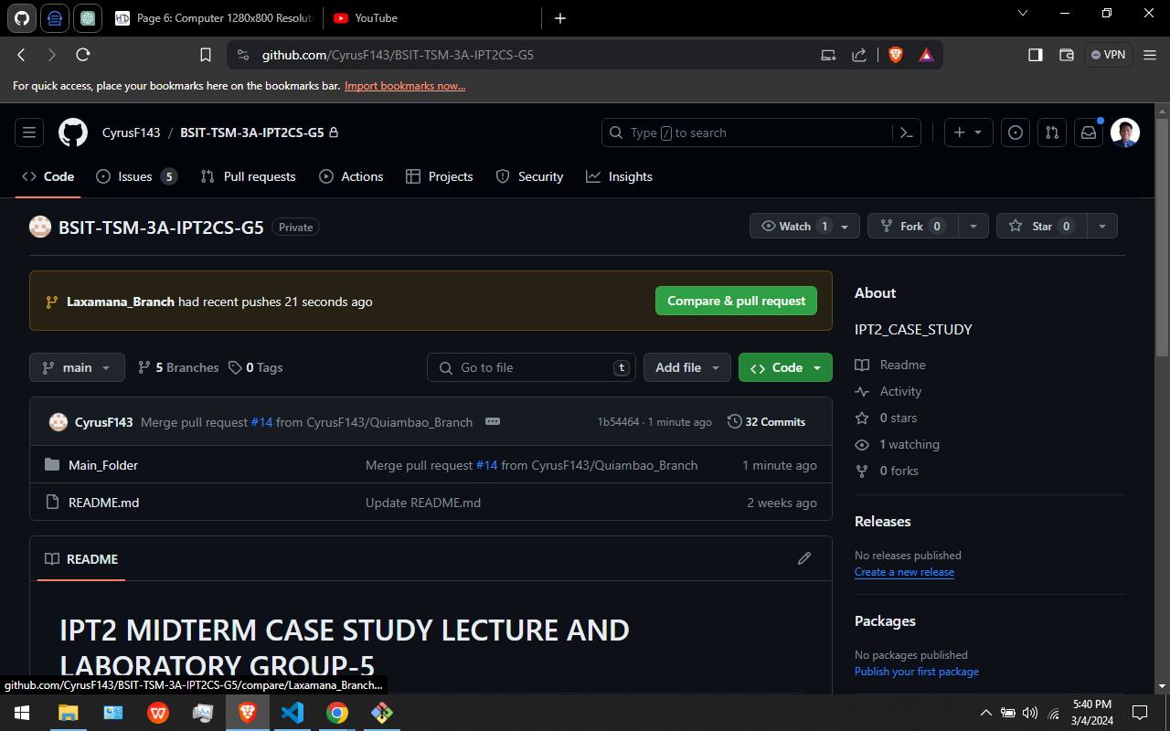

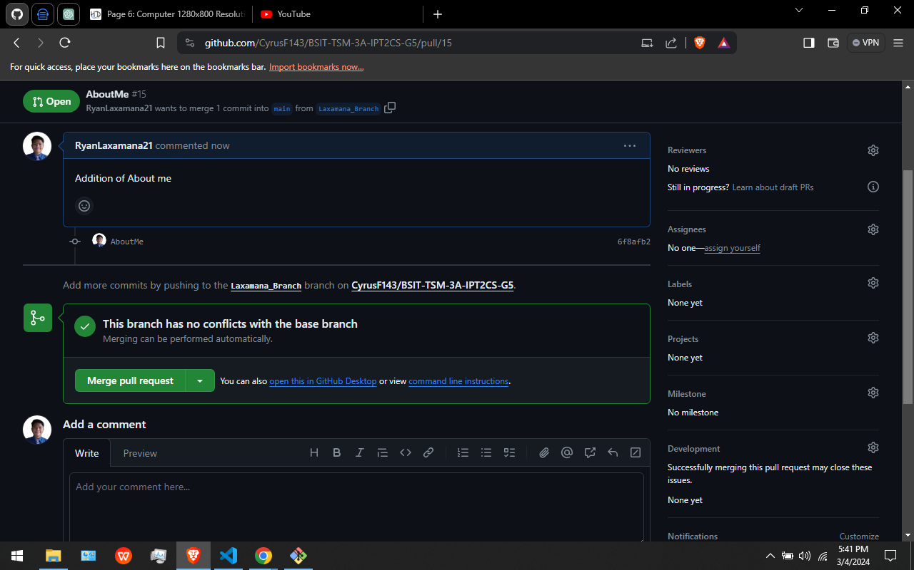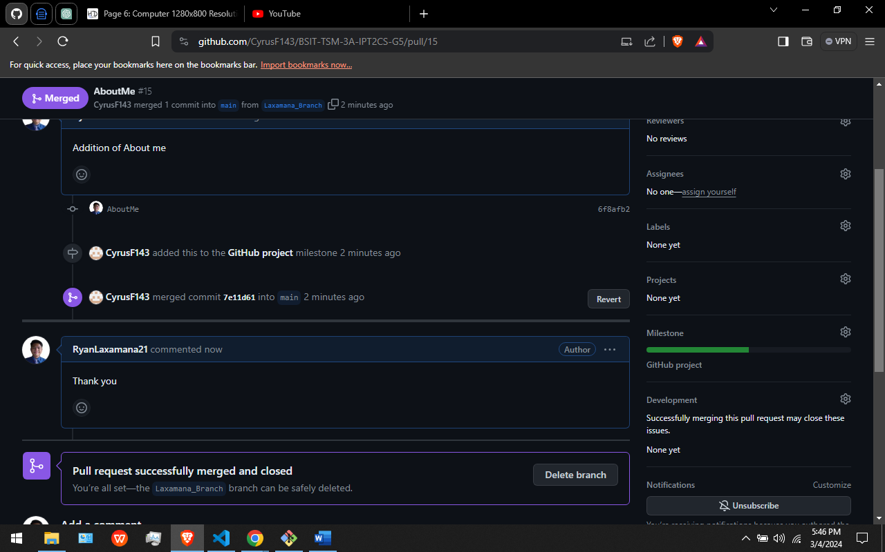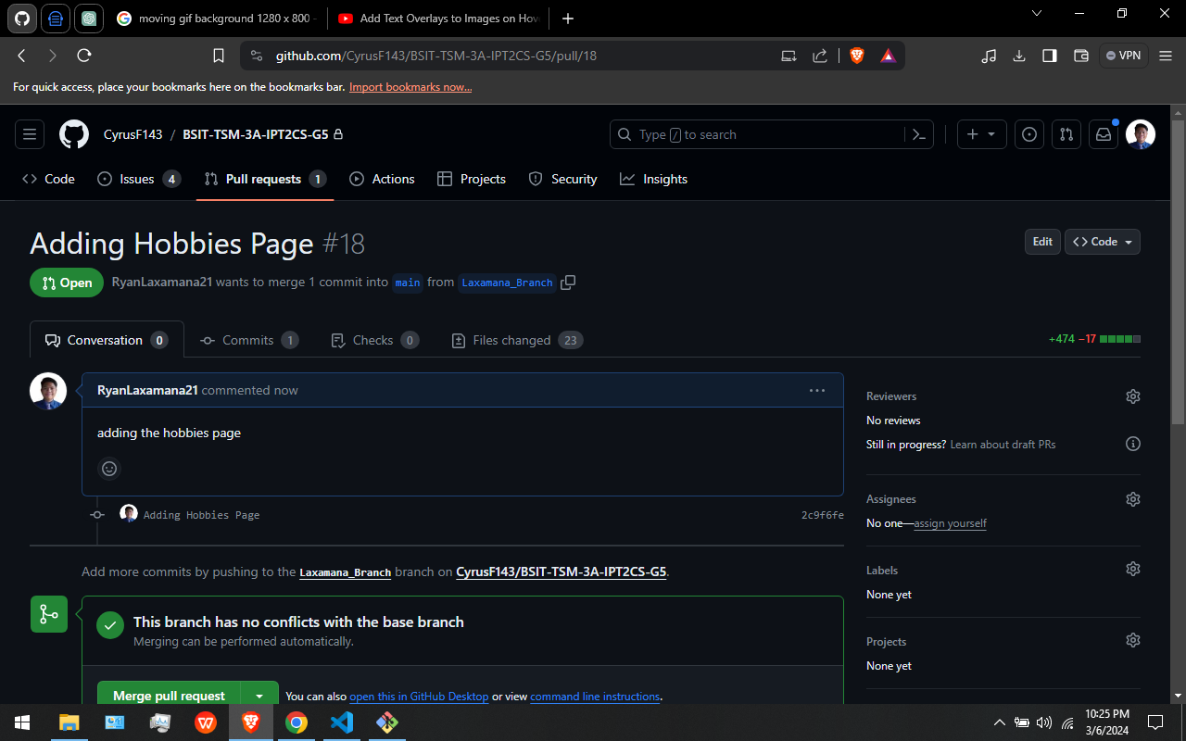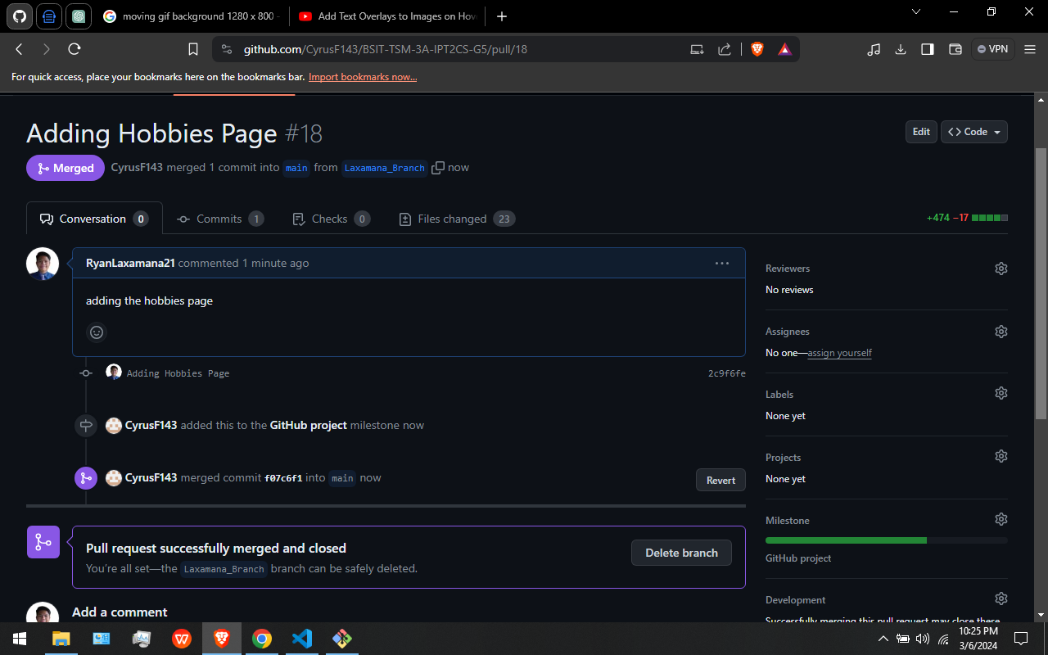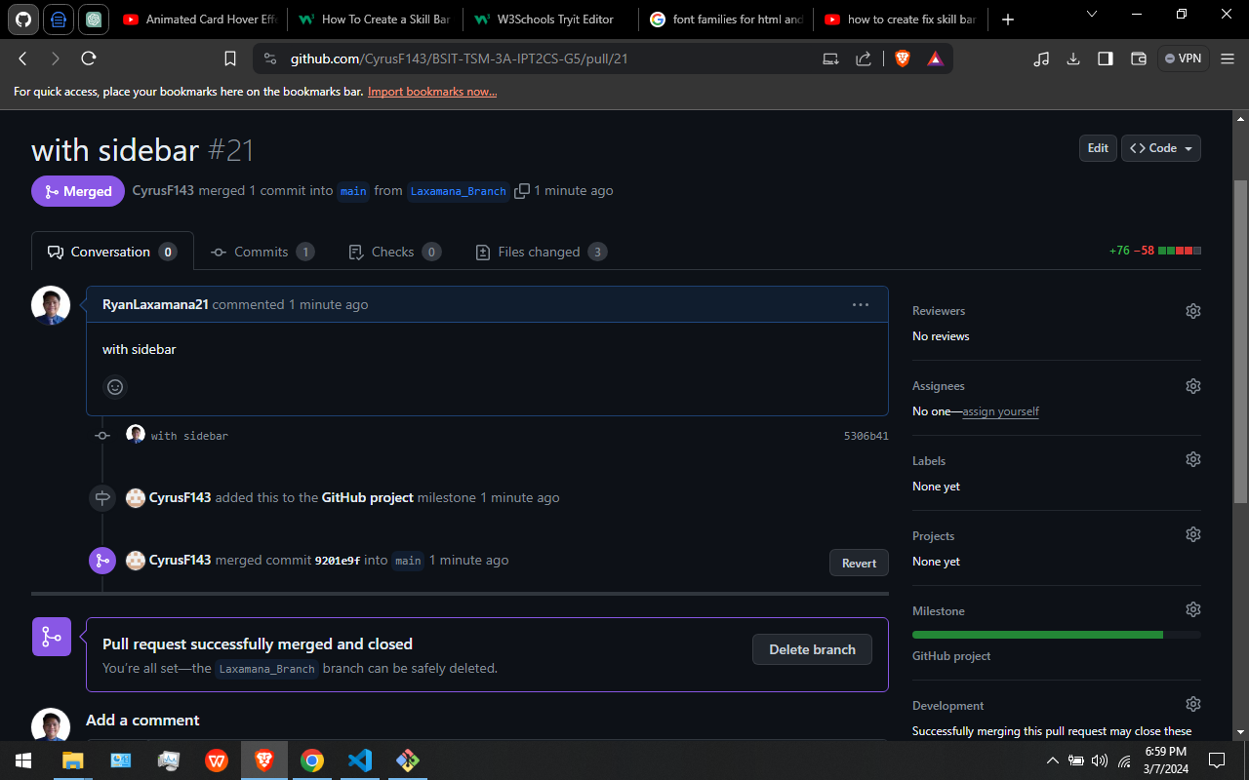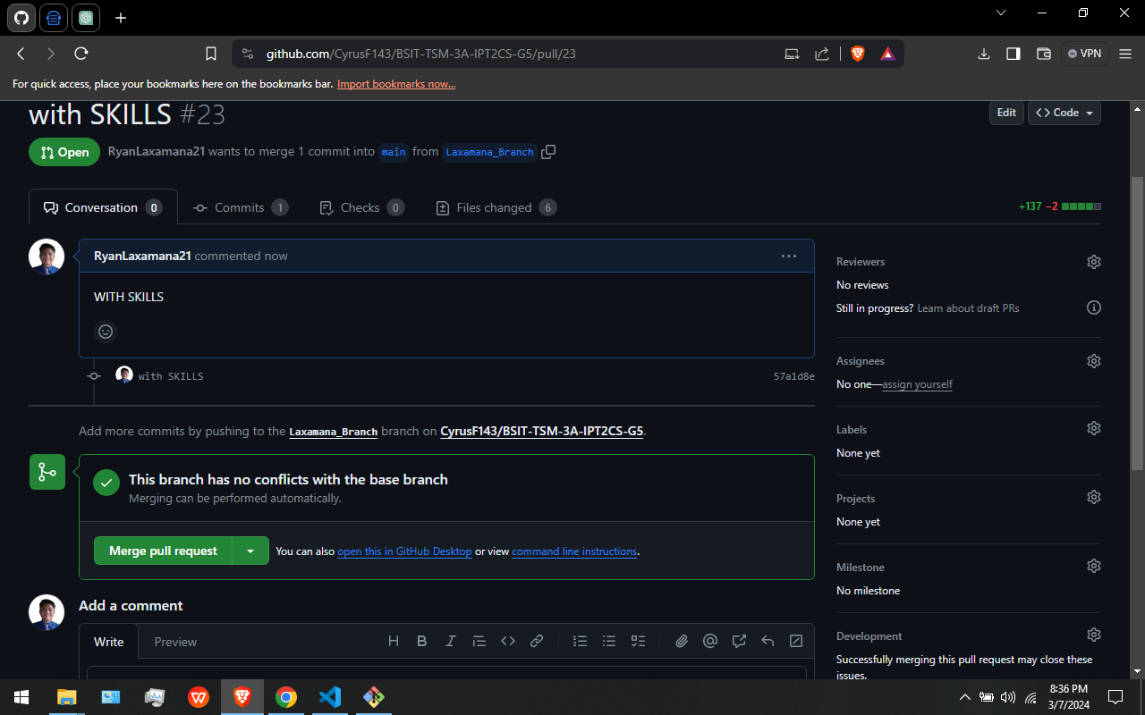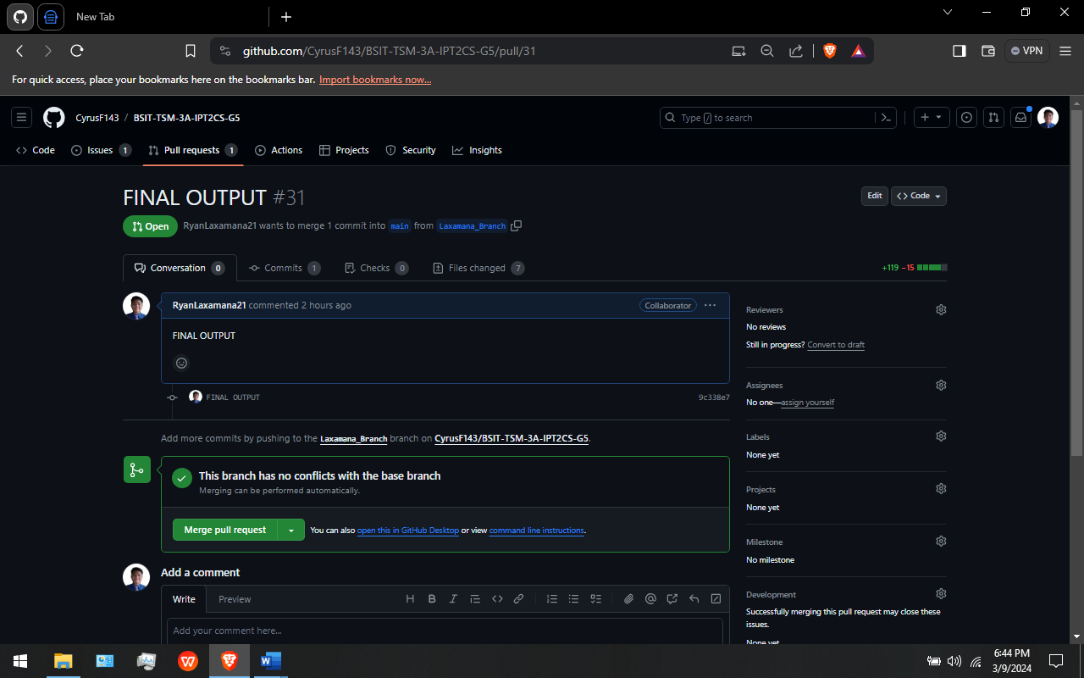

In This Figures: These are my pull requests. After I create a pull request I wait for our leader to reply on my pull request and also to merge my pull request.

**MILESTONE:** You can use milestones to track progress on groups of issues or pull requests in a repository. When you create a milestone, you can associate it with issues and pull requests. To better manage your project, you can view details about your milestone [11].



In This Figure: This is our Milestone Created by our leader. We members can access and look for it anytime.

**BRANCH:** Git branches are effectively a pointer to a snapshot of your changes. When you want to add a new feature or fix a bug—no matter how big or how small—you spawn a new branch to encapsulate your changes. [5]



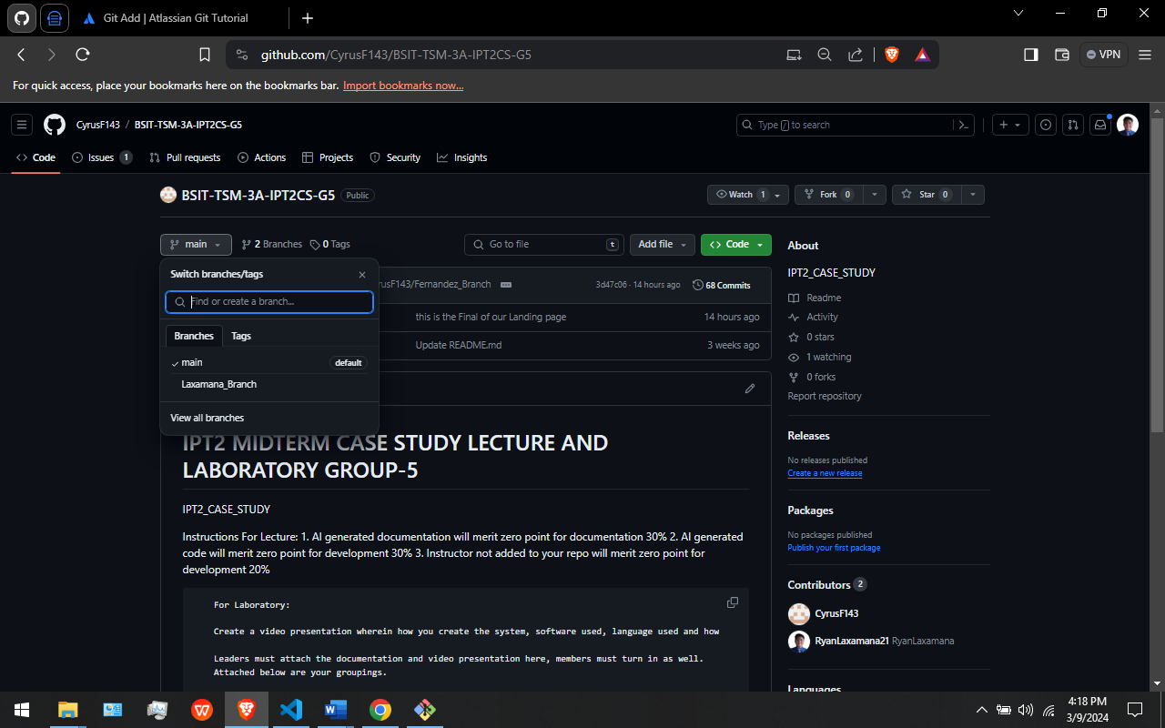

In This Figures: I created my Branch using gitbash Then adding, committing and pushing it on our github repository.

**CREATING MY PROFILE WEBSITE**

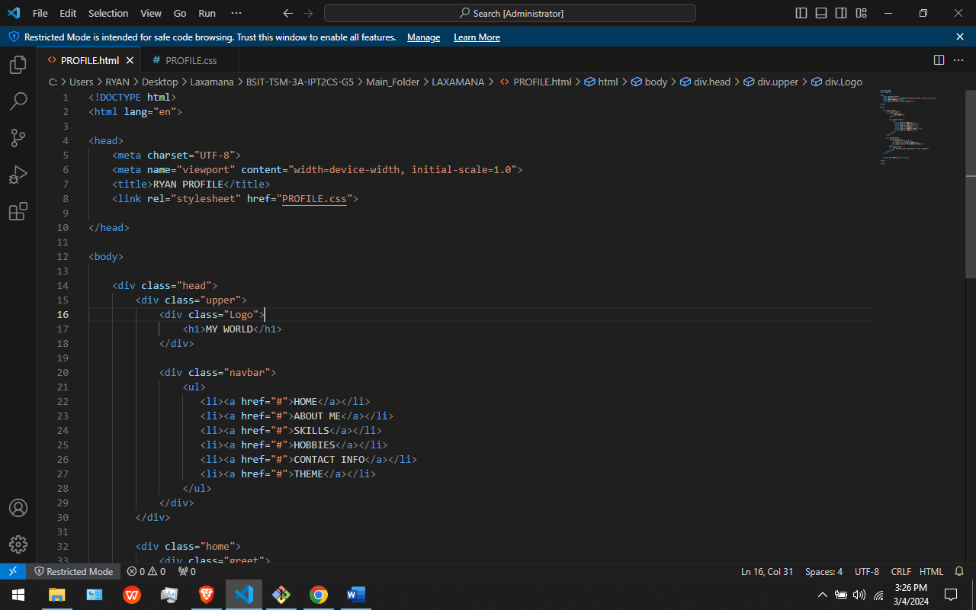

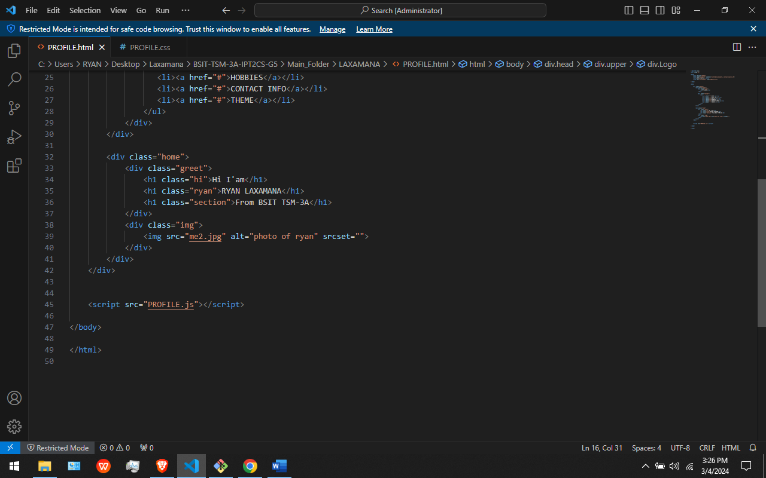

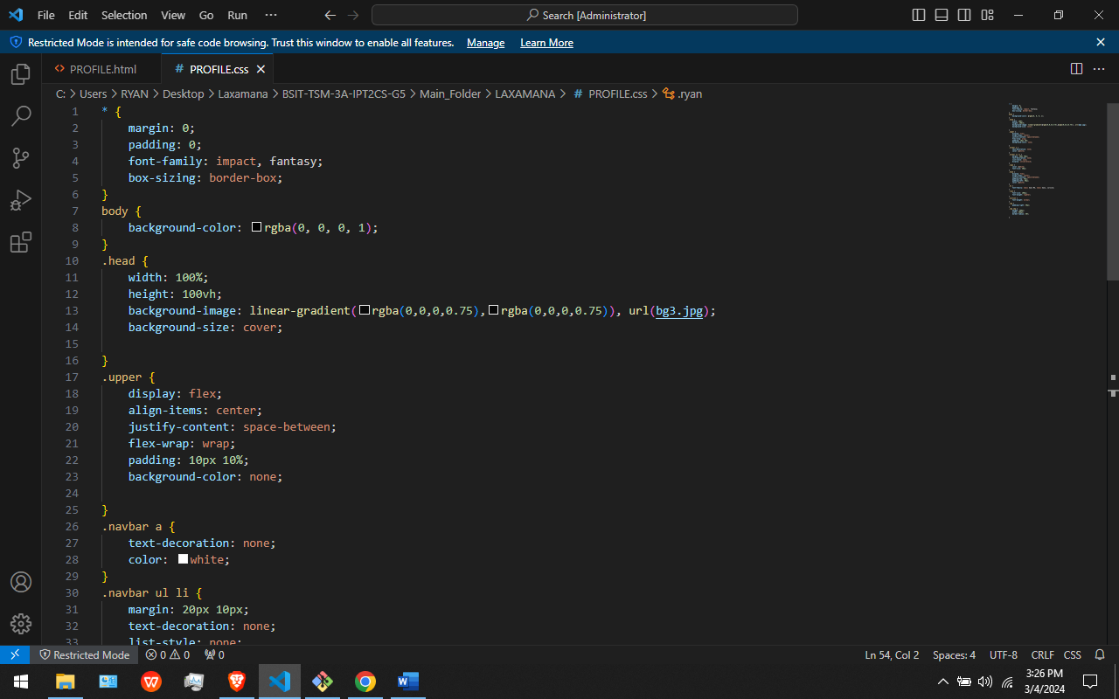

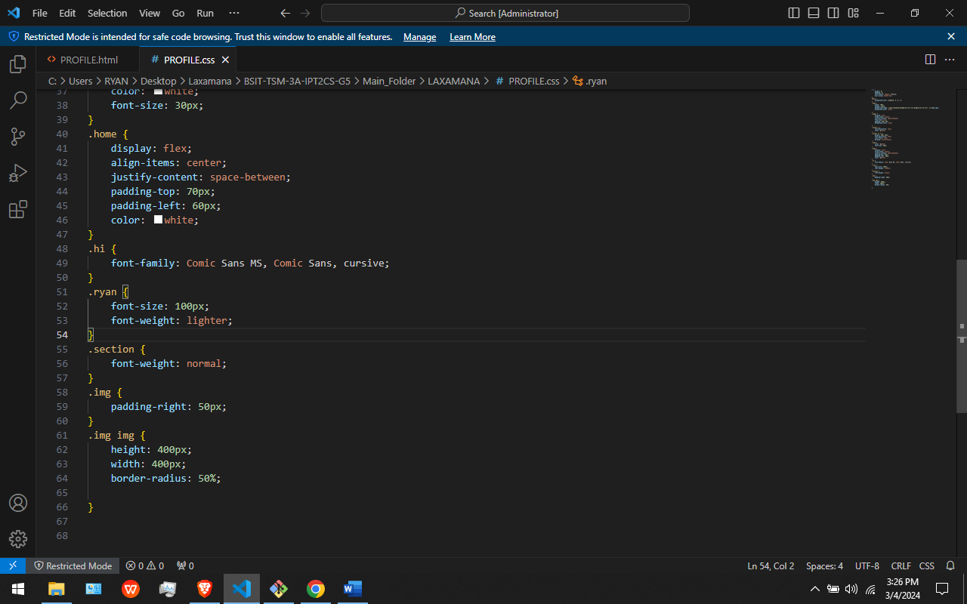

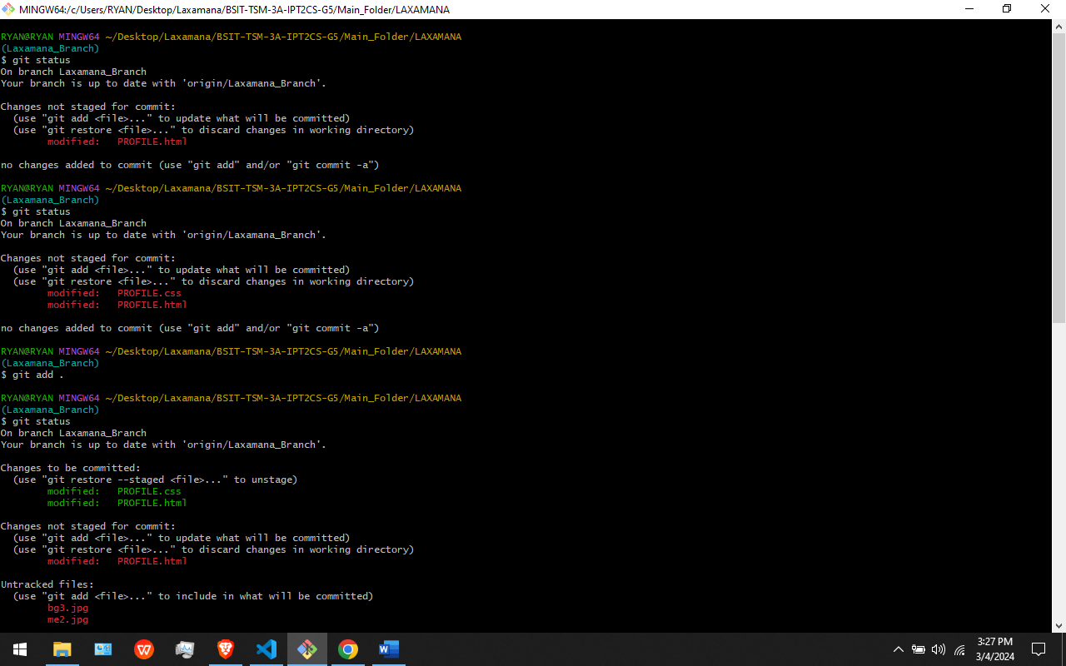



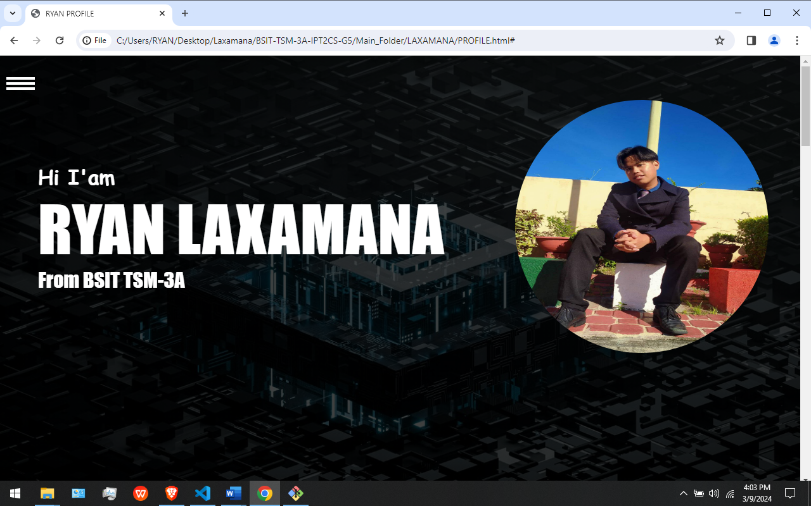

In This Figures: I Created My Greeting page using HTML and CSS. I also Add, Commit and Pushed the Greeting page I created using Git Add, Git Commit, Git Push commands. The git add command adds a change in the working directory to the staging area. It tells Git that you want to include updates to a particular file in the next commit. However, git add doesn't really affect the repository in any significant way—changes are not actually recorded until you run git commit [12]. A commit is the Git equivalent of a "save". Traditional saving should be thought of as a file system operation that is used to overwrite an existing file or write a new file. Alternatively, Git committing is an operation that acts upon a collection of files and directories [12]. git push origin will push the current branch to the branch of the matching name in the remote repository. [7]

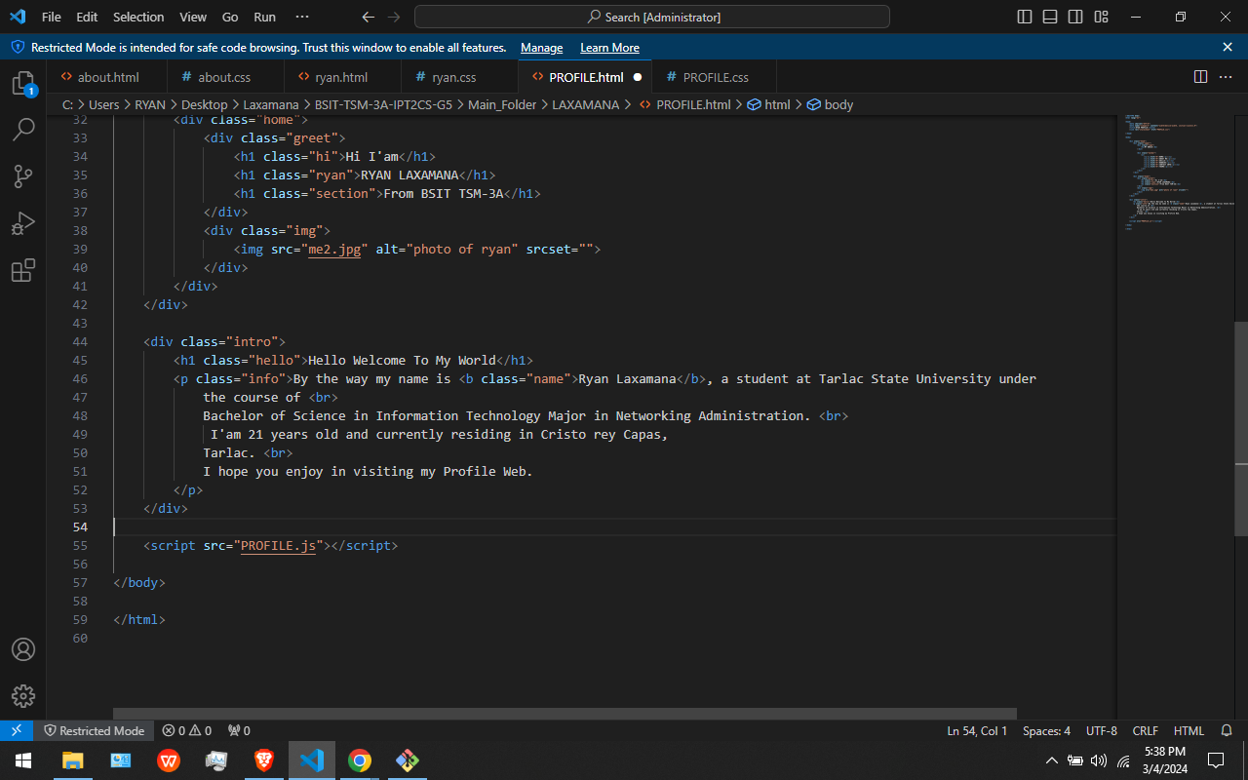

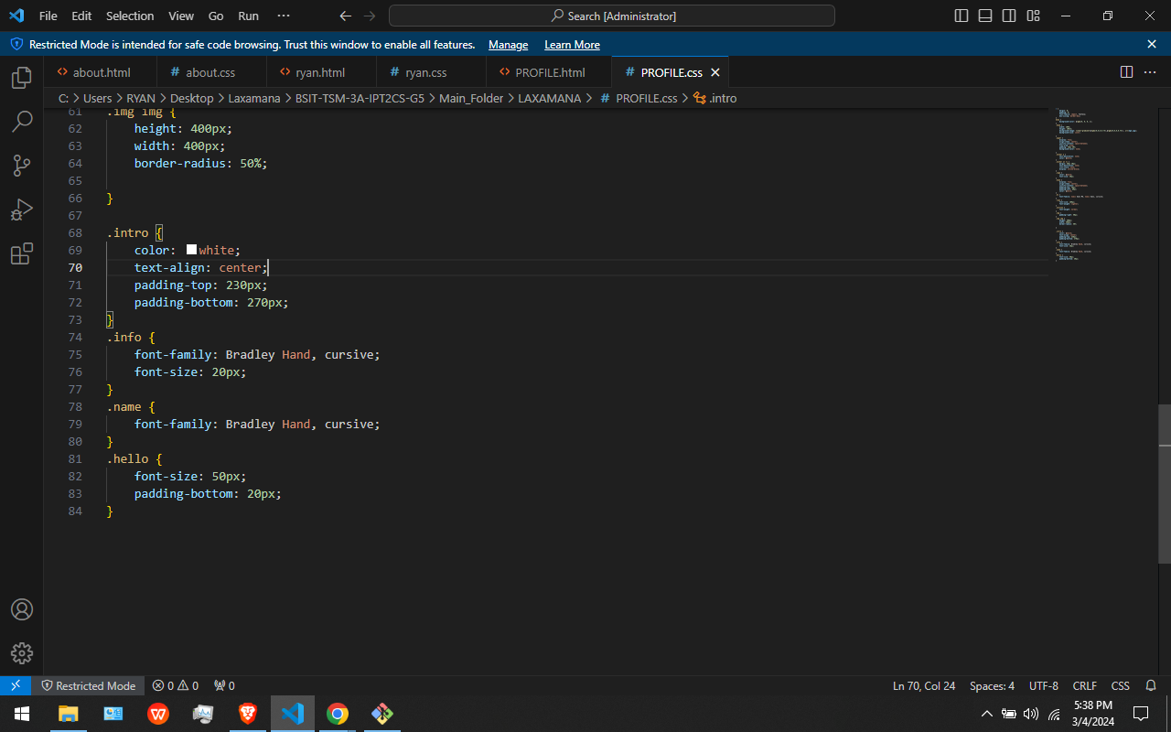





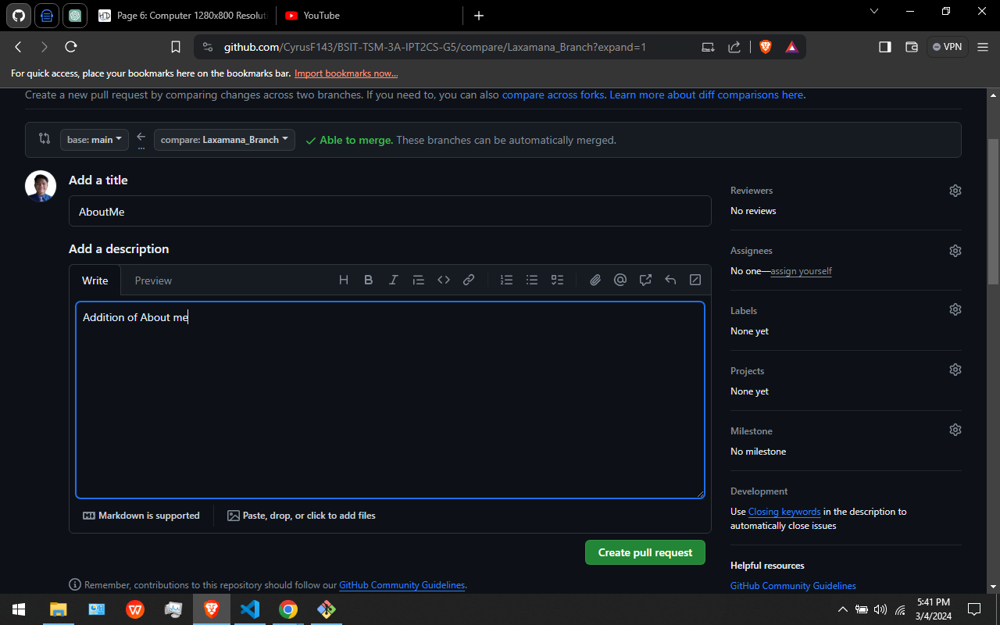



In this Figure. I Add the About me Page in the website. After that I Add it using Git add the commit it using Git commit Then push it using git push command. After that I Use github to pull request and merge the pull request.

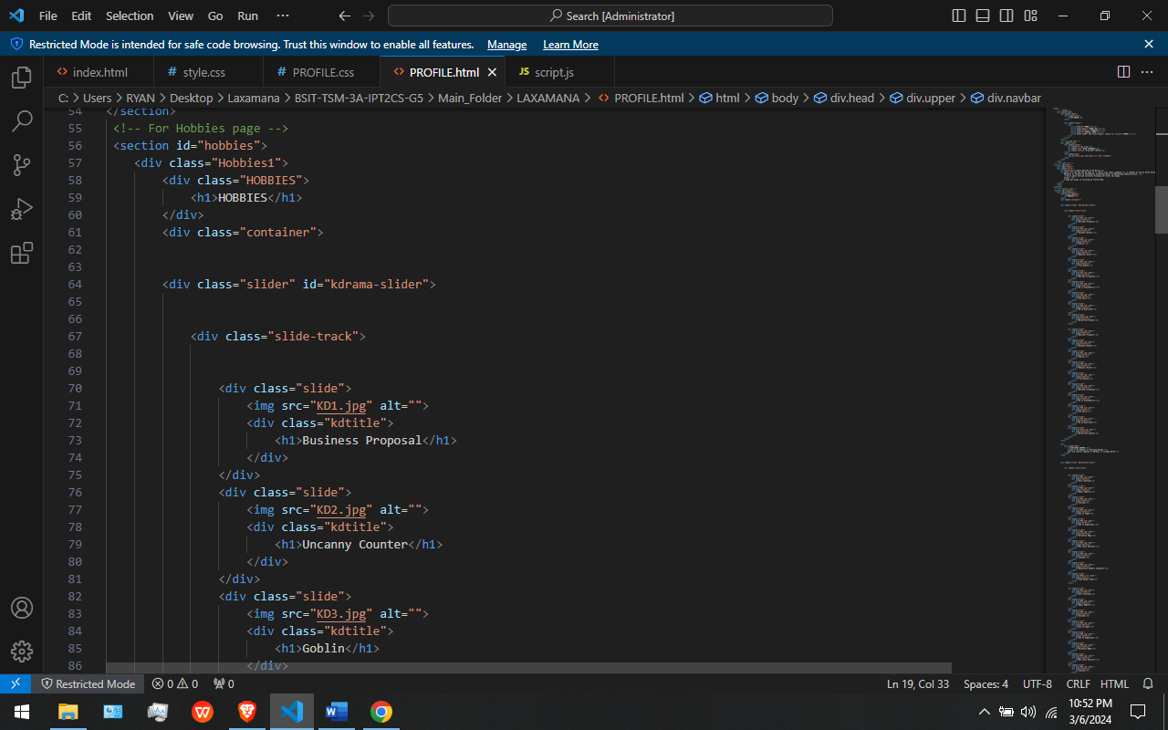

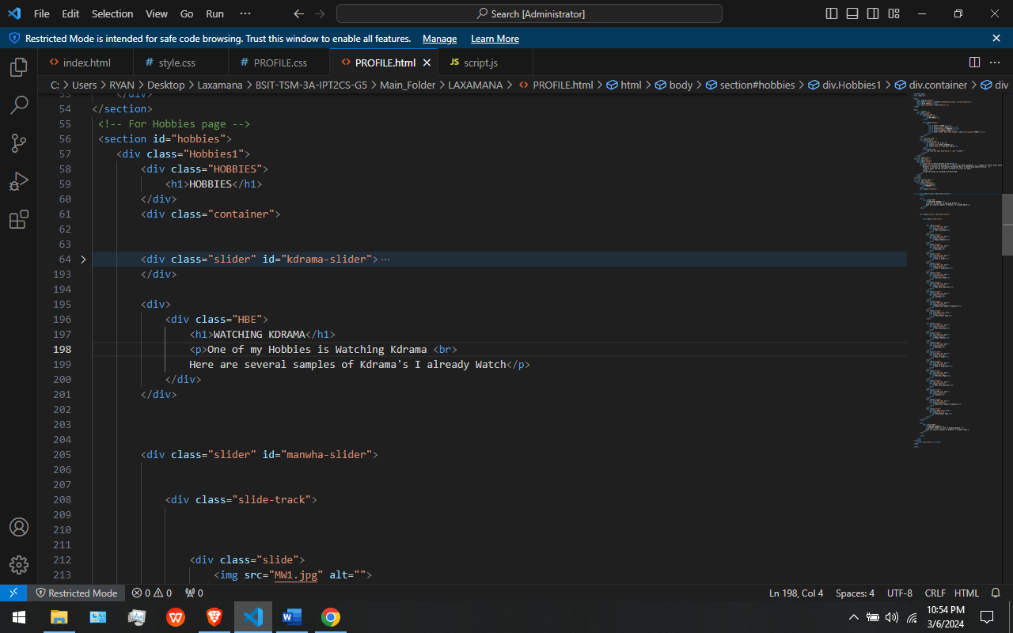

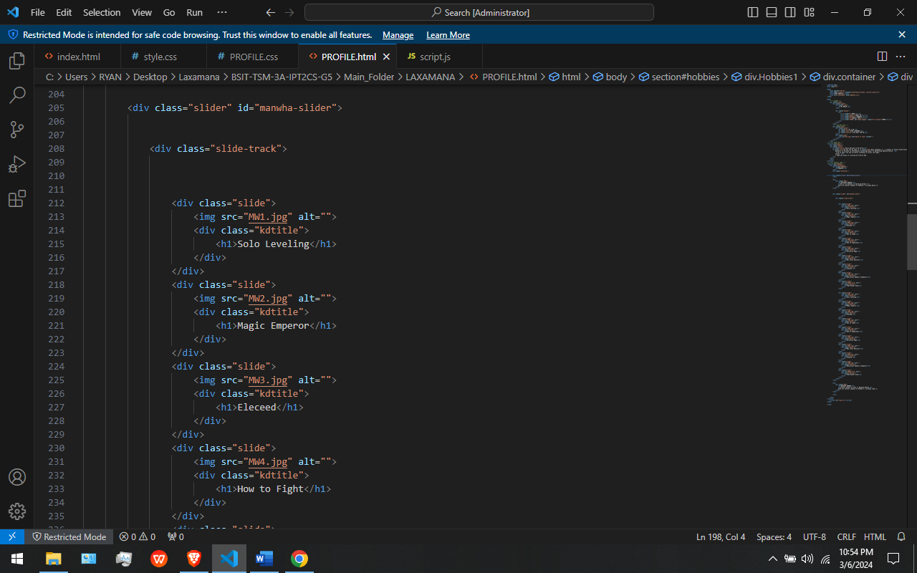

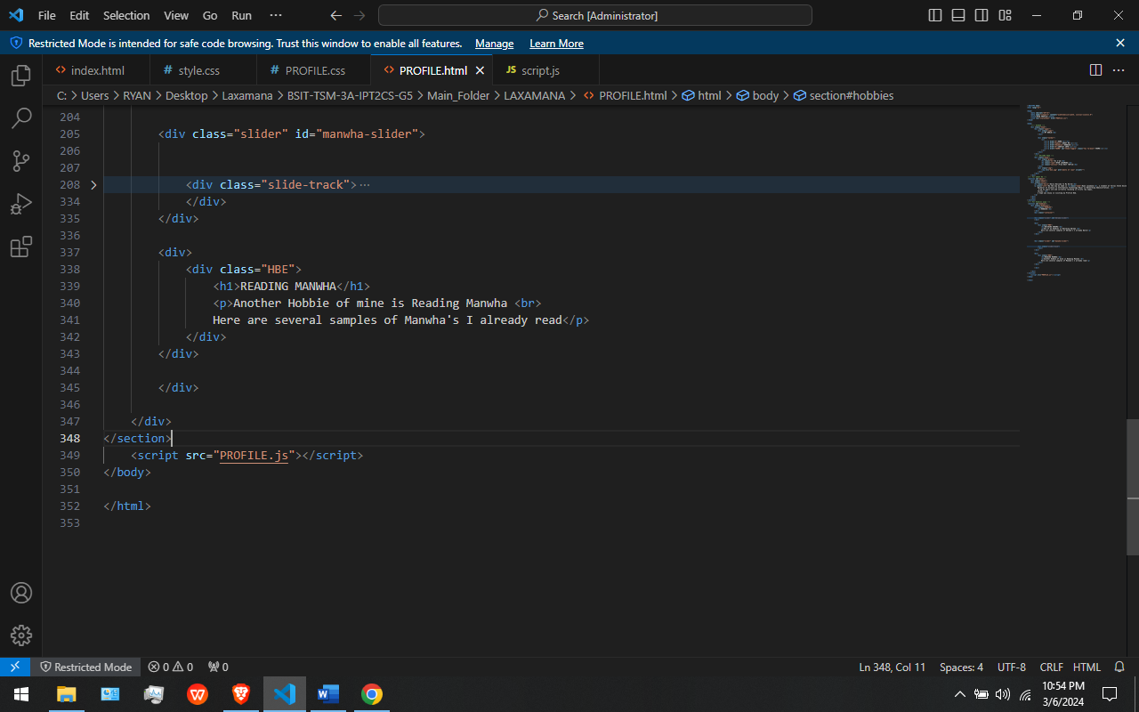

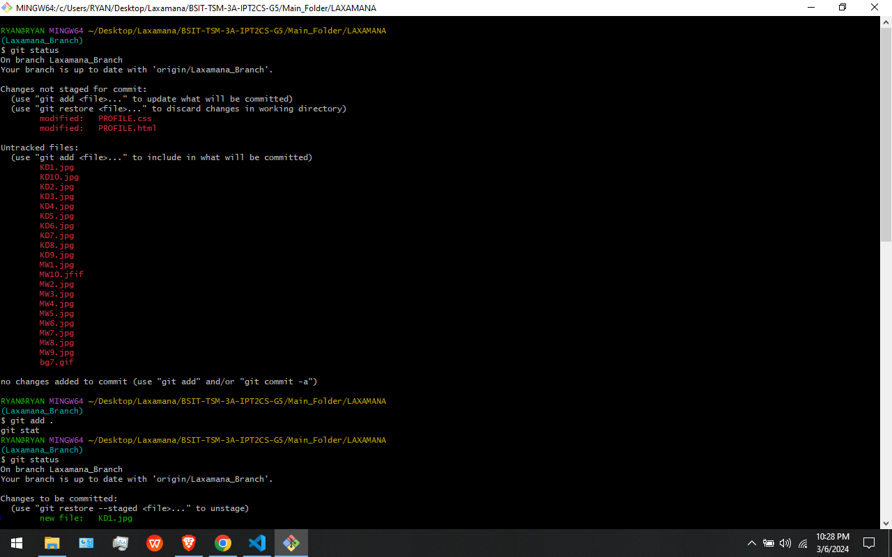

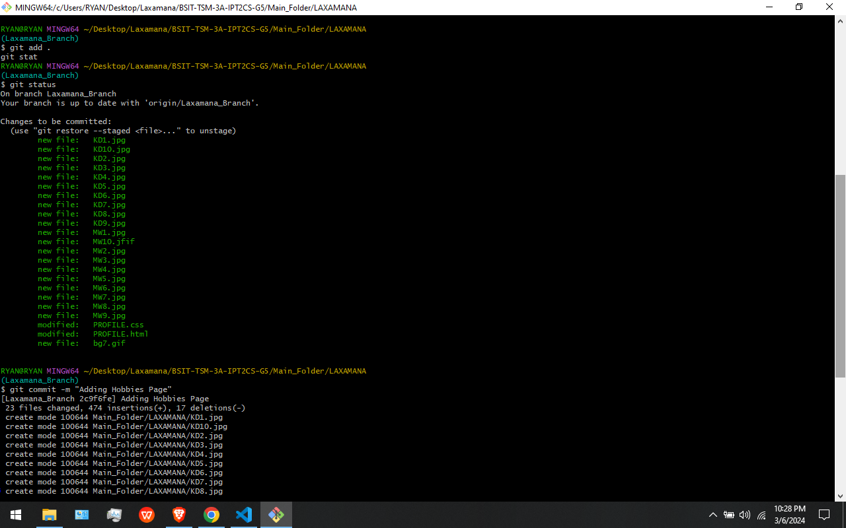



In This Figures: This is where I add the Hobbies page in my profile website where some of my hobbies are being stated. I use “git add”, “git commit”, and “git push” to add, commit, and push my updates in the git hub repository.

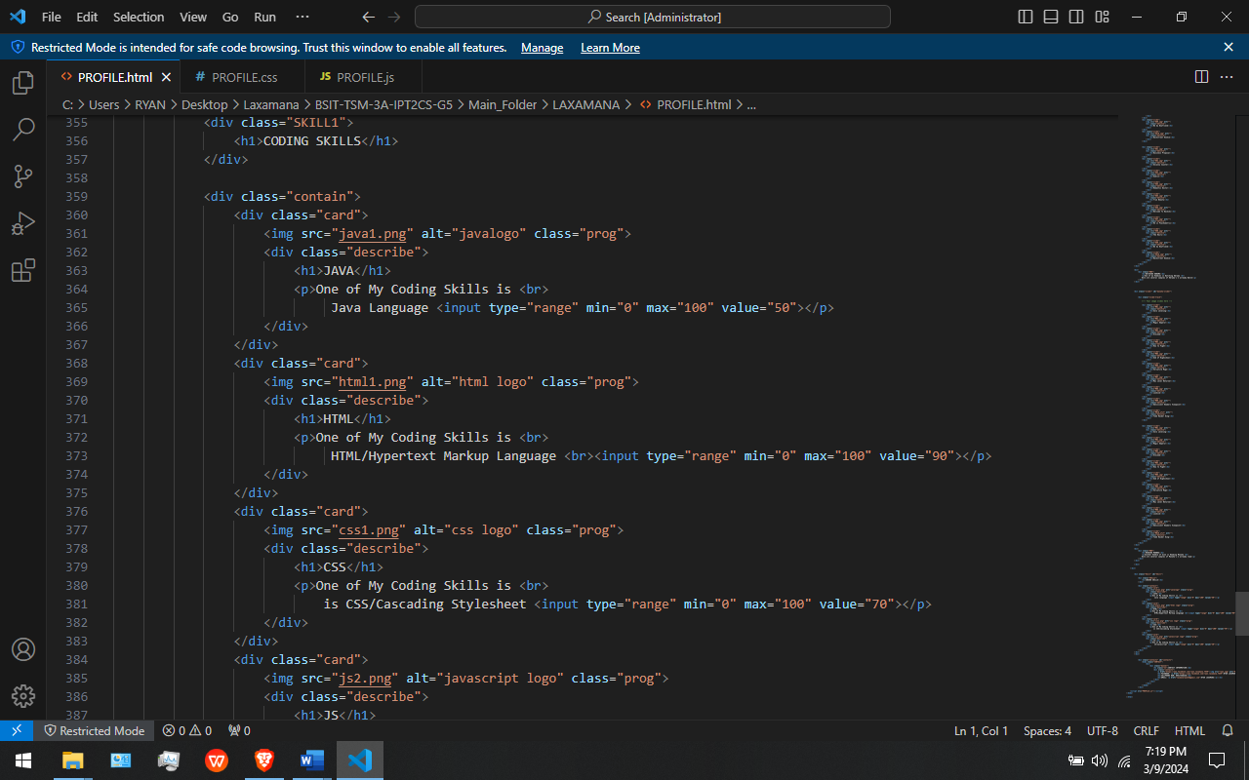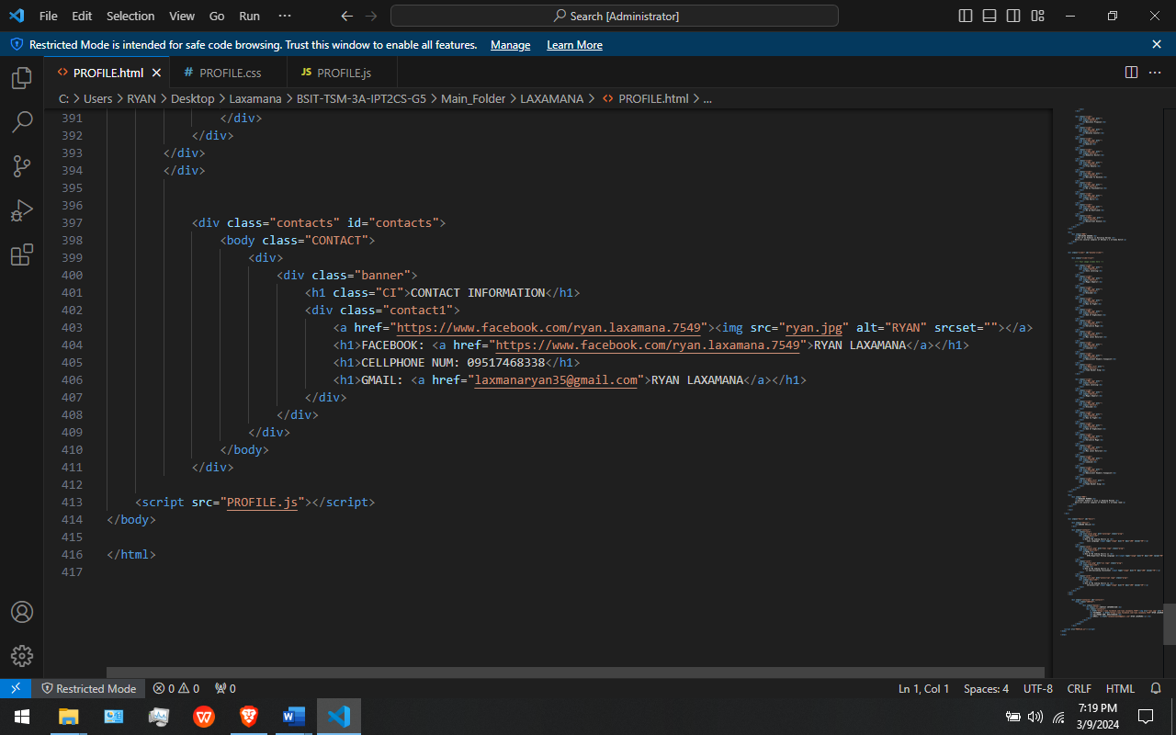

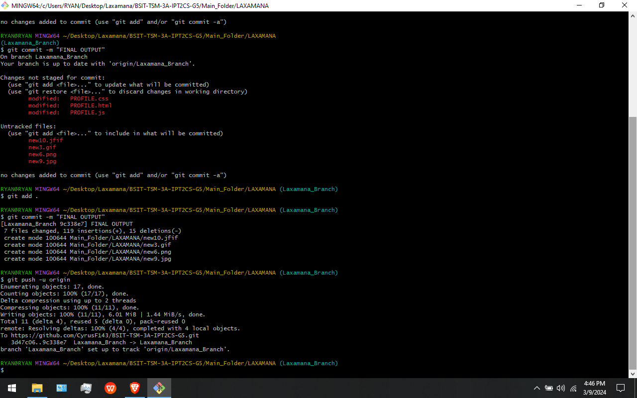

In This Figures: In this part I add the Skills and Contact information page in my profile web page. I use git add, git commit, and git push to push my updates to the github repository.

**MY FINAL PROFILE WEB PAGE OUTPUT**

**DARK THEME/MAIN THEME**

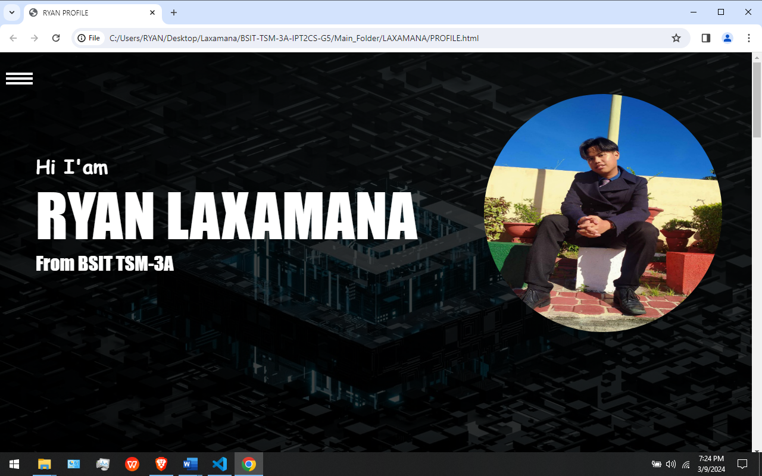

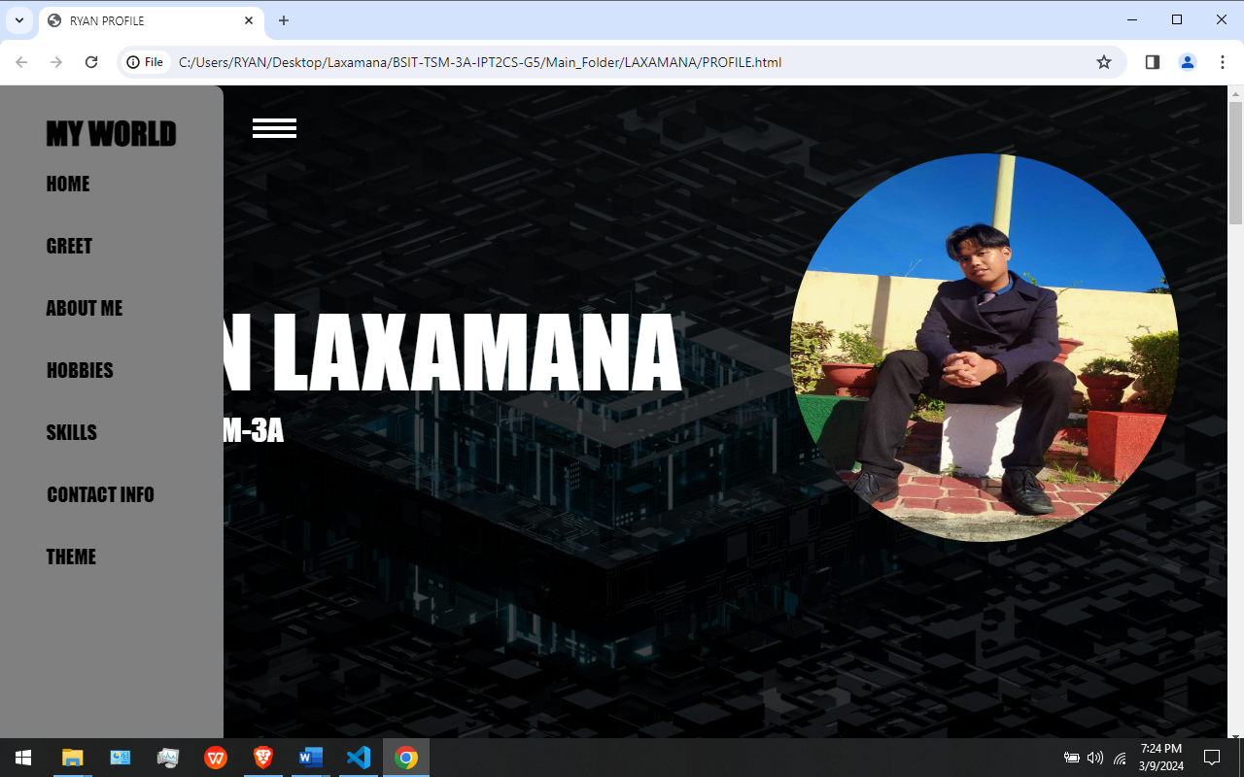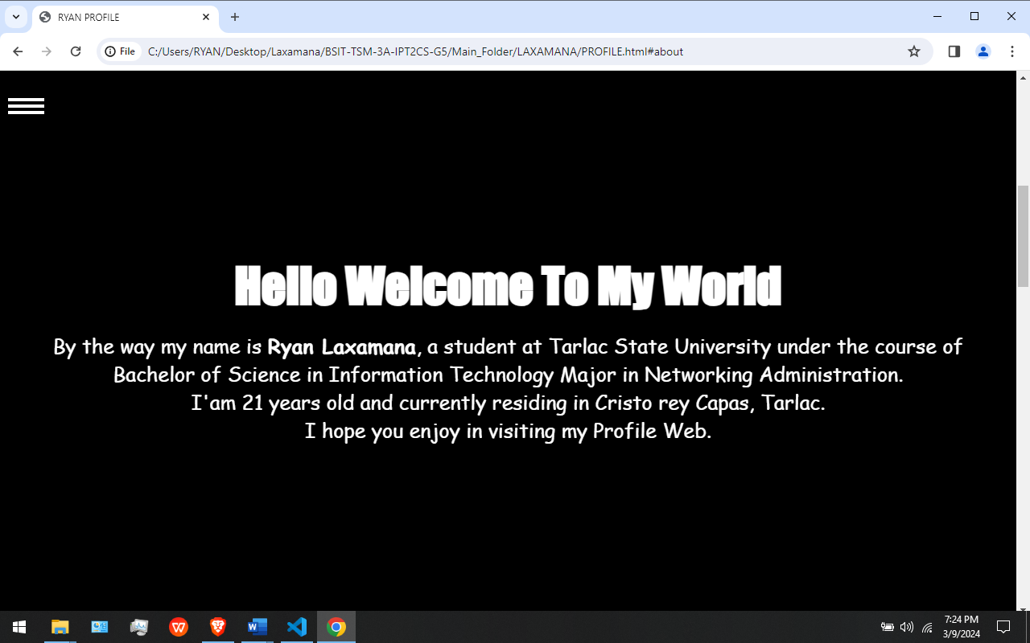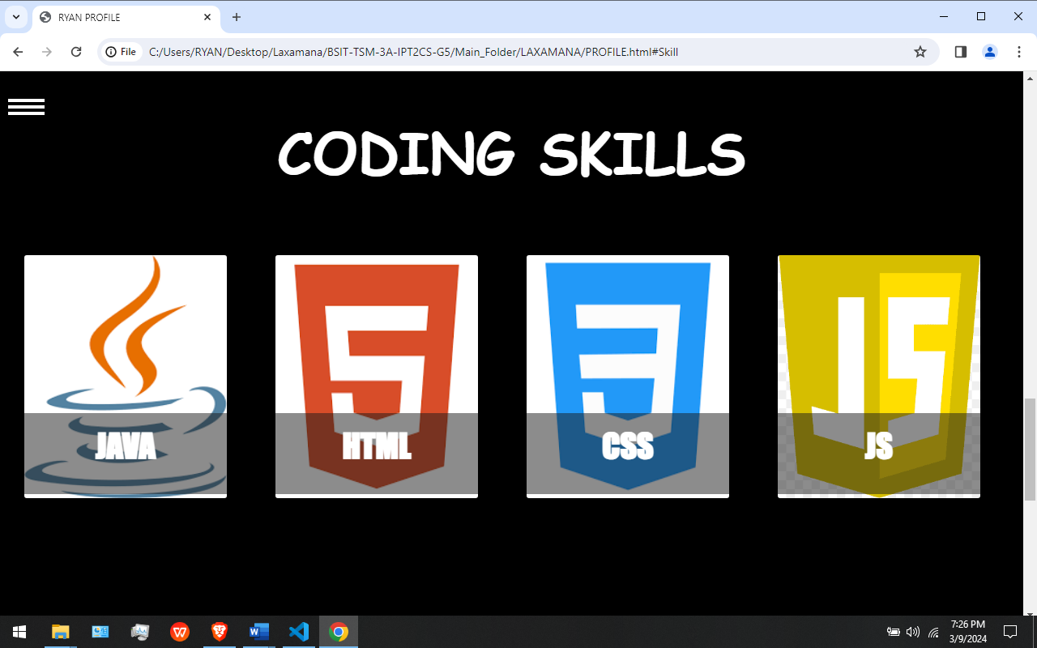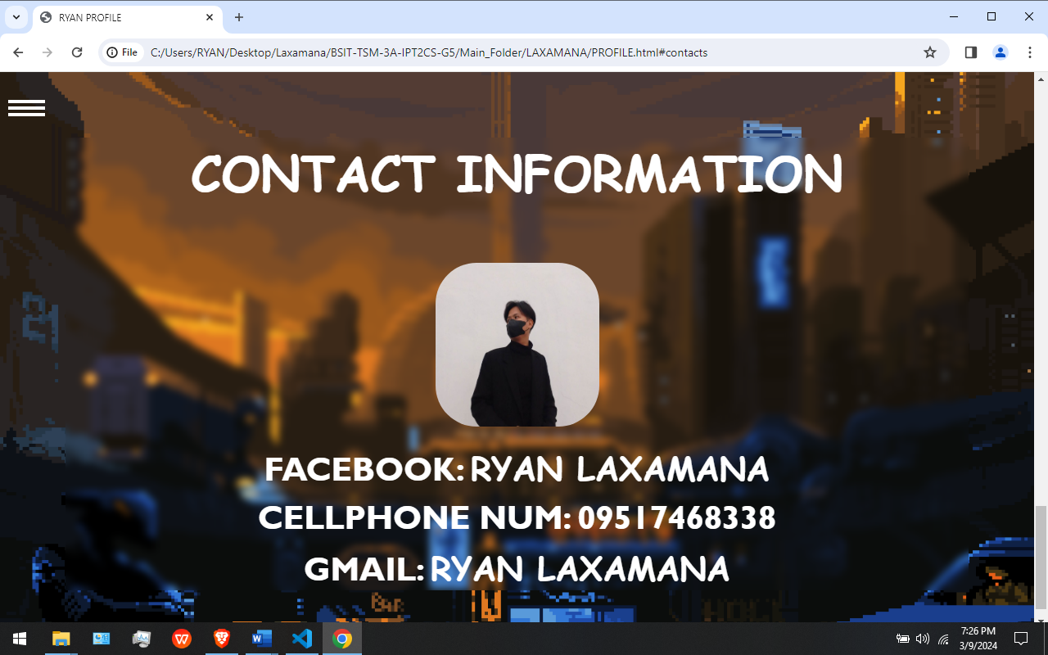

**LIGHT THEME/SUB THEME**

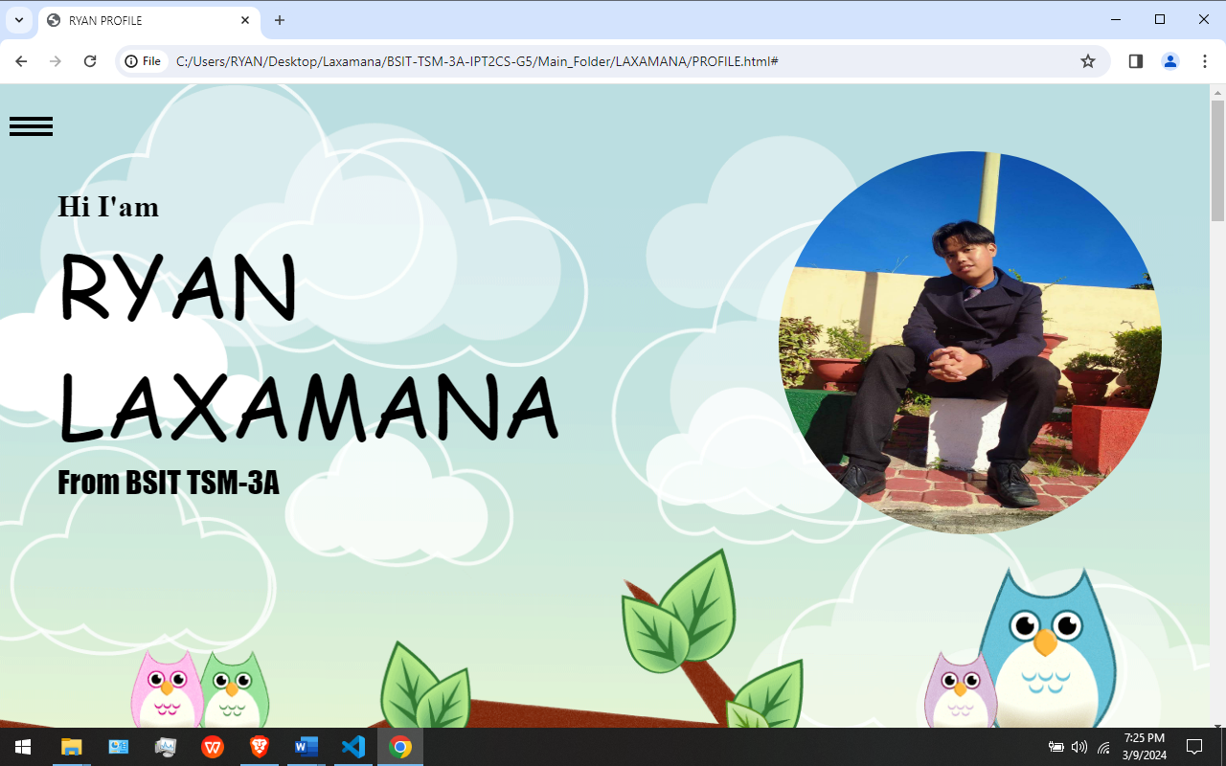

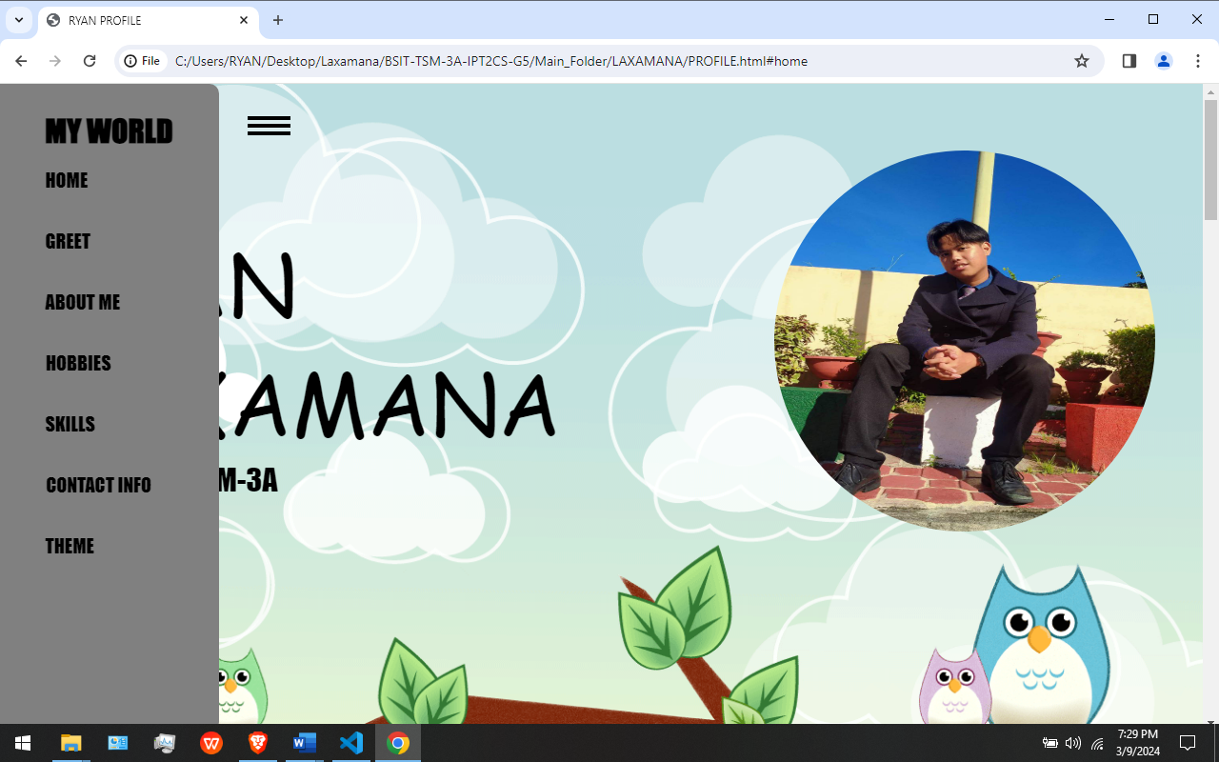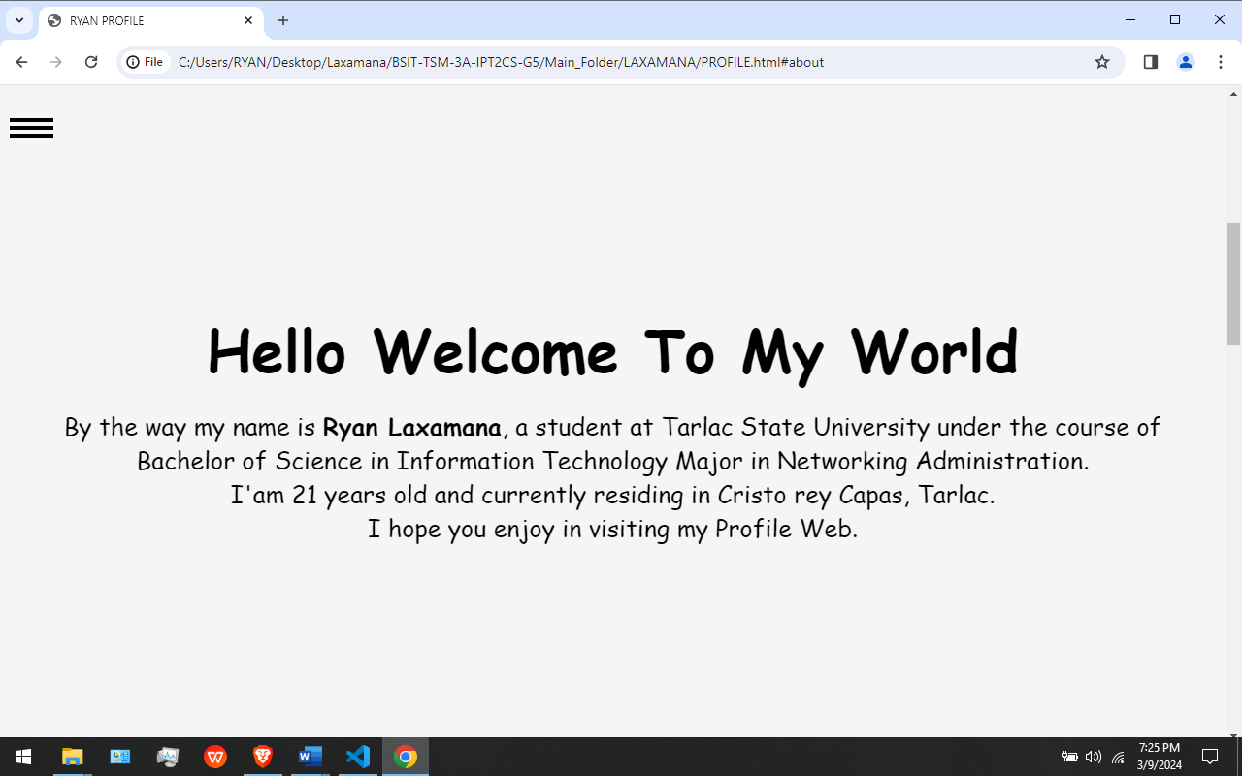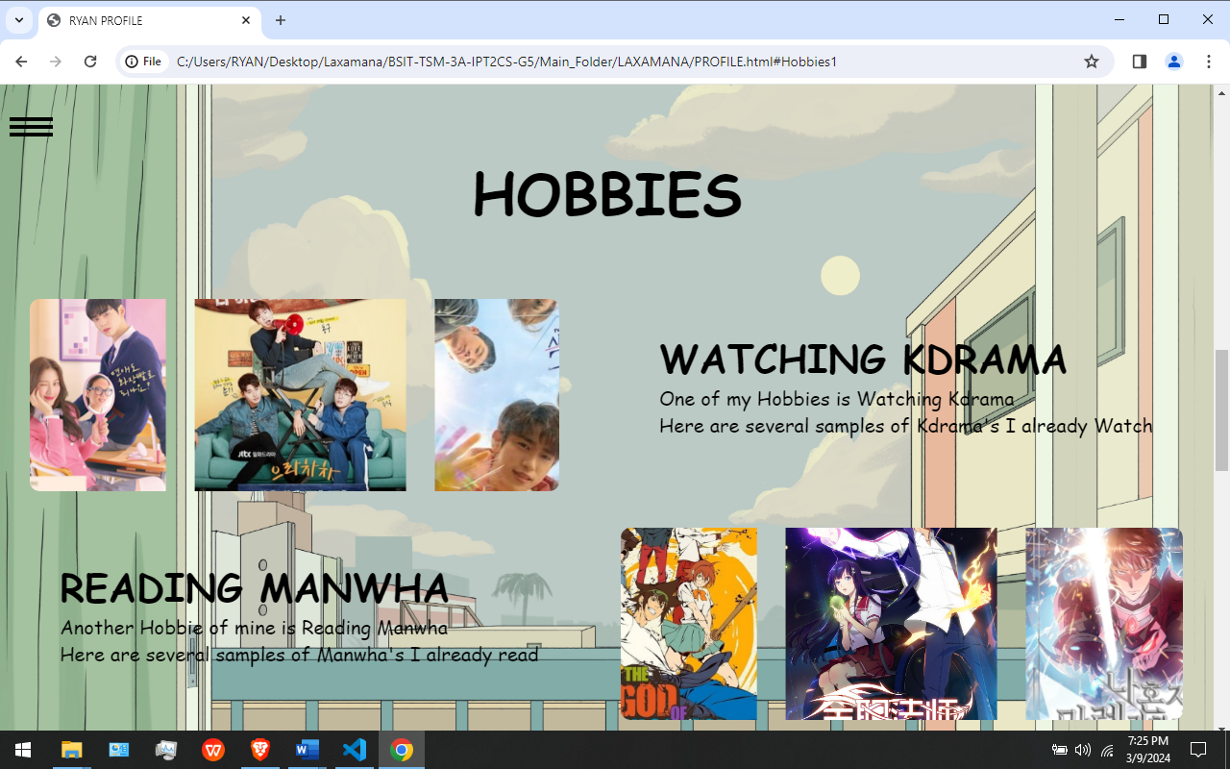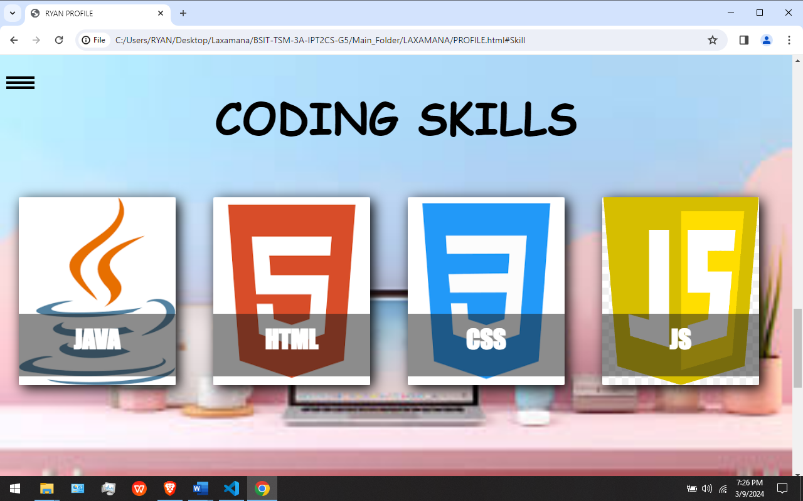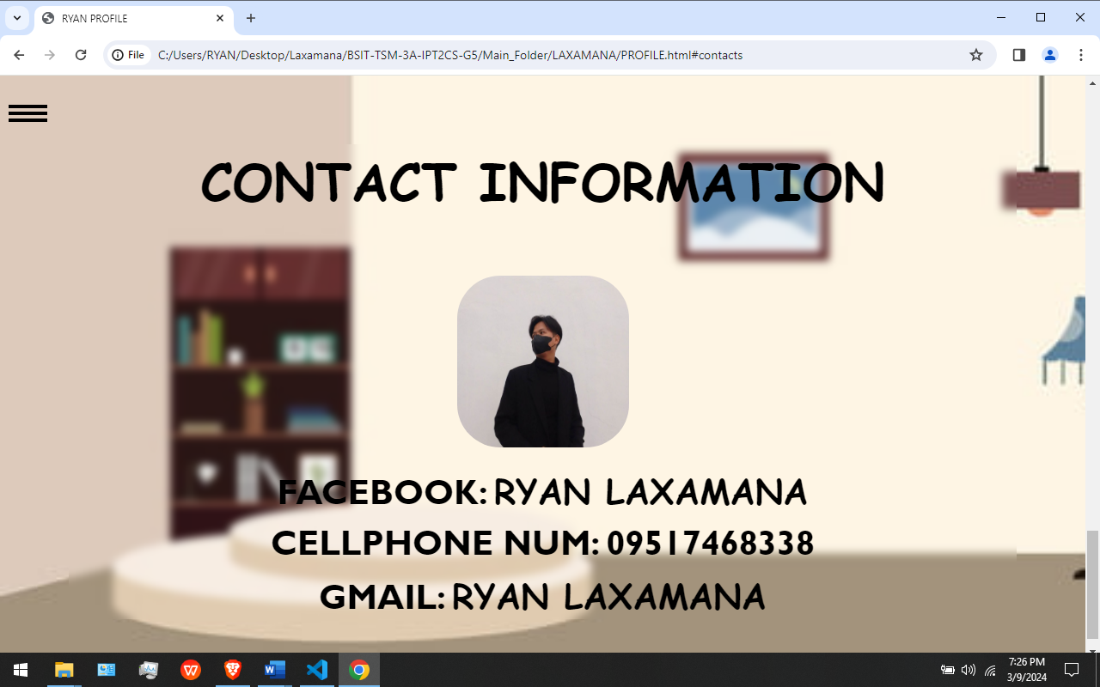

# **Case Analysis (Git and GitHub Workflow)**

## **Leones Documentation**

### **Remote Repository (GitHub) Milestone**

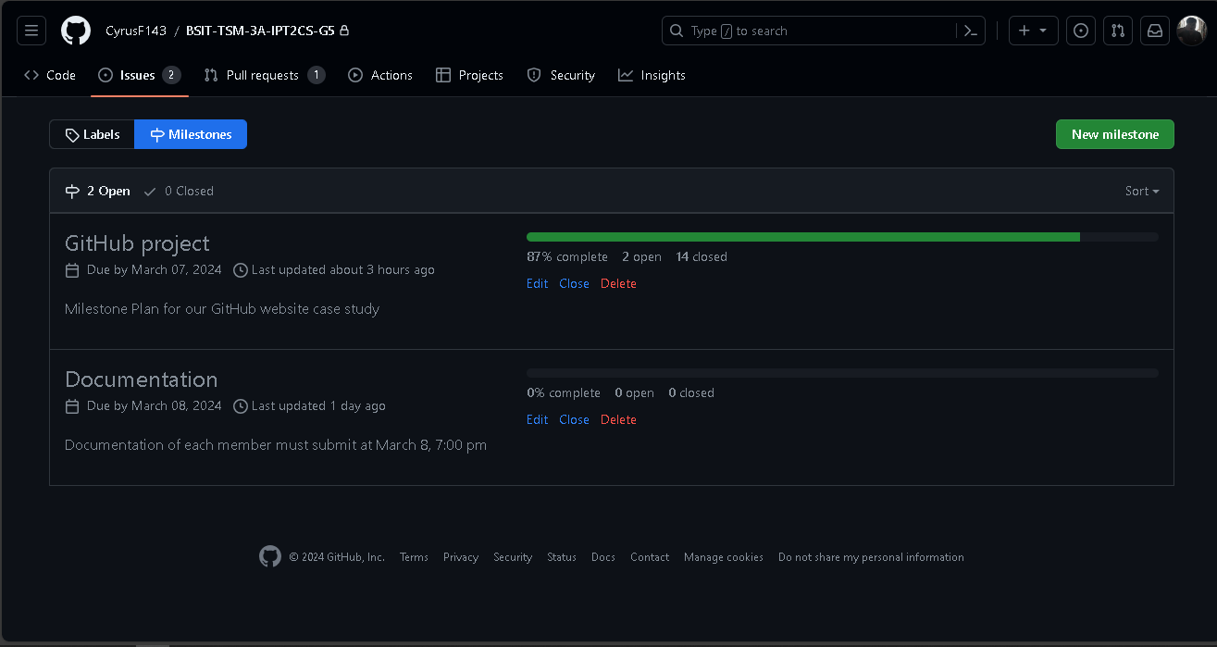

In this figure. I have accessed the milestone that was created by our Leader in our GitHub Repository.

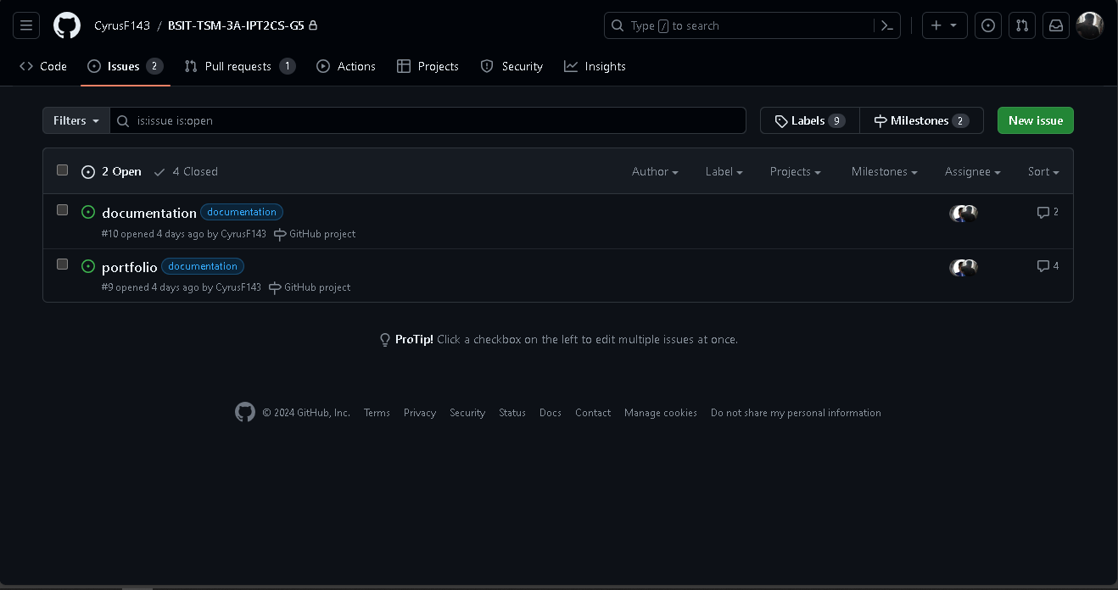 In this figure. It shows the Issues that was made by our Leader and each of the members be able to comment on each of the section in the issue.

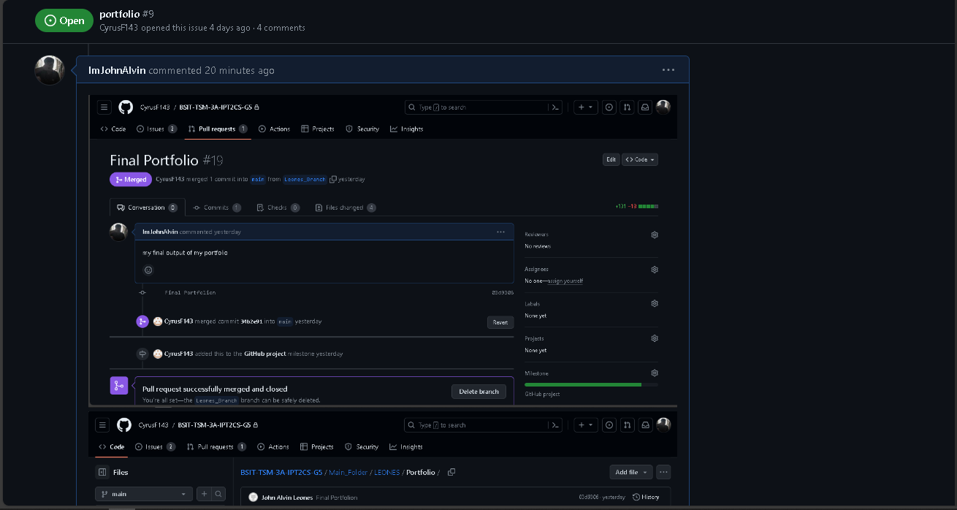

In this figure. I have commented on the section of portfolio which contains my that my final portfolio has been merge to our GitHub Repository.

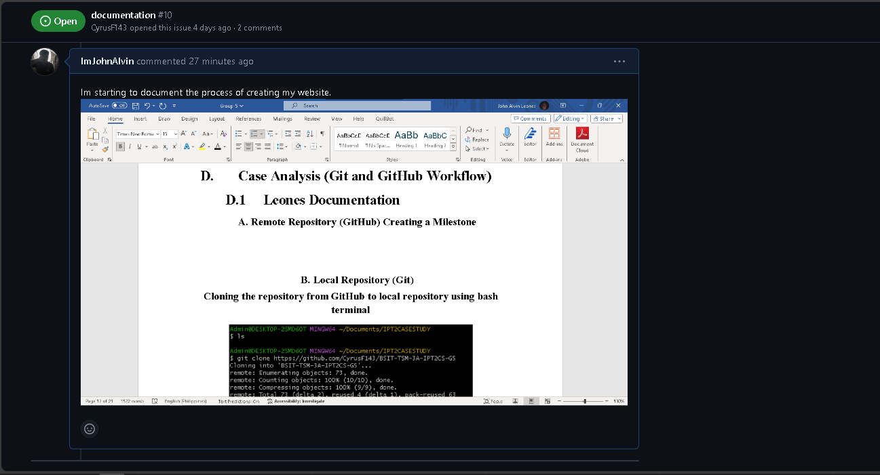

In this figure. I have commented on the section of documentation which is that I’m starting on creating my whole documentation in the creation of website.

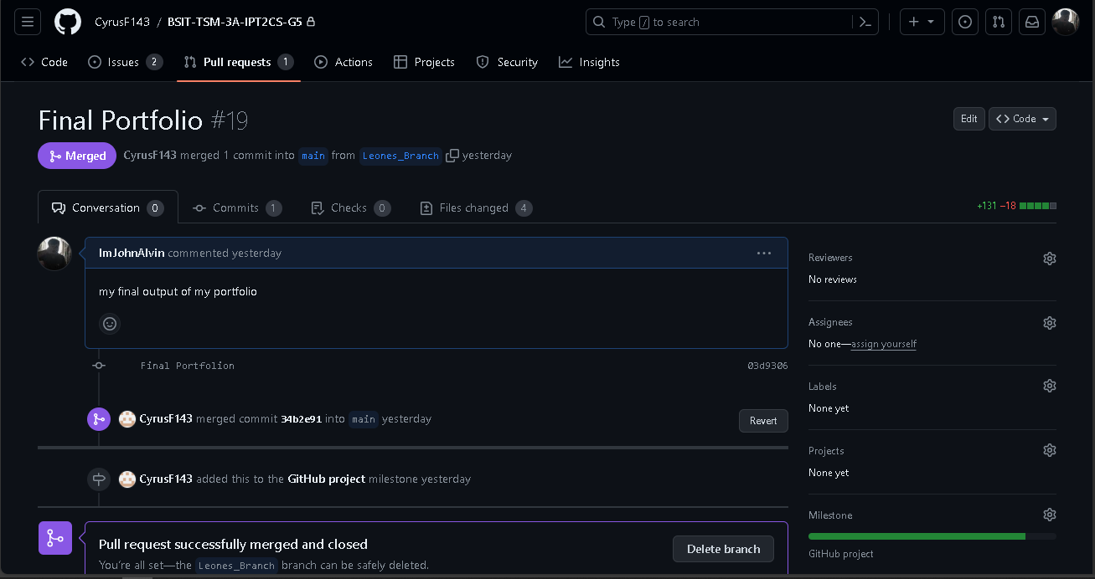

In this figure. I have pull-request my Final Portfolio in my own Branch. It was successfully merged.

### **Local Repository (Git)**

**Cloning the repository from GitHub to local repository using bash terminal**

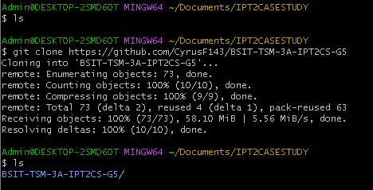

In this figure. We already have our GitHub Repository which was created by our Leader. I did was to clone our Git Repository in Github. To make this process I copied the link of our Git Repository and proceed to the process, “git clone ***URL OF THE GITHUB REPOSITORY***”. To copy all the file from the GitHub Repository. Clones a repository into a newly created directory, creates remote-tracking branches for each branch in the cloned repository. [4]

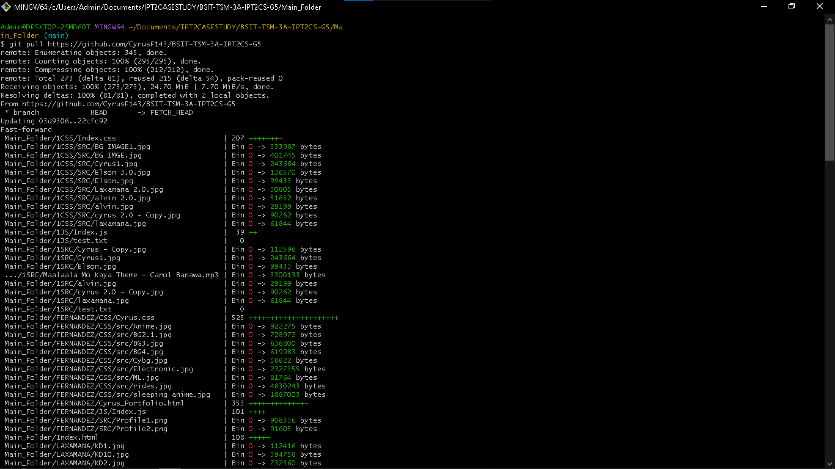

In this figure. Since we are about to finish our own website in our GitHub Repository. I have updated my local repository based on the files that was pushed in our remote repository, to make this process I followed the command “git pull ***URL OF THE GITHUB REPOSITORY***”. The git pull command is used to fetch and download content from a remote repository and immediately update the local repository to match that content. [11]

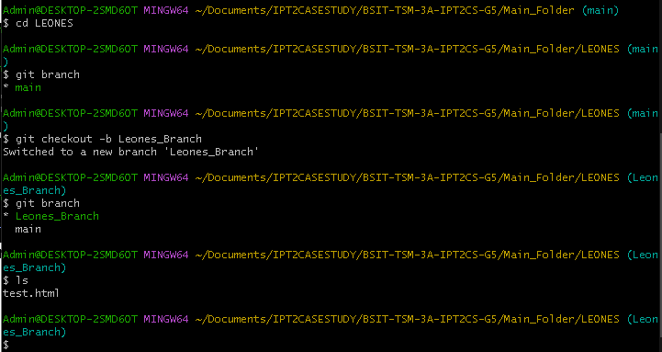

In this Figure. I first access my folder on our GitHub Repository, “cd ***FOLDER NAME***””. After that I did create my own branch on respective folders that was assign by my Leader for my website, to make this process I followed this command “git checkout -b ***Name of your Branch***”. Git branches are effectively a pointer to a snapshot of your changes. When you want to add a new feature or fix a bug—no matter how big or how small—you spawn a new branch to encapsulate your changes. [5]

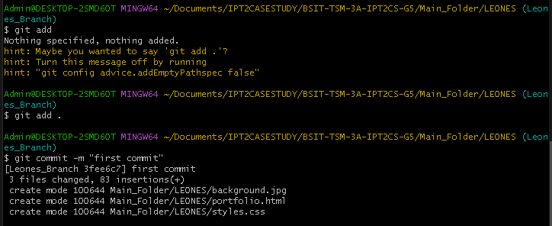

In this figure. I have added my files of my portfolio in the creation my portfolio website from my local to the GitHub Repository, to make this process if did first “git add ***File***” my files and then “git commit -m “***Message***””. The process “git add” will allow you to switch the file status to tracked and “git commit” will allow you to fully commit and get the snapshot of the file.

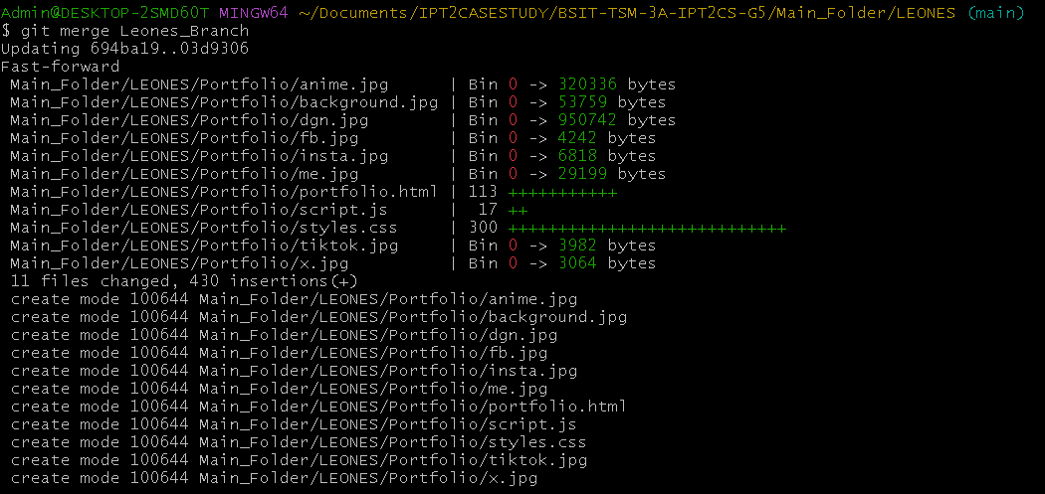

In this figure. I have merge my local branch to my main branch in our GitHub Repository, to make this process I followed this command, “git merge ***Branch Name***”. Incorporates changes from the named commits (since the time their histories diverged from the current branch) into the current branch. [6]

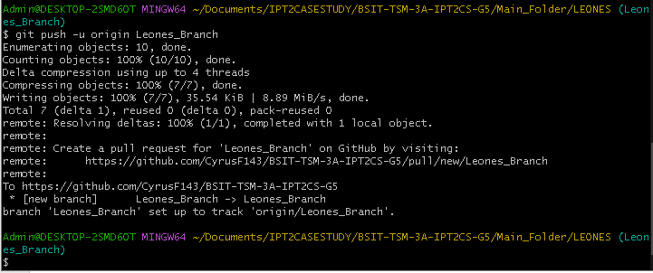

In this figure. I have pushed my local main to the GitHub branch, to make this process I followed this command, “git push -u origin ***Branch Name***”. Git push origin will push the current branch to the branch of the matching name in the remote repository. [7]

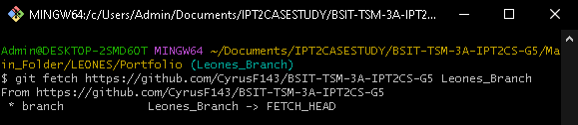

In this figure. I have fetched my Branch in our GitHub Repository to download my commits, files, and refs, to make this process I followed this command, “git fetch “***URL OF THE GITHUB REPOSITORY” “BRANCH NAME”***”. Fetching is what you do when you want to see what everybody else has been working on. [8]

**Creating the first version of my HTML Portfolio**





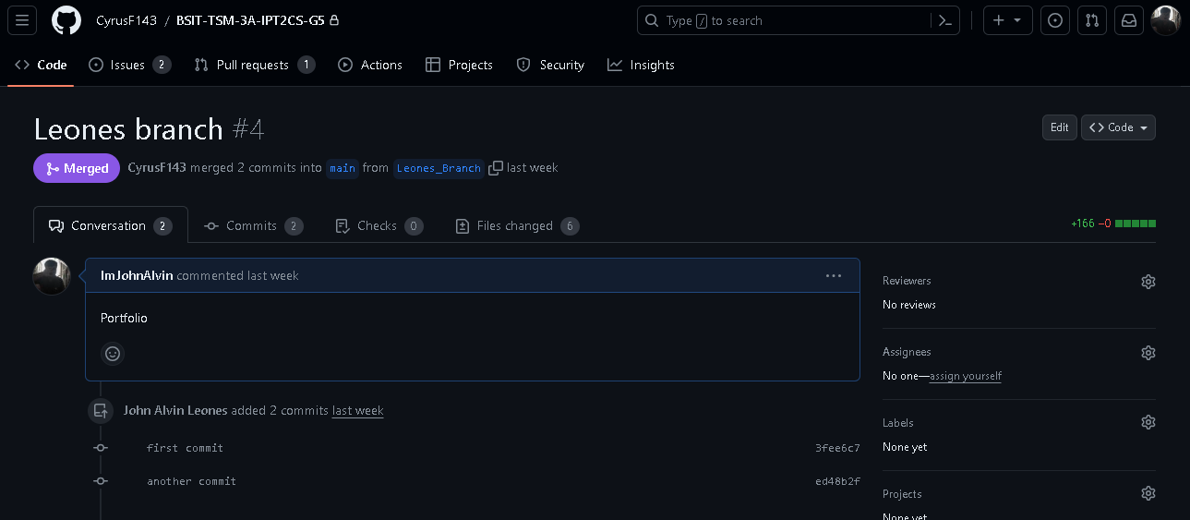

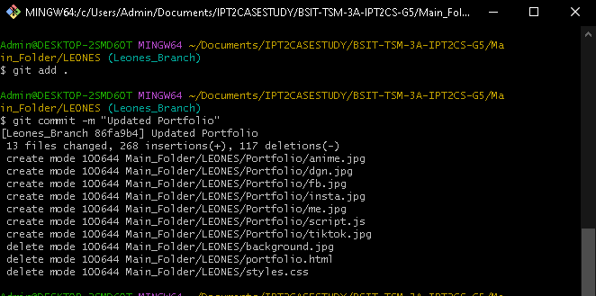

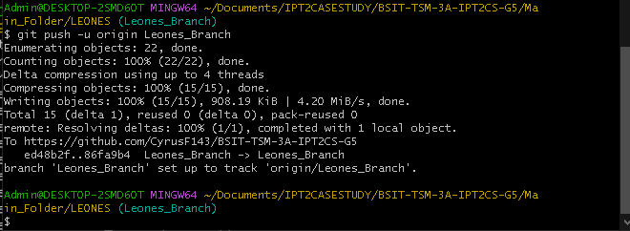

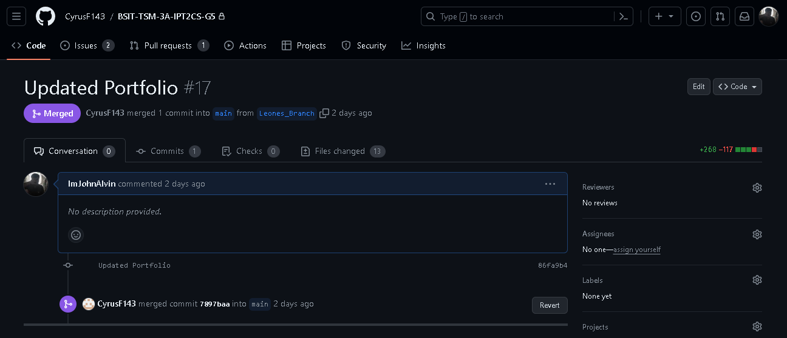







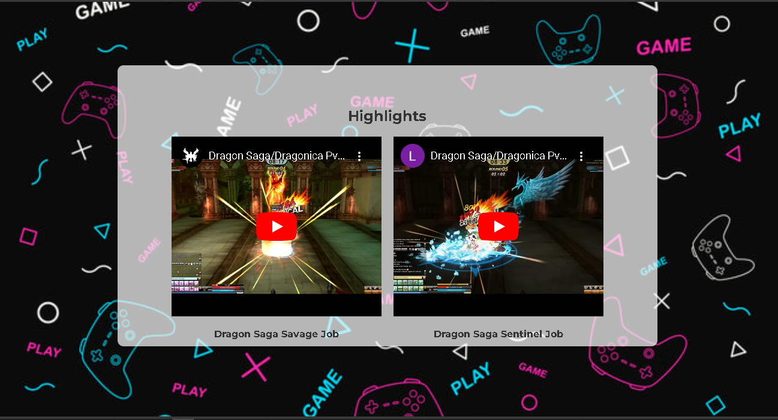

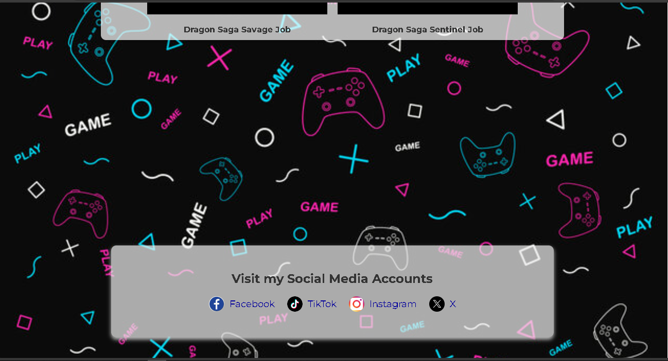

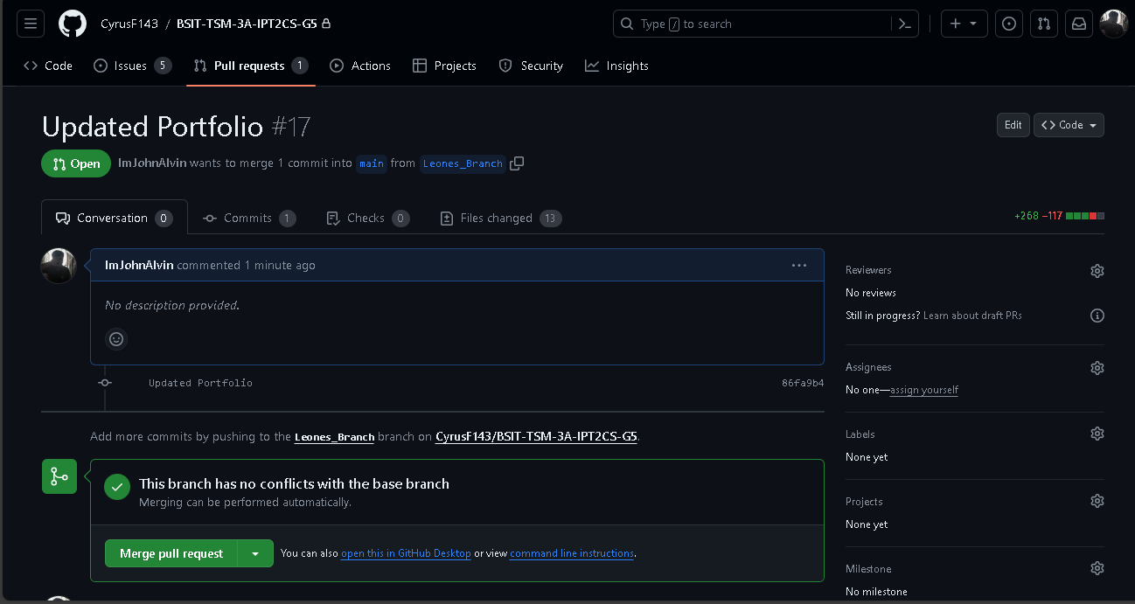

# **Case Analysis (Git and GitHub Workflow)**

## **Quiambao Documentation**

### **Remote Repository (GitHub) Creating a Milestone**

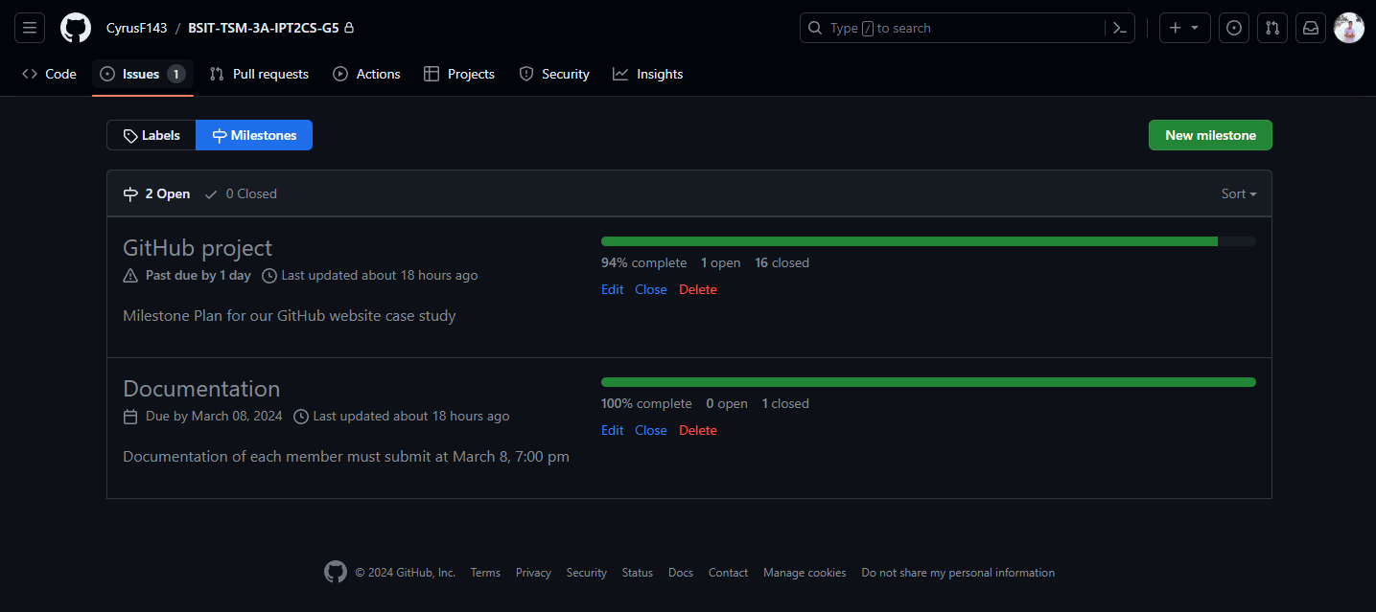

**THIS PICTURE IS THE MILESTONE OF OUR REPOSITORY MADE BY THE LEADER IN GITHUB REPOSITORY.**

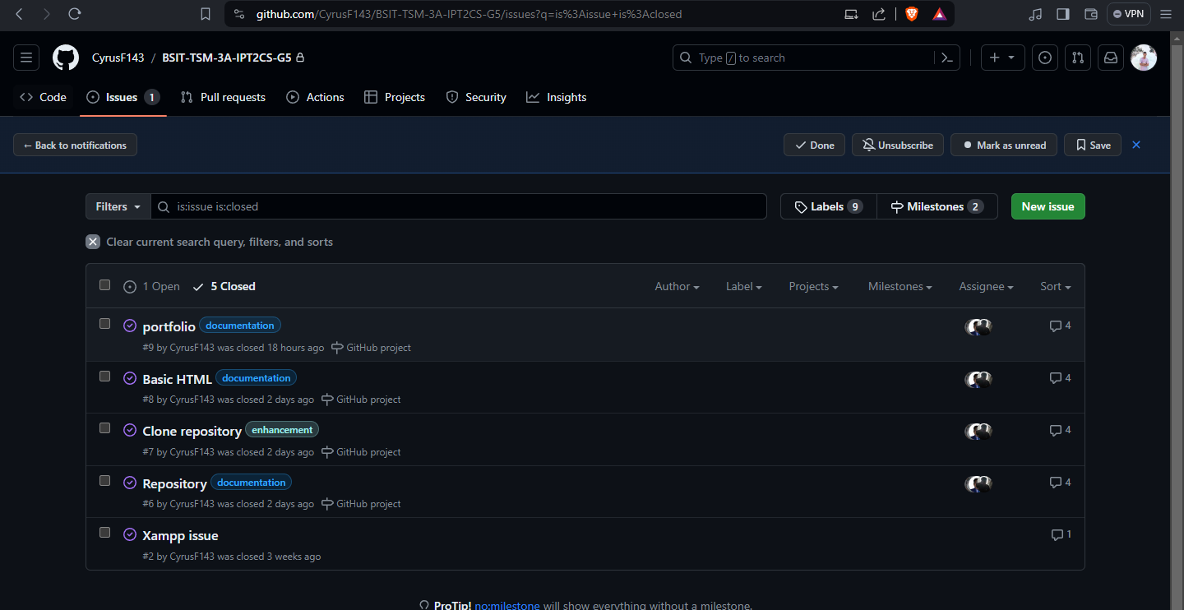

**IN THIS PICTUREIS IS THE ISSUES OF OUR REPOSITORY MADE OF OUR LEADER THAT EACH MEMBER REQUIRED TO COMMENT THE ISSUES**

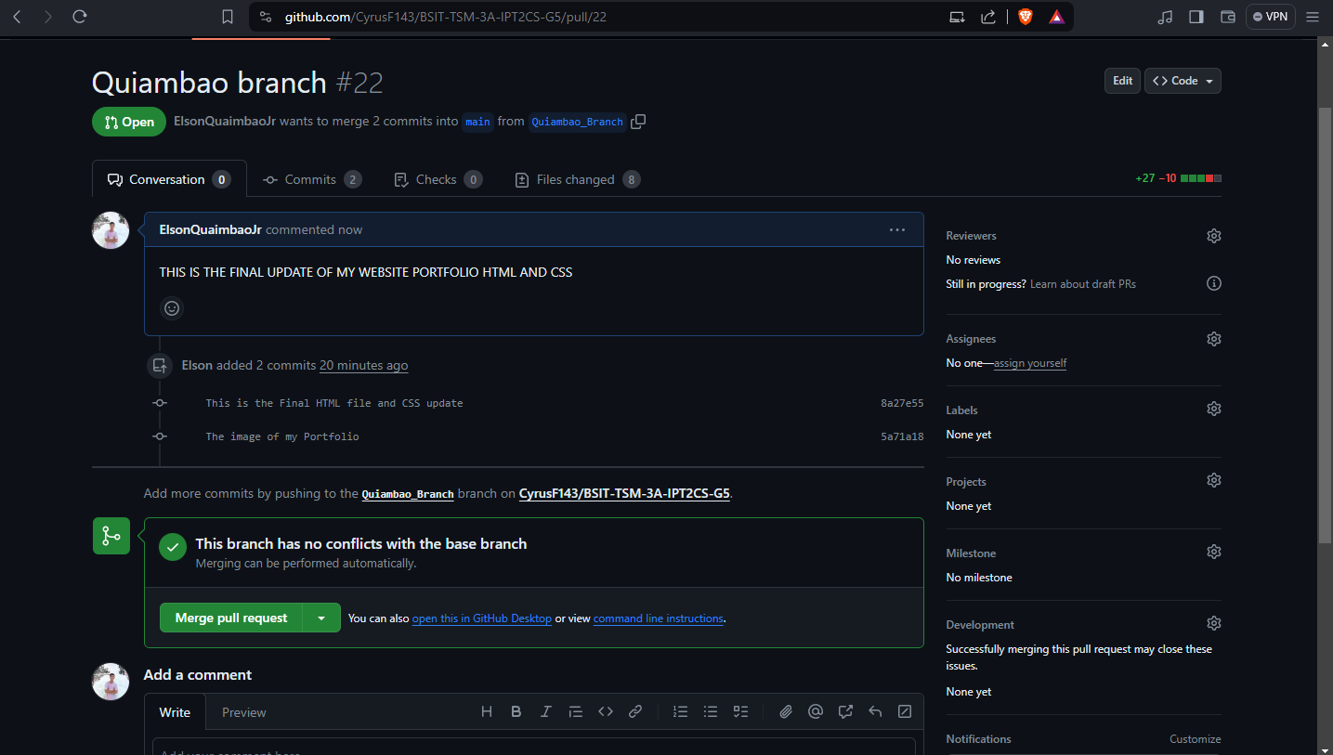

**IN THIS PICTURE, IS MY FINAL PULL REQUEST OF MY HTML FILE AND CSS DESIGN IN THE GITHUB REPOSITORY**

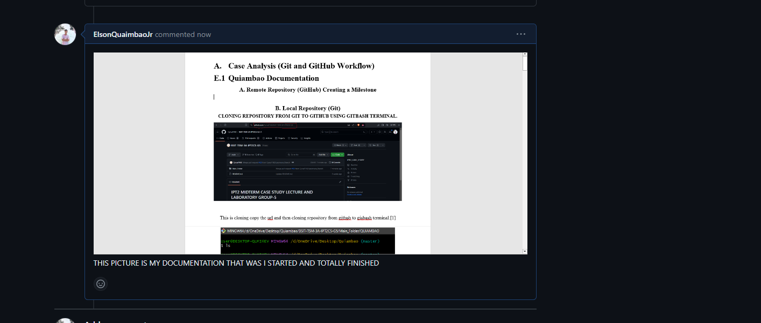

**IN THIS PICTURE, I AM STARTING CREATED MY DOCUMENTATION AND TOTALLY FINISH, ABOUT CREATING MY PORTFOLIO**

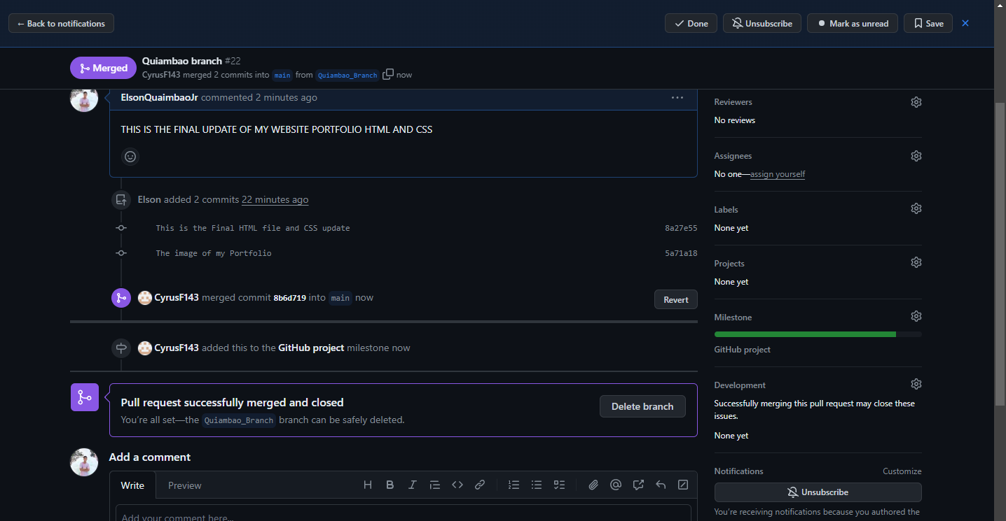

**IN THIS PICTURE IS THE FINAL PUILL AND MERGE IN MY BRANCH AND TOTALLY SUCCESSFUL MERGE.**

### **Local Repository (Git)**

**CLONING REPOSITORY FROM GIT TO GITHUB USING GITBASH TERMINAL.**

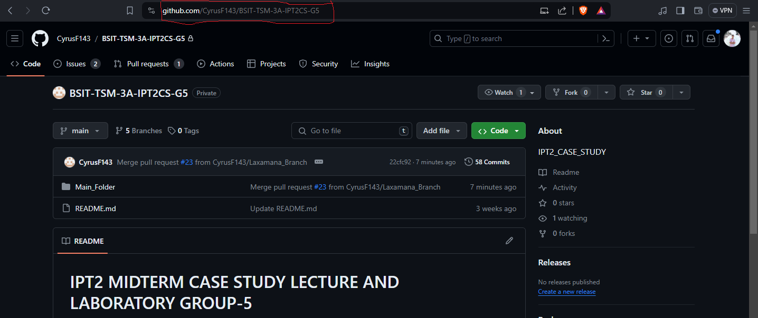

This is cloning copy the url and then cloning repository from github to gisbash terminal.[1]

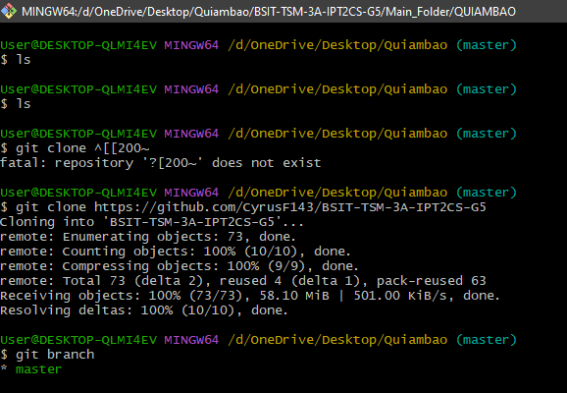

This terminal you see the bash terminal and then I type git clone and insert the url of the repository to clone the repository. The git clone command copies an existing Git repository.[2]

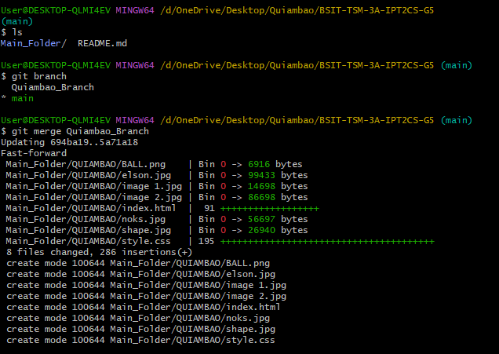

This picture is I merge my local branch to my main repository. The git merge command lets you take the independent lines of development created by git branch and integrate them into a single branch. Note that all of the commands presented below merge into the current branch.[3]

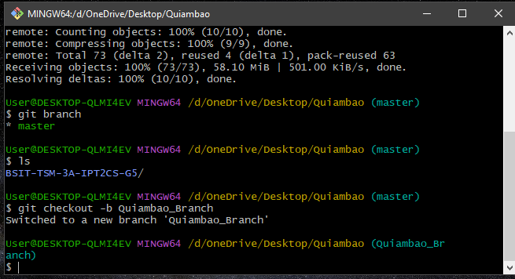

**Working on local-repo and creating a local-branch.**

In this part I created my branch in clone local repository and name it to my last name Quiambao-Branch. Git branches are effectively a pointer to a snapshot of your changes. When you want to add a new feature or fix a bug—no matter how big or how small—you spawn a new branch to encapsulate your changes.[4]

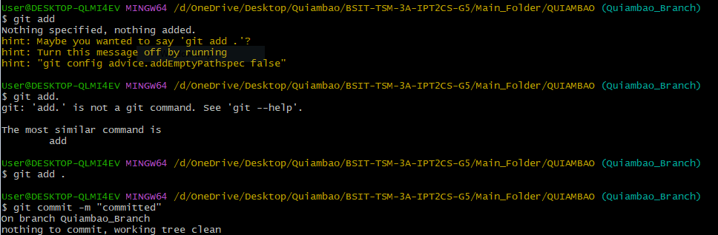

In this picture I add my branch in main folder to my perspective folder, and this branch is untracked by using git add the branch is now tracked. The git add command adds a change in the working directory to the staging area.

In this part is I commit the branch for working free clean now the branch is in staged. The git commit command is one of the core primary functions of Git. Prior use of the git add command is required to select the changes that will be staged for the next commit. Then git commit is used to create a snapshot of the staged changes along a timeline of a Git projects history.[5]

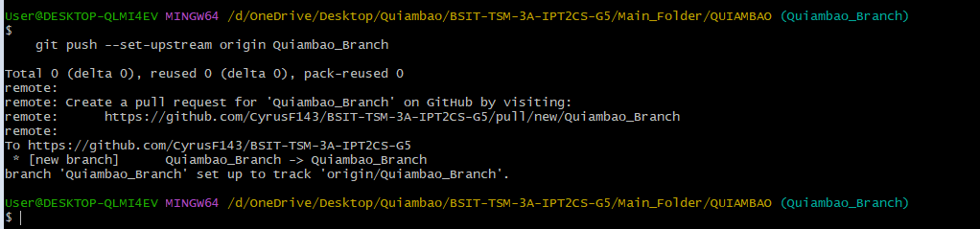

In this part I push my branch in to the local repository and successfully pushed/ the git push command is used to upload local repository content to a remote repository. Pushing is how you transfer commits from your local repository to a remote repo.[6]

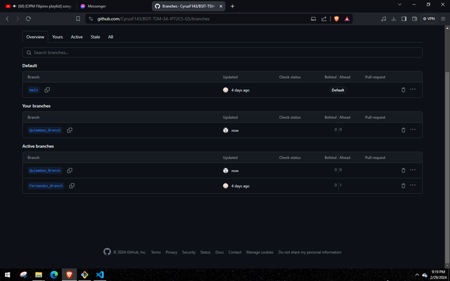

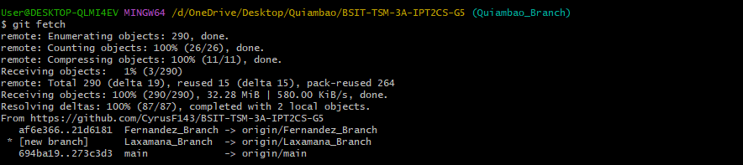

This picture is to fetch my branch in our main repository to downloads all commits n review, git fetch is a primary command used to download contents from a remote repository. git fetch is used in conjunction with git remote , git branch , git checkout , and git reset to update a local repository to the state of a remote. The git fetch command is a critical piece of collaborative git work flows.[7]

**CREATING MY FIRST VERSION OF MY HTML**

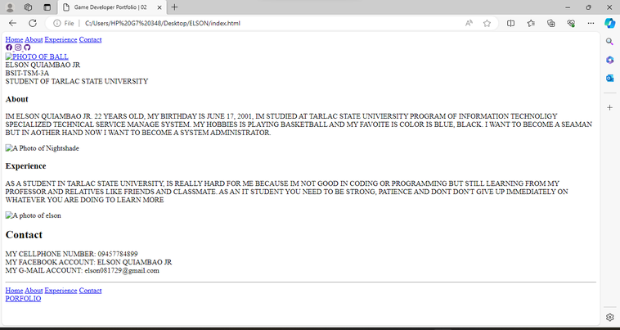

THIS IS MY HTML PORTFOLIO NO DESIGN IN CSS AND THE BASIC INFORMATION ABOUT ME AND EXPERINCE AND CONTACT.

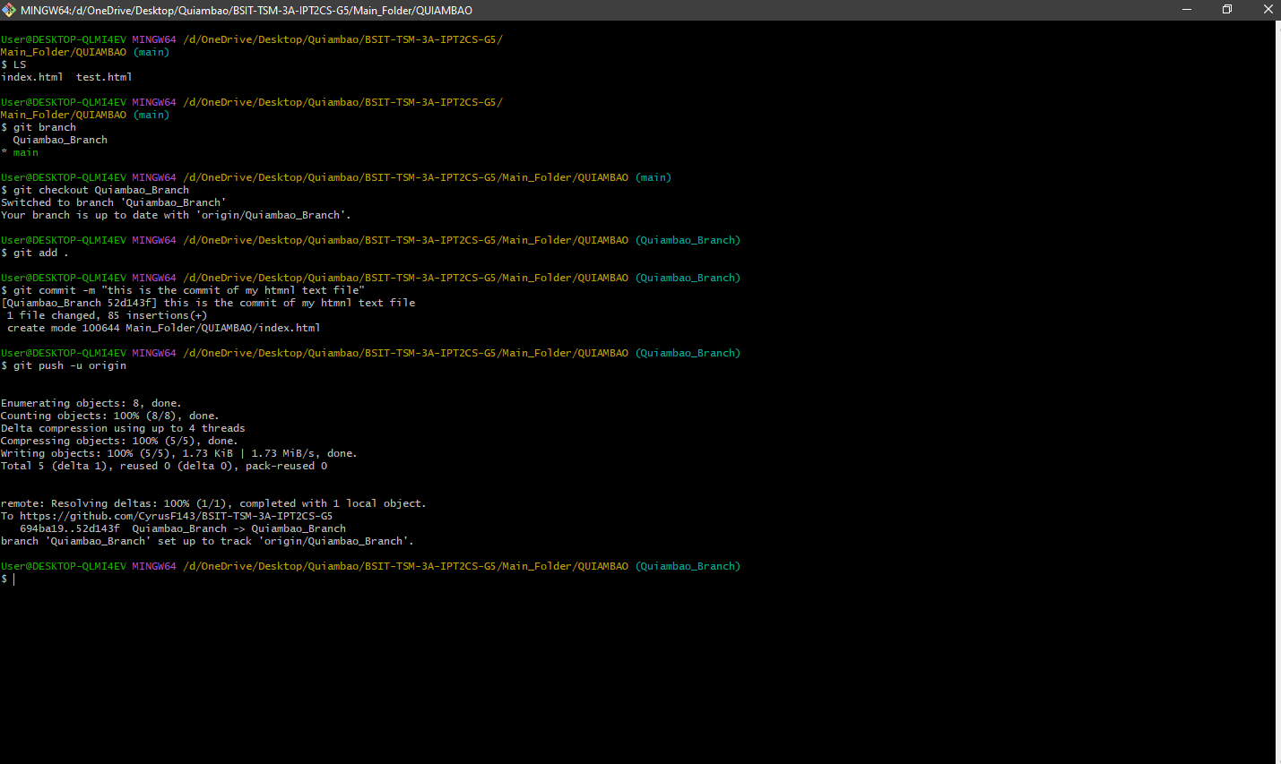

THIS PICTURE IS MY HTML FILE IS TO ADD COMMIIT PUSH ON THE REPOSITORY TO MAIN AND PERSPECTIVE FOLDER.

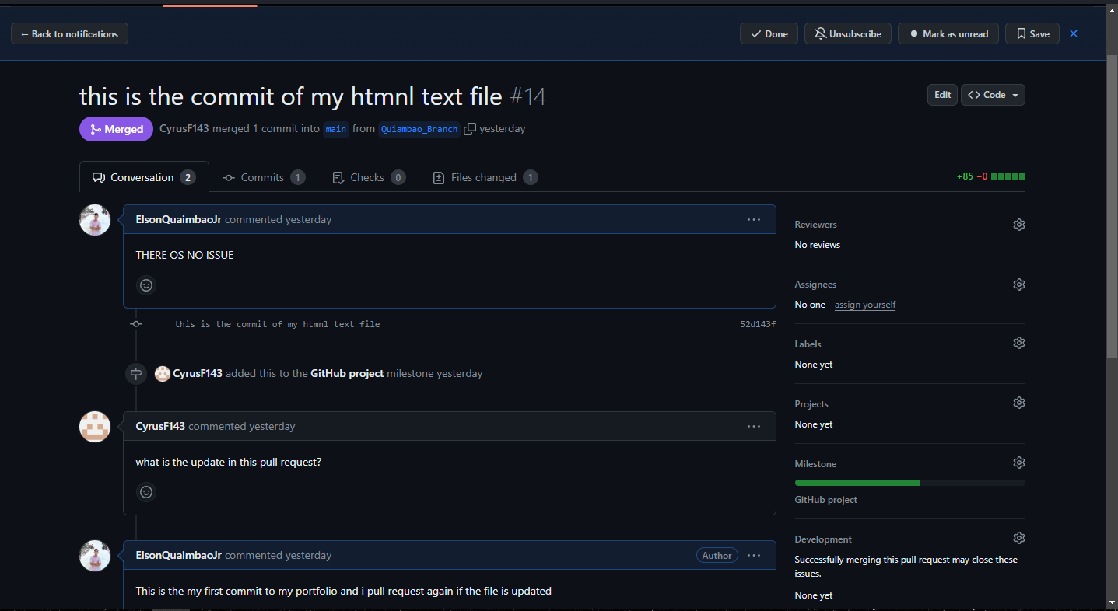

AND THIS PART IS THE OUTPUT OF MY FIRST PULL REQUEST IN MY REPOSITORY

**ADDING CSS DESING**

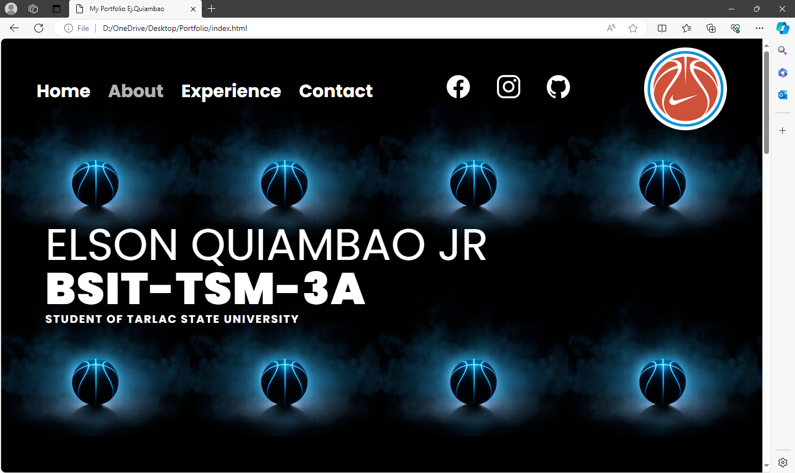

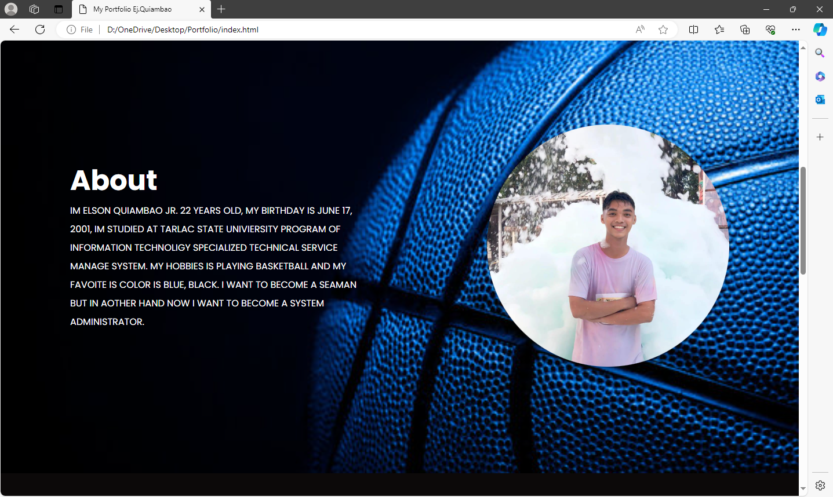

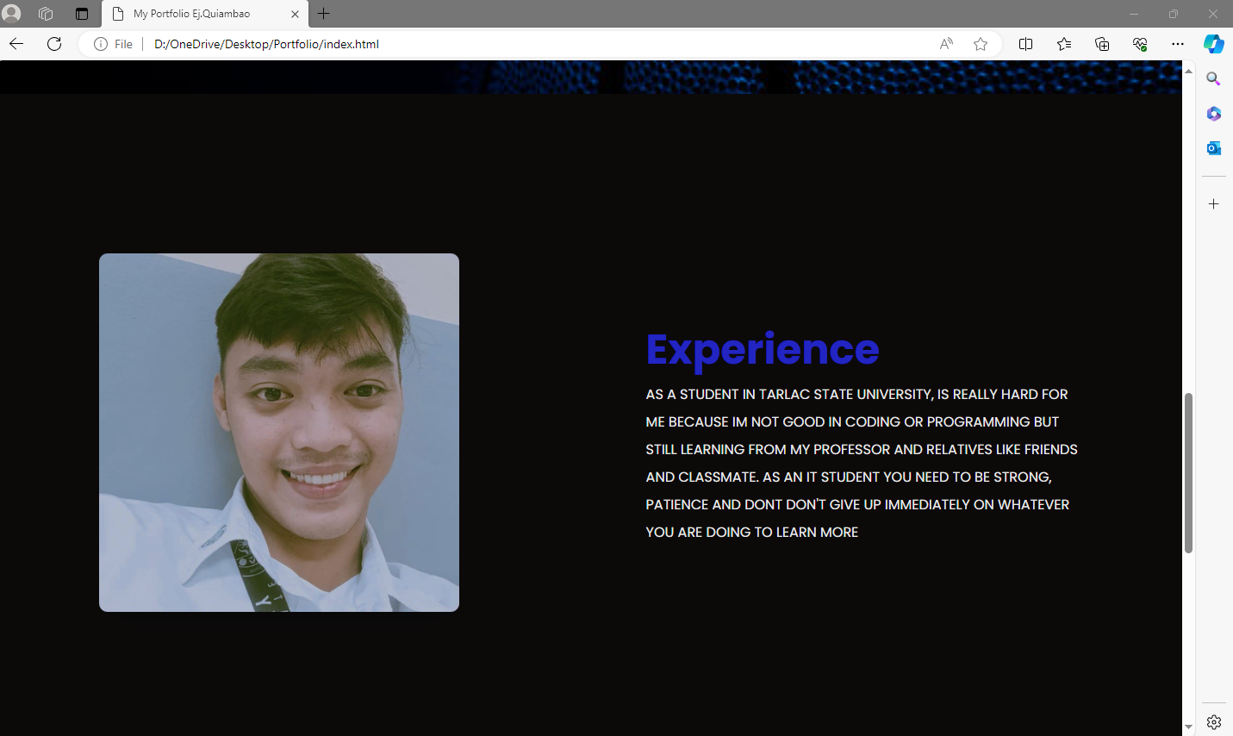

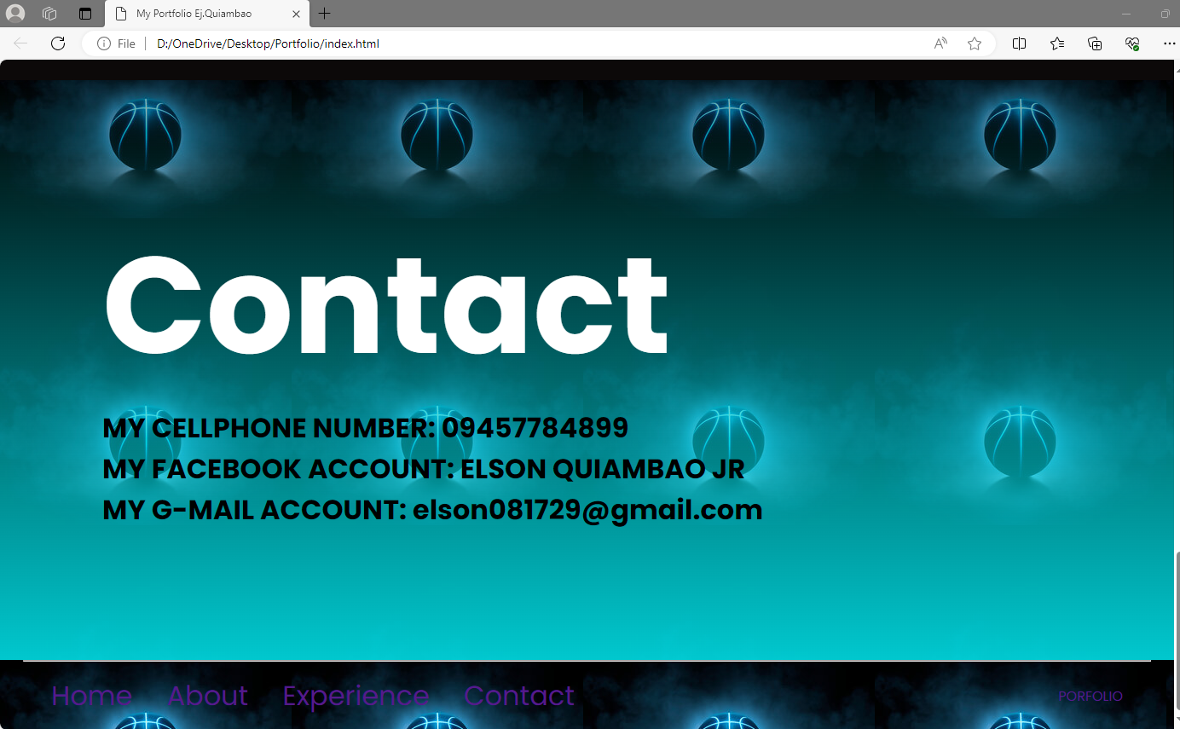

IN THIS PART I DESIGNING MY HTML FILE PORTFOLIO USING CSS AND THIS IS THE OUTPUT OF MY HOME PAGE. ABOUT, EXPERIENCE AND CONTACT.

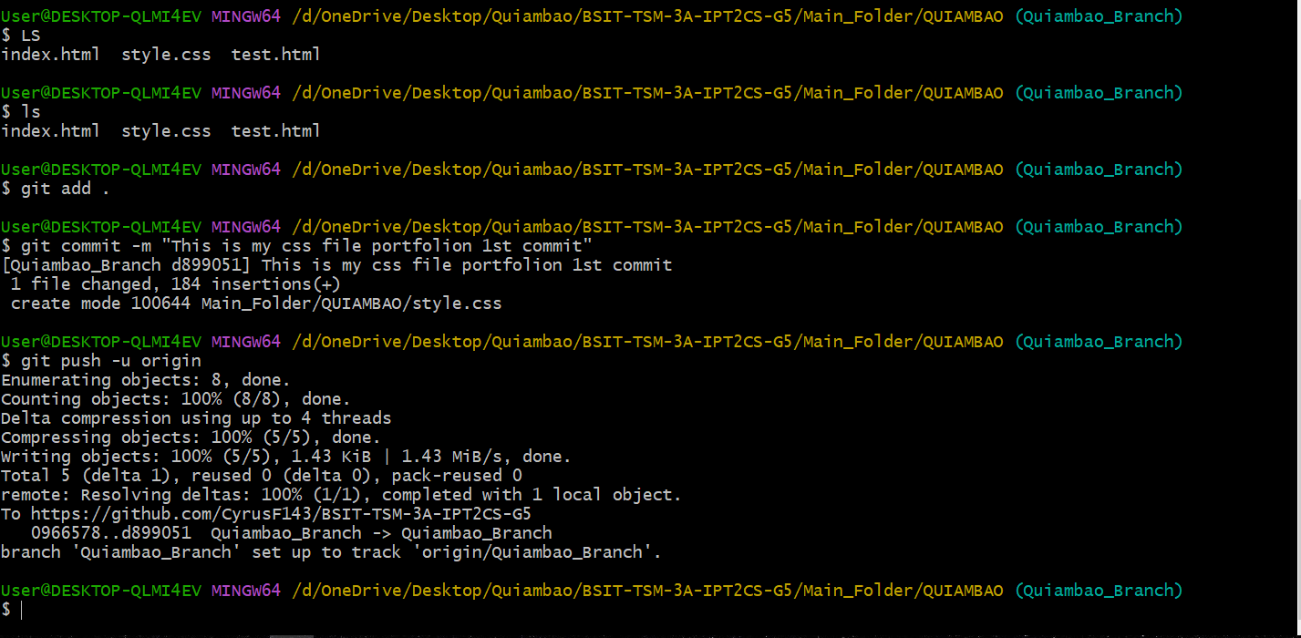

AND THIS PART IS THE GITBASH TERMINAL TO ADD COMMIT AND PUSH CSS DESIGNE TO UPDATE MY HTML FILE PORTFOLIO WEBSITE

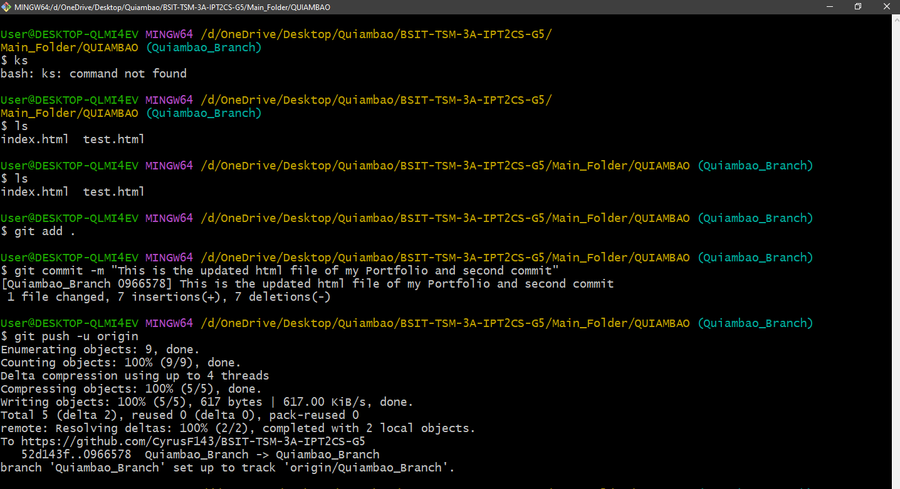

THIS IS THE SECOND ADD COMMIT AND PUSH OF MY HTML FILE PORTFOLIO TO UPDATE

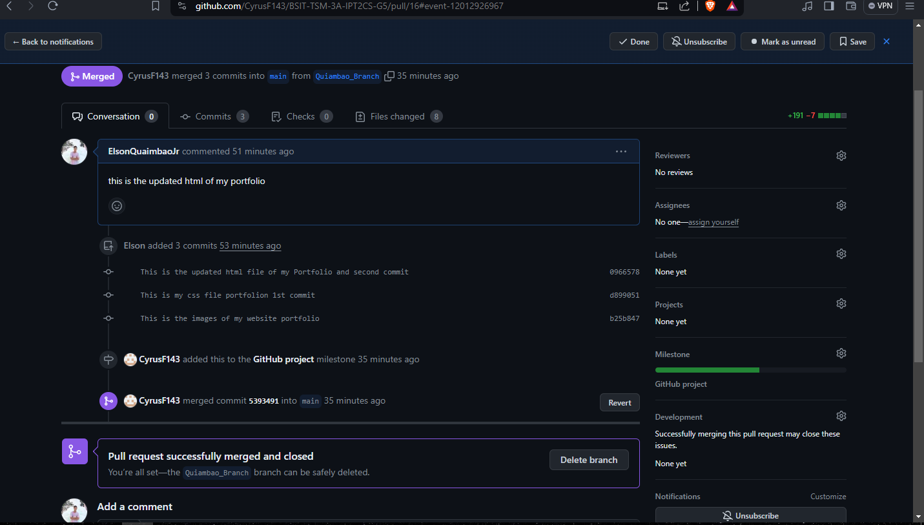

AND THEN THIS IS THE SECOND PULL REQUEST OF MY HTML FILE





THIS IS THE FINAL UPDATE OF MY HTML FILE AND CSS AND THE LAST PULL REQUEST AND MERGE.

# **Individual HTML**

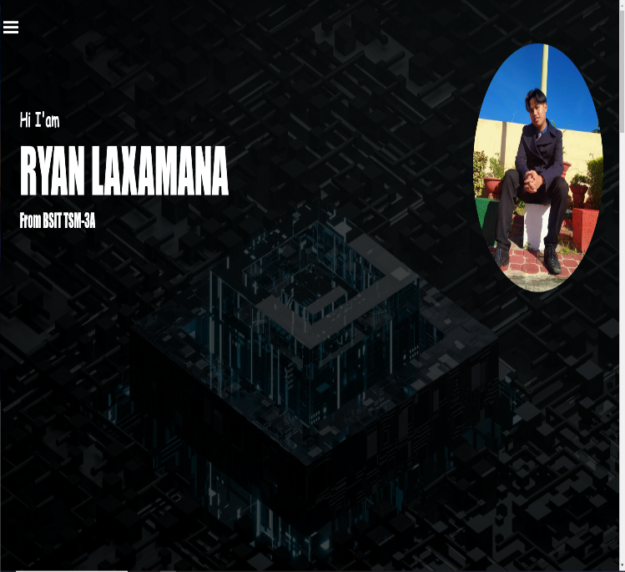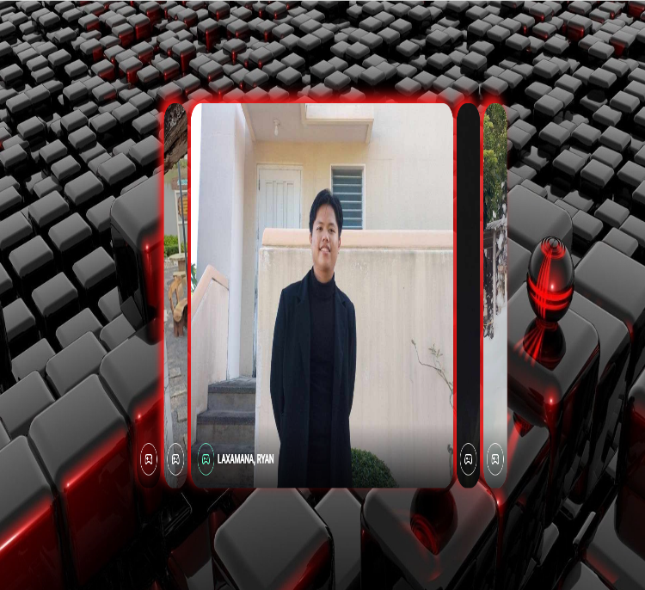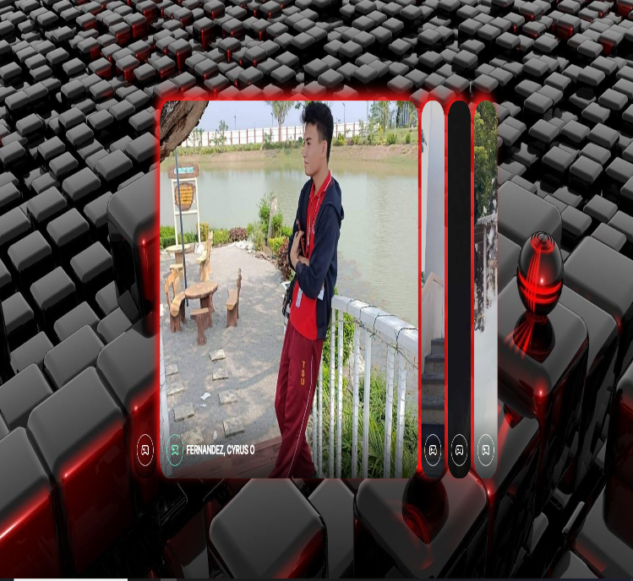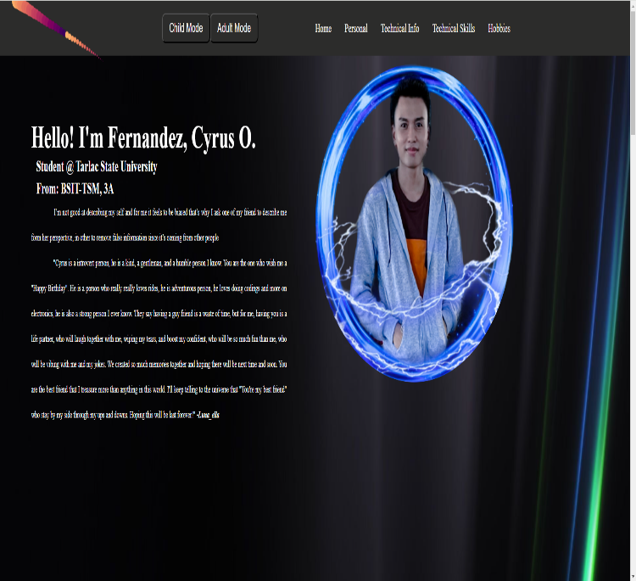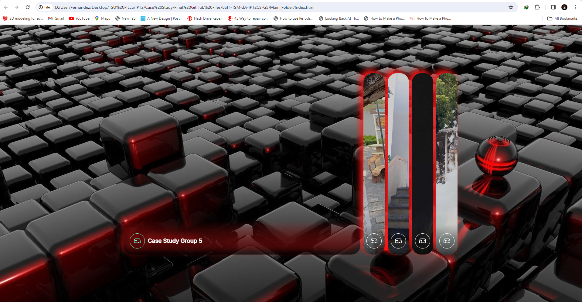

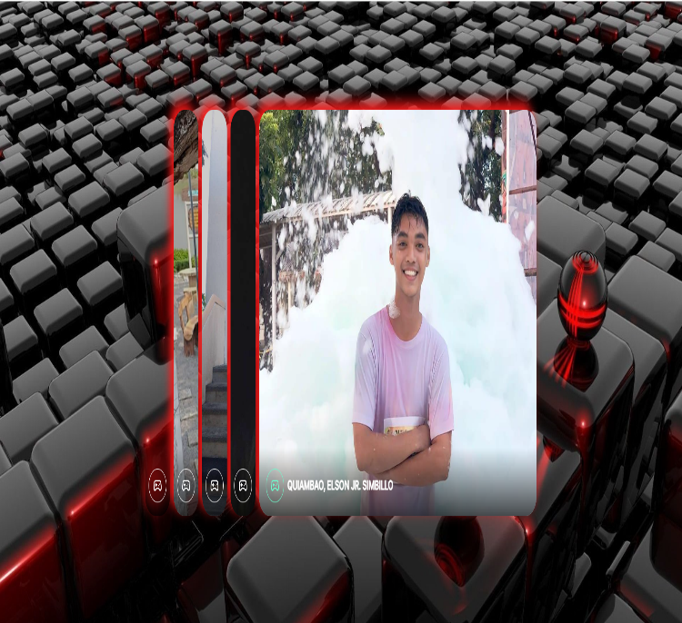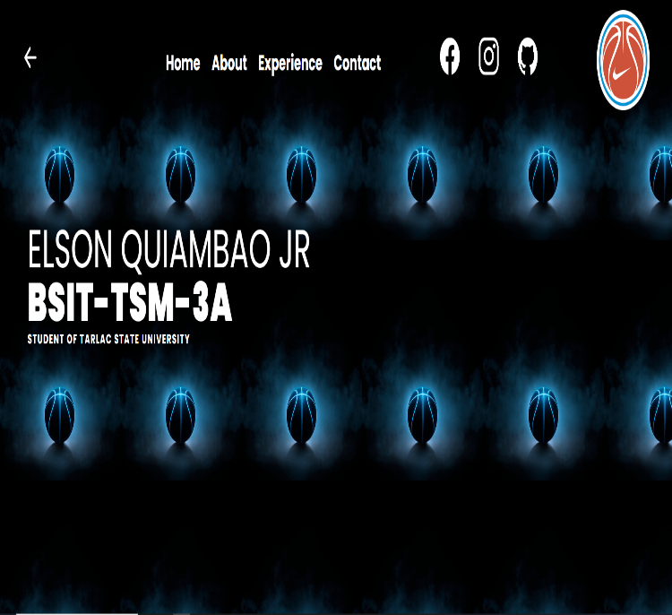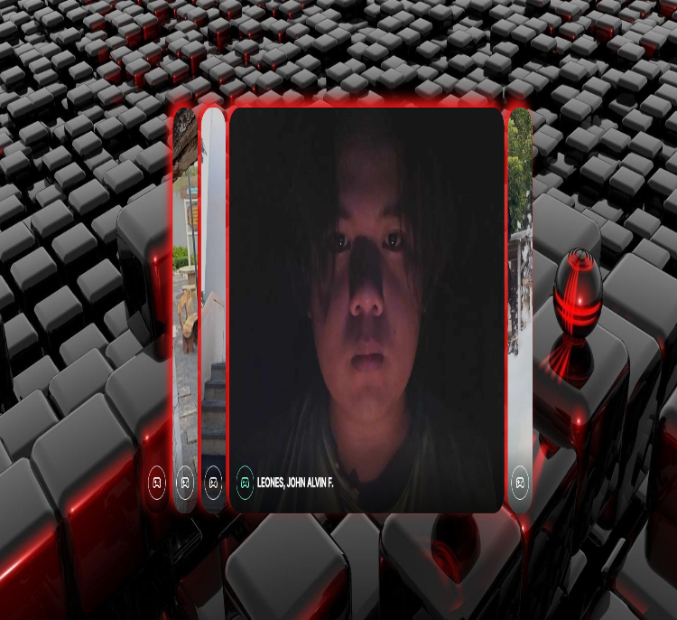

# **References**

|  |  |
| --- | --- |
| [1] | "About repositories," GitHub Docs, [Online]. Available: https://docs.github.com/en/repositories/creating-and-managing-repositories/about-repositories. [Accessed 3 3 2024]. |
| [2] | "About milestones," GitHub Docs, [Online]. Available: https://docs.github.com/en/issues/using-labels-and-milestones-to-track-work/about-milestones. [Accessed 3 3 2024]. |
| [3] | "About issues," GitHub Docs, [Online]. Available: https://docs.github.com/en/issues/tracking-your-work-with-issues/about-issues. [Accessed 3 3 2024]. |
| [4] | "--local-branching-on-the-cheap," Git, [Online]. Available: https://git-scm.com/docs/git-clone. [Accessed 3 3 2024]. |
| [5] | "Git Branch," ATLASSIAN, [Online]. Available: https://www.atlassian.com/git/tutorials/using-branches. [Accessed 3 3 2024]. |
| [6] | "--everything-is-local," GIT, [Online]. Available: https://git-scm.com/docs/git-merge. [Accessed 3 3 2024]. |
| [7] | A. Khoo, "Git Push Origin," warp, [Online]. Available: https://www.warp.dev/terminus/understanding-git-push-origin#:~:text=git%20push%20origin%20is%20a,a%20remote%20repository%20(origin).&text=origin%20is%20the%20conventional%20shorthand,repository%20provider)%20for%20your%20project.. [Accessed 3 3 2024]. |
| [8] | "Git fetch," ATLASSIAN, [Online]. Available: https://www.atlassian.com/git/tutorials/syncing/git-fetch. [Accessed 3 3 2024]. |
| [9] | "everything-is-local," Git, [Online]. Available: https://git-scm.com/docs/git-pull. [Accessed 8 3 2024]. |
| [10] | "Pull Request," GitHub Docs, [Online]. Available: https://docs.github.com/en/pull-requests/collaborating-with-pull-requests/proposing-changes-to-your-work-with-pull-requests/about-pull-requests. [Accessed 9 3 2024]. |
| [11] | "ATLASSIAN," Atlassian, [Online]. Available: https://www.atlassian.com/git/tutorials/syncing/git-pull#:~:text=The%20git%20pull%20command%20is,Git%2Dbased%20collaboration%20work%20flows.. [Accessed 7 March 2024]. |